Prostate Cancer Control in Canada – 2015

Hold Ctrl and click on a figure title below to follow the link.
- Figure 1.1 Incidence and mortality rates for prostate cancer (men aged ≥ 35), Canada, age-standardized to the 2011 population – from 1992 to 2011 3
- Figure 1.2 Incidence rates for prostate cancer (men aged ≥ 35), by province, age-standardized to the 2011 population – 2008-2010 combined 4
- Figure 1.3 Mortality rates for prostate cancer (men aged ≥ 35), by province, age-standardized to the 2011 population – 2009-2011 combined 5
- Figure 1.4 Incidence† and mortality†† rates for prostate cancer (men aged ≥ 35), by age group, Canada, age-standardized to the 2011 population – 2008-2010 combined and 2009-2011 combined 6
- Figure 1.5 Percentage of men (aged ≥ 35) reporting at least one PSA test† in the past one year, two years or ever, by province/territory – 2010-2013 reporting years combined 7
- Figure 1.6 Percentage of men (aged ≥ 35) reporting at least one PSA test† in the past one year, two years or ever, by age group, Canada – 2010-2013 reporting years combined 8
- Figure 2.1 Stage-specific incidence rates for prostate cancer (men aged ≥ 35), by province, age-standardized to the 2011 population — 2010 diagnosis year 9
- Figure 2.2 Incidence rates for non-metastatic prostate cancer (men aged ≥ 35)†, by province, by risk category, age-standardized to the 2011 population — 2012 diagnosis year 10
- Figure 2.3 Distribution of non-metastatic prostate cancer cases (men aged ≥ 35), by risk category, by age group — 2012 diagnosis year 11
- Figure 3.1 Median and 90th percentile surgery wait times from booking date to surgery for prostate cancer, by province — 2014 12
- Figure 3.2 90th percentile radiation therapy wait times from ready-to-treat to start of radiation for prostate cancer, by province — 2013 treatment year 13
- Figure 3.3 Median and 90th percentile radiation therapy wait times from ready-to-treat to start of radiation for prostate cancer, by province, by risk category — 2013 treatment year 14
- Figure 3.4 Percentage of prostate cancer patients (men aged ≥ 35) receiving various types of treatment,† by risk category, by province — 2010 diagnosis year 15
- Figure 3.5 Percentage of prostate cancer patients receiving various types of treatment† for men aged 75 or younger, by risk category, by province — 2010 diagnosis year 16
- Figure 3.6 Percentage of prostate cancer patients receiving various types of treatment† for men over age 75, by risk category, by province — 2010 diagnosis year 17
- Figure 3.7 Percentage of prostate cancer patients (men aged ≥ 35) receiving various types of radiation therapy,† by risk category, by province — 2010 diagnosis year 18
- Figure 3.8 Percentage of prostate cancer patients receiving radical prostatectomies, by surgical approach (%), by province — 2013-2014 combined 19
- Figure 4.1 Percentage of prostate cancer patients reporting a negative experience rating across dimensions of care, by province – ranging from 2011 to 2013 20
- Figure 4.2 Emotional support dimension: Percentage of prostate cancer patients reporting a negative experience rating, by province – ranging from 2011 to 2013 21
- Figure 4.3 Information, communication and education dimension: Percentage of prostate cancer patients reporting a negative experience rating, by province – ranging from 2011 to 2013 22
- Figure 4.4 Percentage of men with prostate cancer receiving radiation therapy within one year prior to death, by province – 2011 23
- Figure 4.5 Percentage of prostate cancer deaths occurring in hospital, private home or other, by province – 2011 24
- Figure 4.6 Percentage of prostate, breast, lung and colorectal cancer deaths occurring in hospital, private home or other, Canada – 2011 25
- Figure 5.1 Distribution of cancer research investment (2012), new cancer cases (2010) and cancer deaths (2011), by disease site, Canada 26
- Figure 5.2 Distribution of investment in prostate cancer research across areas of research for top five funders, Canada — 2005 and 2012 27
- Figure 5.3 Per capita investment (male population) in prostate cancer research, by province — 2005 and 2012 28
- Figure 5.4 Ratio of adult prostate cancer patients enrolled in clinical trials to number of incident cases, by disease site, four most common cancers and all cancers† — 2013 enrolment year 29
- Figure 5.5 Ratio of adult prostate cancer patients enrolled in clinical trial to number of incident cases, by province — 2013 enrolment year 30

Figure 1.1 Incidence and mortality rates for prostate cancer (men aged ≥ 35), Canada, age-standardized to the 2011 population – from 1992 to 2011
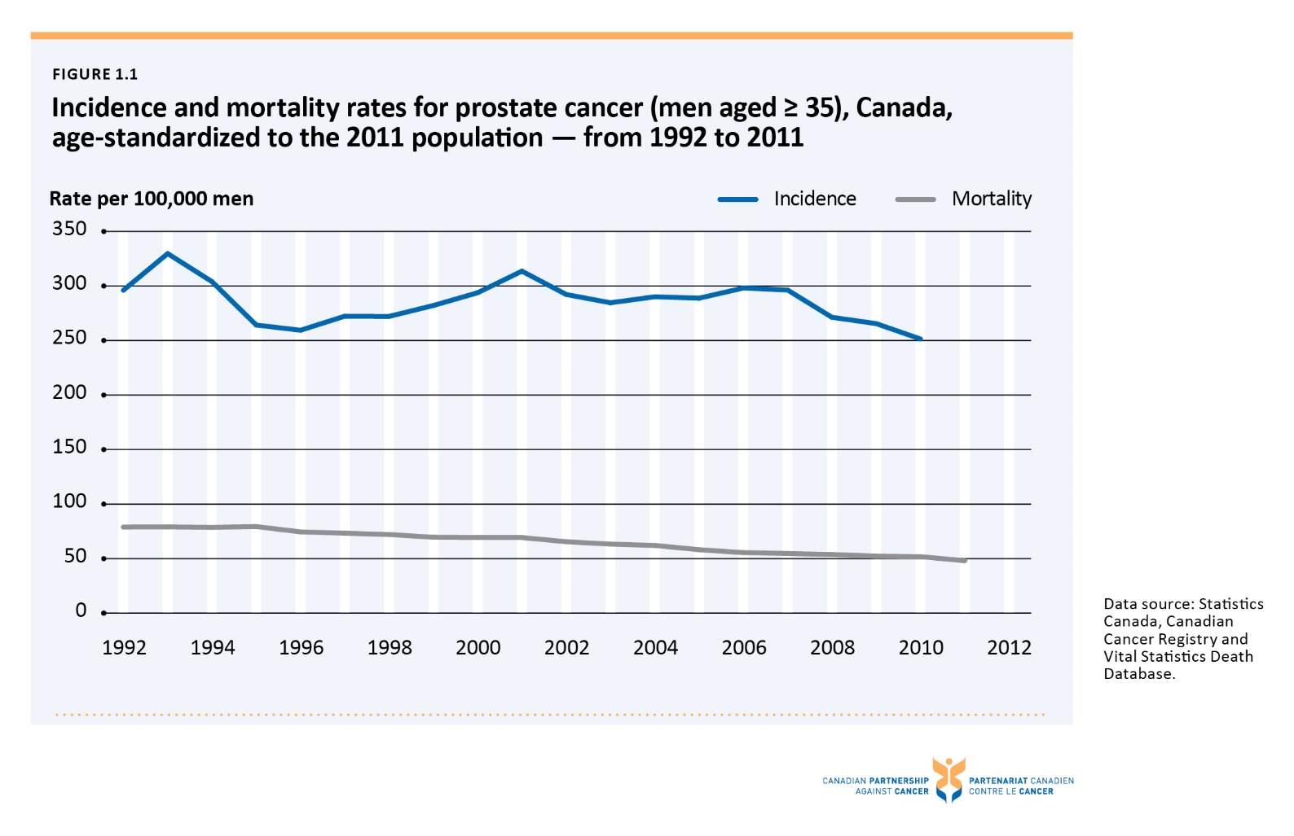

Figure 1.2 Incidence rates for prostate cancer (men aged ≥ 35), by province, age-standardized to the 2011 population – 2008-2010 combined
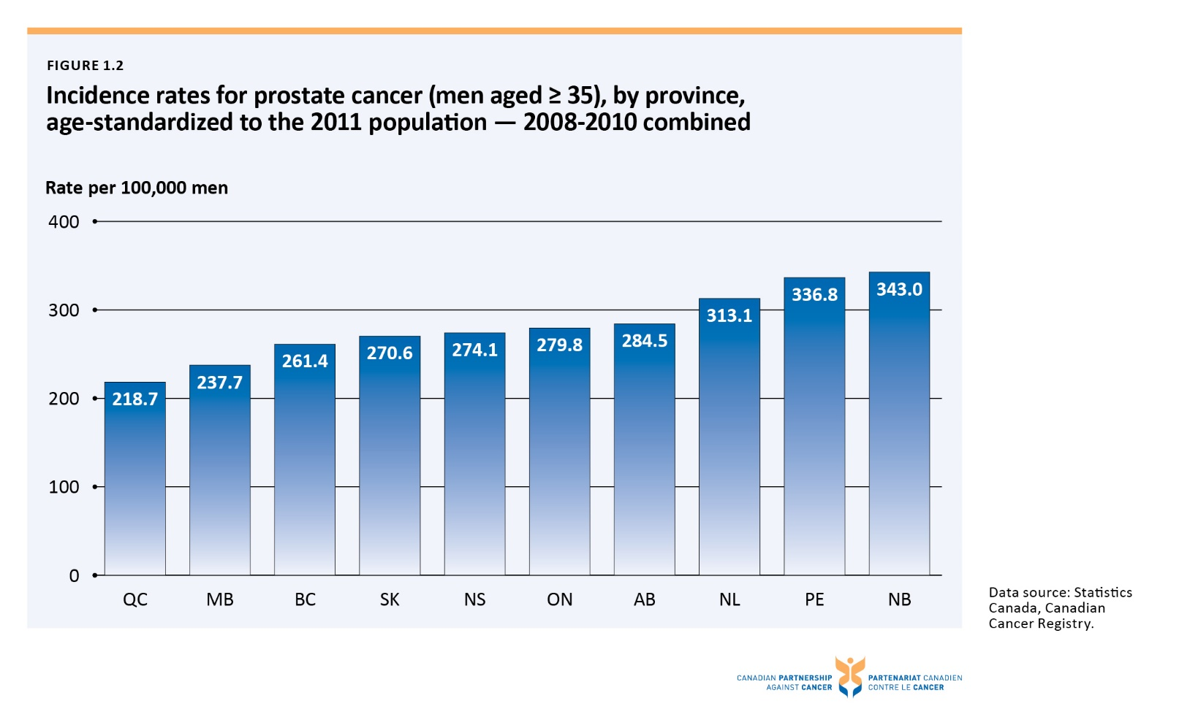

Figure 1.3 Mortality rates for prostate cancer (men aged ≥ 35), by province, age-standardized to the 2011 population – 2009-2011 combined
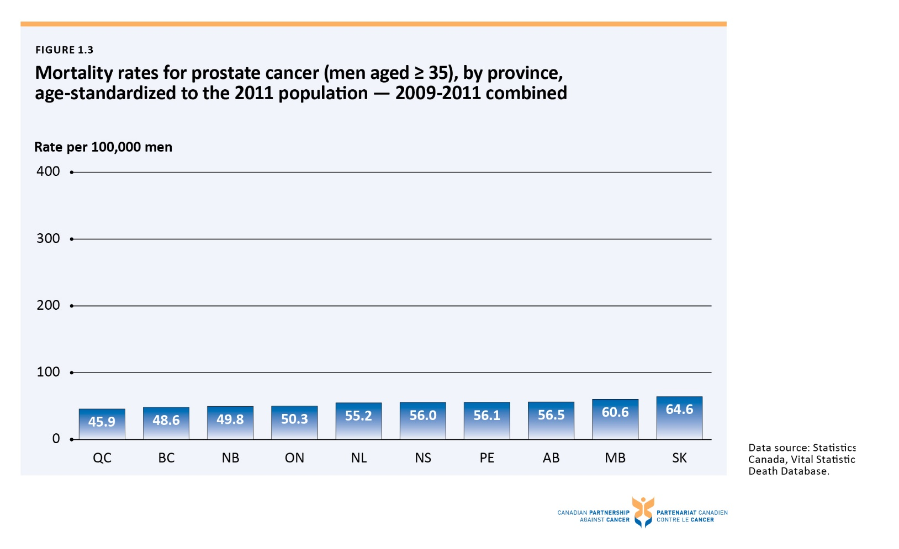

Figure 1.4 Incidence† and mortality†† rates for prostate cancer (men aged ≥ 35), by age group, Canada, age-standardized to the 2011 population – 2008-2010 combined and 2009-2011 combined
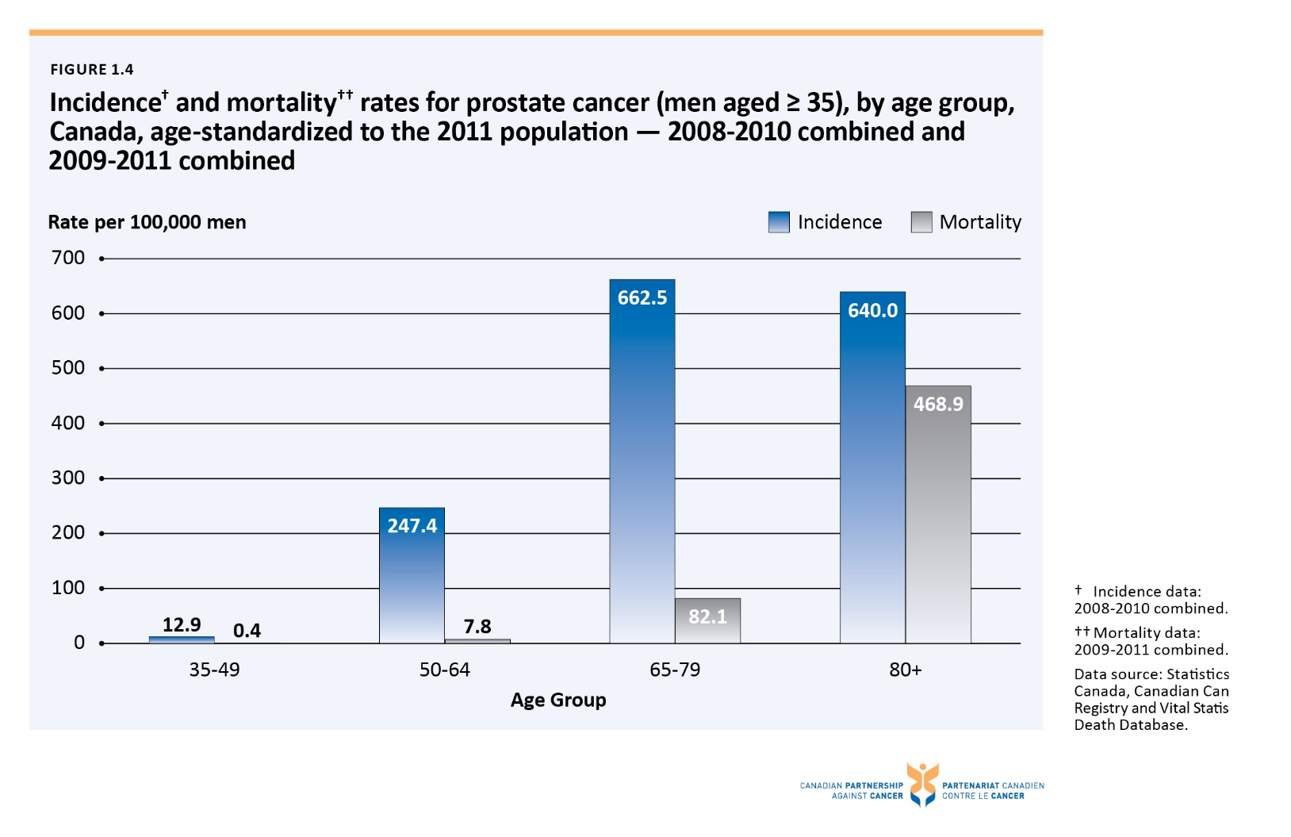

Figure 1.5 Percentage of men (aged ≥ 35) reporting at least one PSA test† in the past one year, two years or ever, by province/territory – 2010-2013 reporting years combined

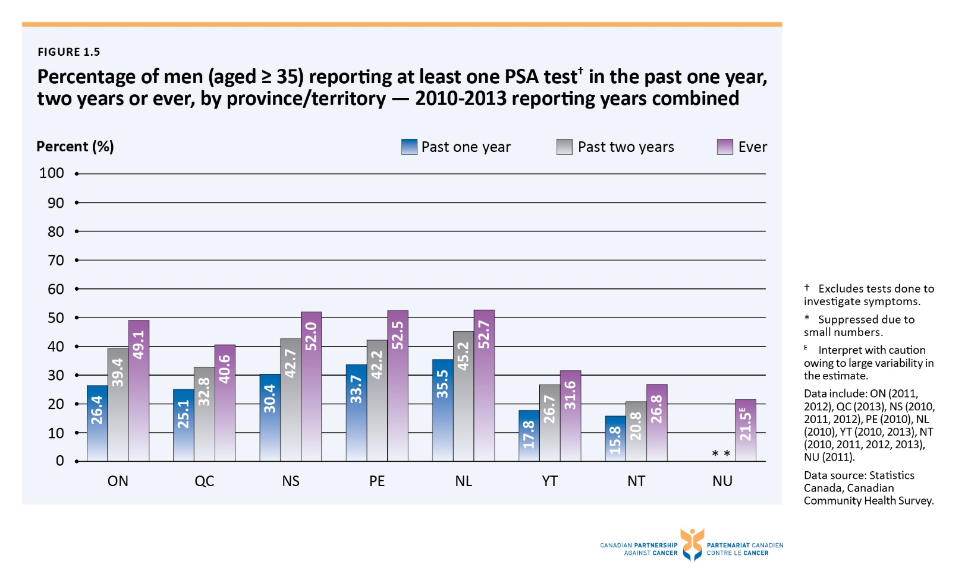

Figure 1.6 Percentage of men (aged ≥ 35) reporting at least one PSA test† in the past one year, two years or ever, by age group, Canada – 2010-2013 reporting years combined
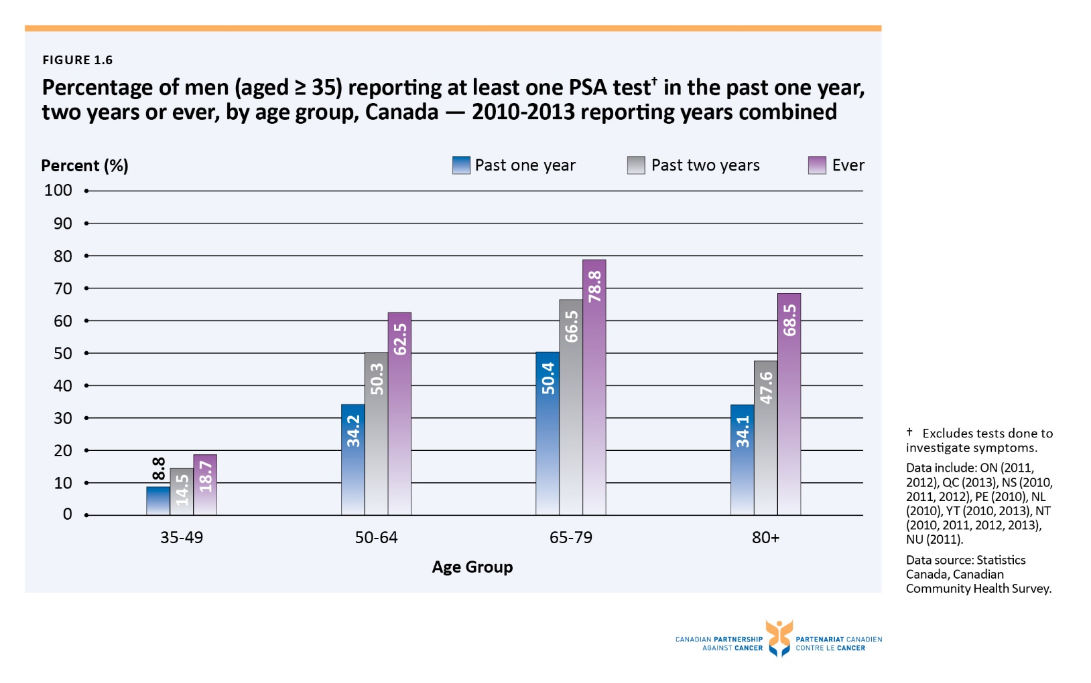

Figure 2.1 Stage-specific incidence rates for prostate cancer (men aged ≥ 35), by province, age-standardized to the 2011 population — 2010 diagnosis year
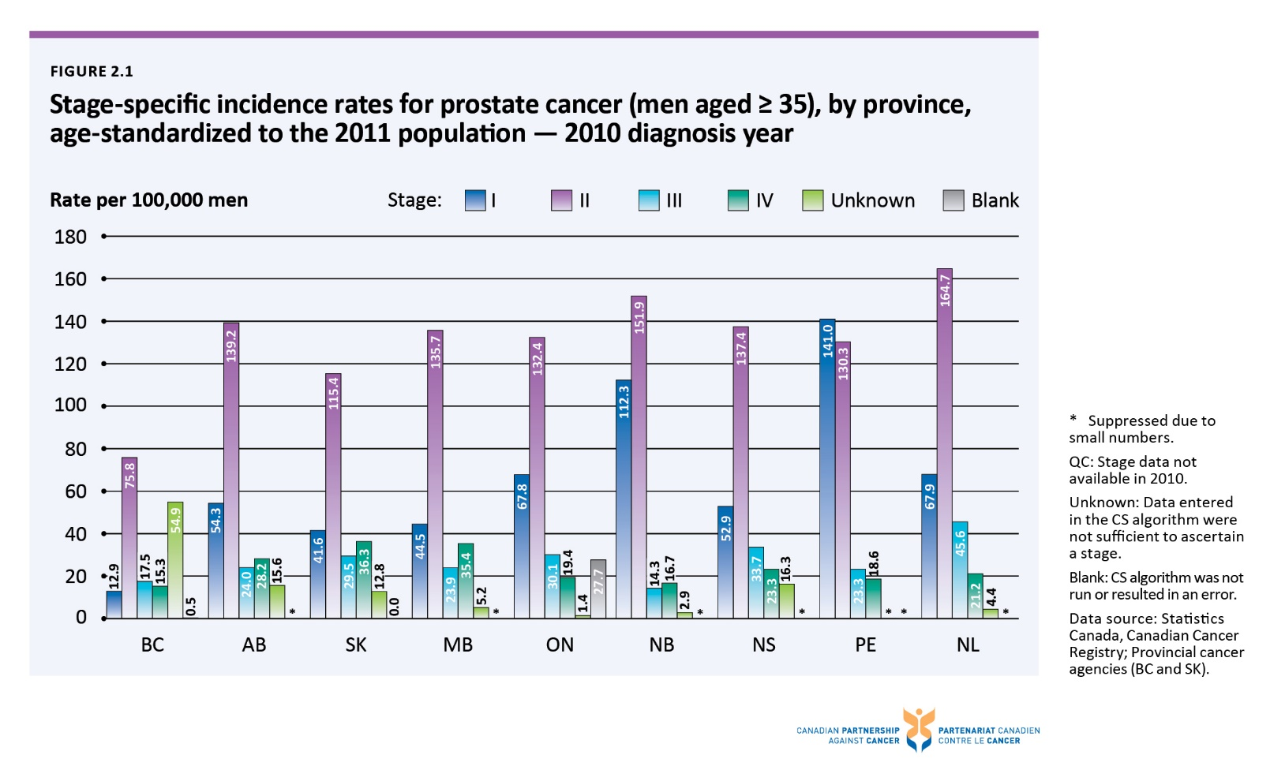

Figure 2.2 Incidence rates for non-metastatic prostate cancer (men aged ≥ 35)†, by province, by risk category, age-standardized to the 2011 population — 2012 diagnosis year
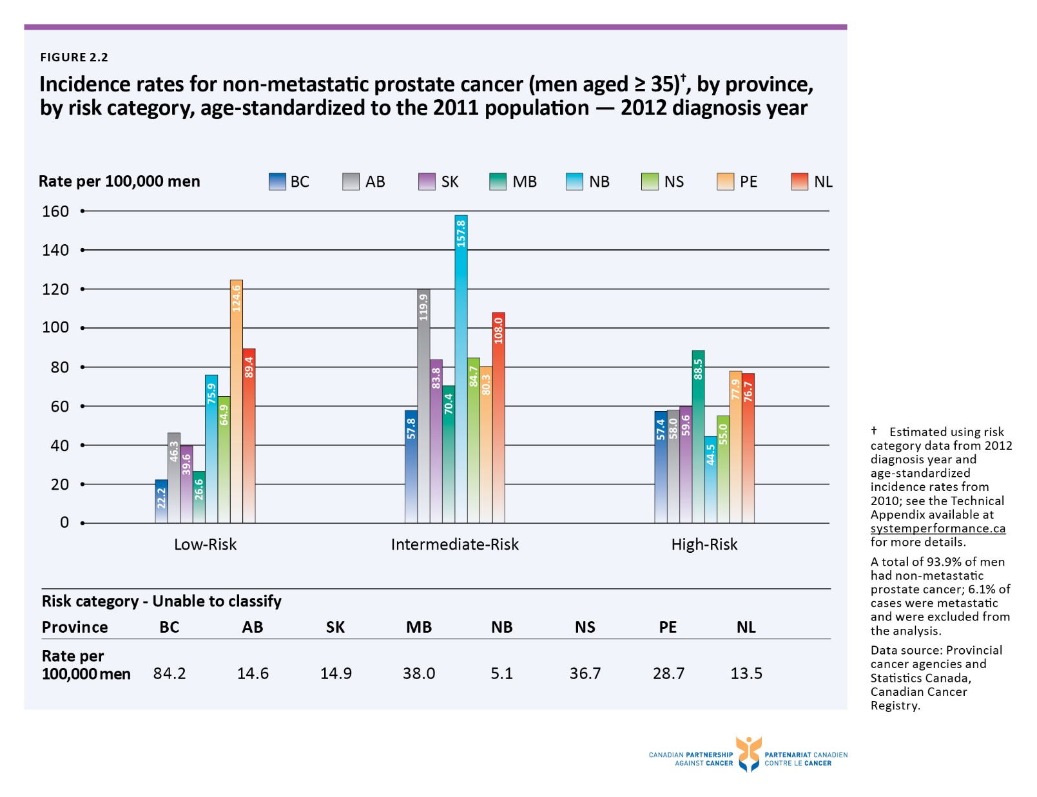

Figure 2.3 Distribution of non-metastatic prostate cancer cases (men aged ≥ 35), by risk category, by age group — 2012 diagnosis year
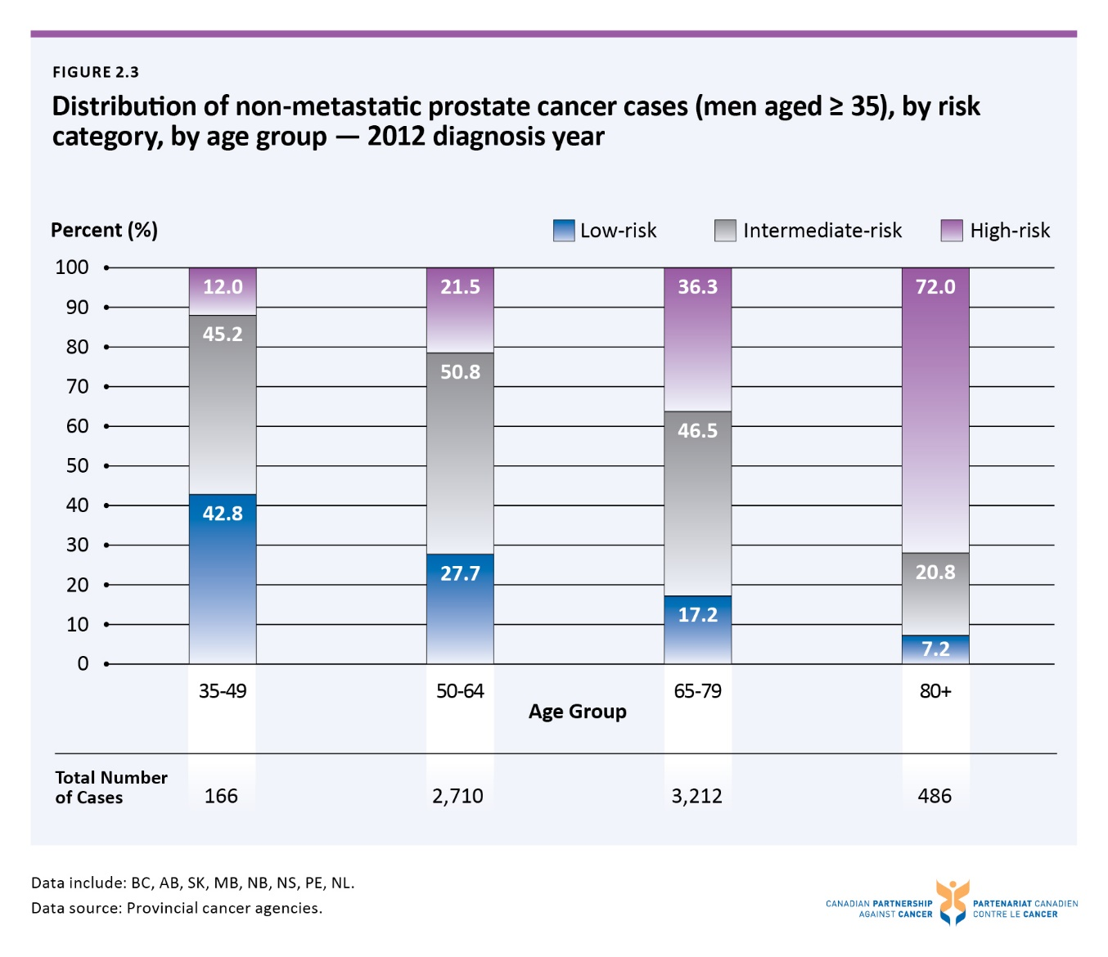

Figure 3.1 Median and 90th percentile surgery wait times from booking date to surgery for prostate cancer, by province — 2014
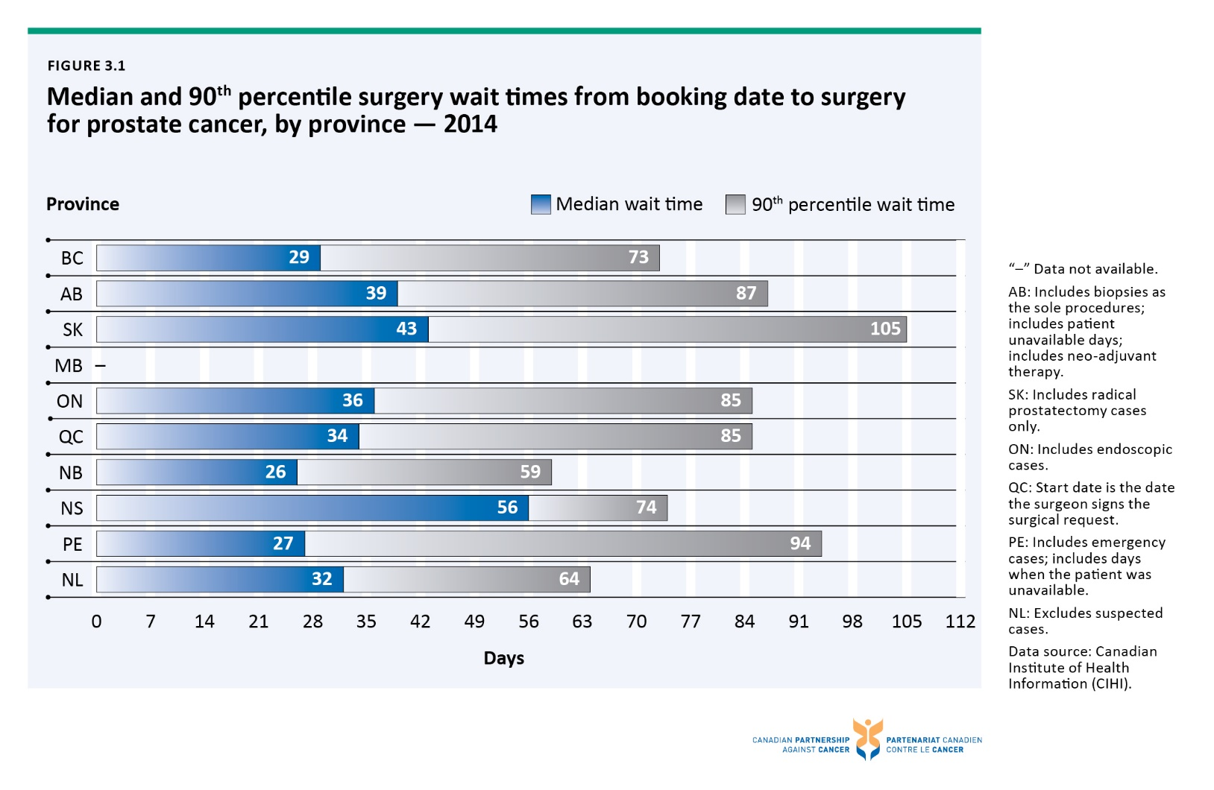

Figure 3.2 90th percentile radiation therapy wait times from ready-to-treat to start of radiation for prostate cancer, by province — 2013 treatment year
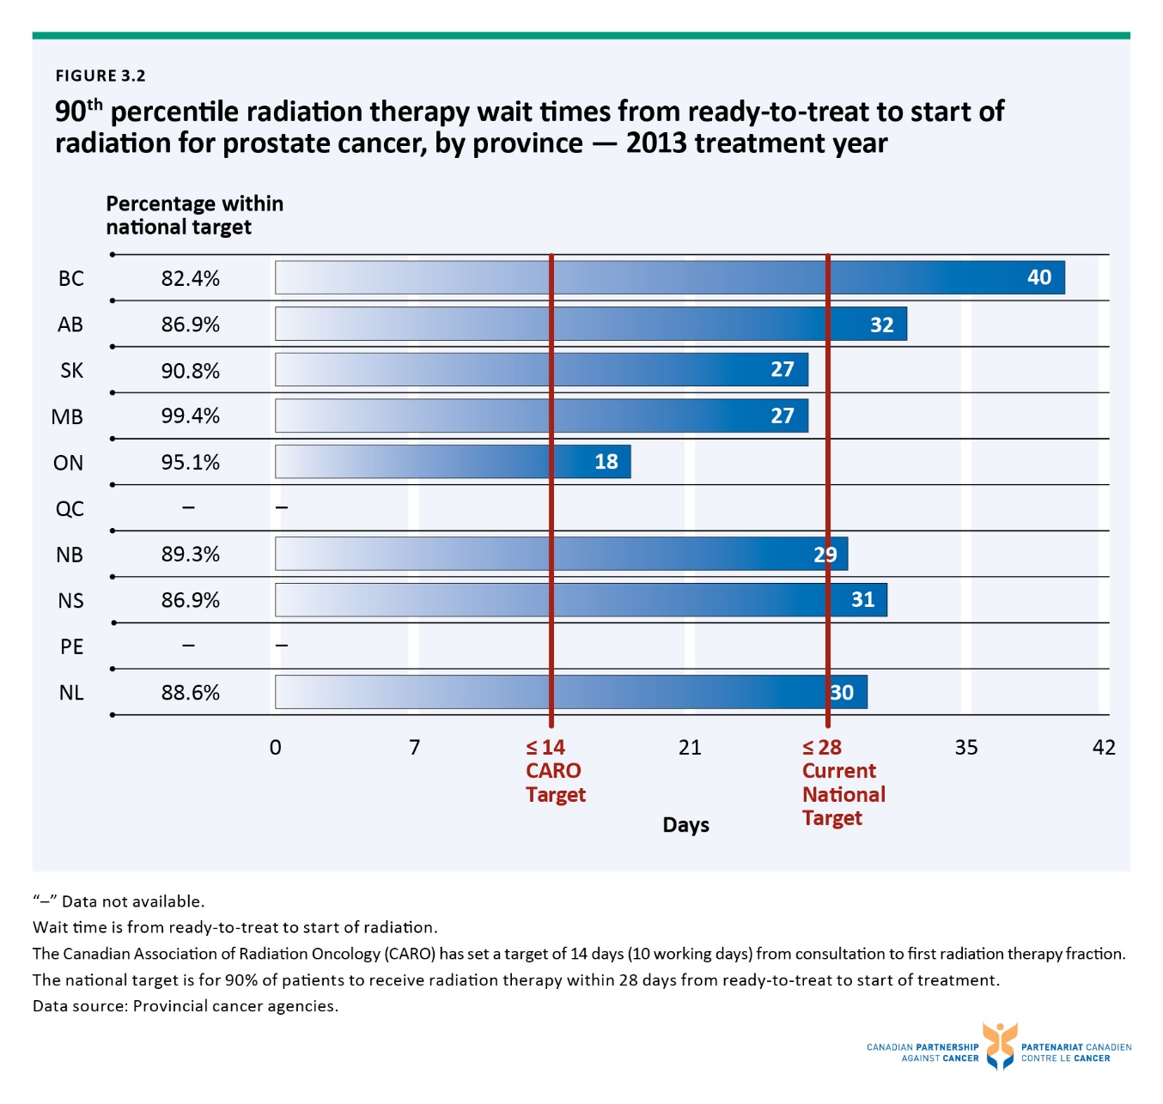

Figure 3.3 Median and 90th percentile radiation therapy wait times from ready-to-treat to start of radiation for prostate cancer, by province, by risk category — 2013 treatment year
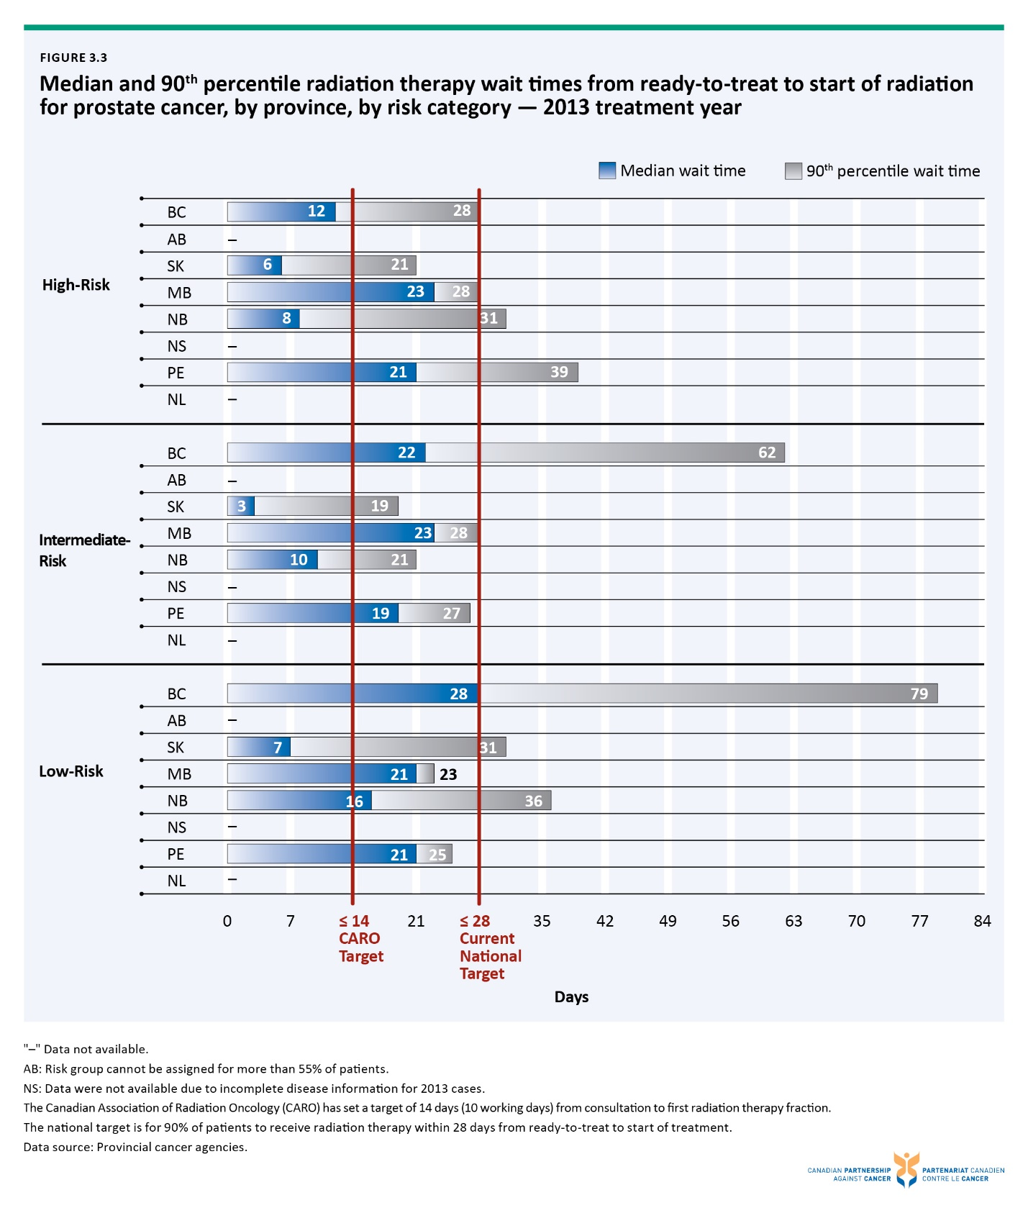

Figure 3.4 Percentage of prostate cancer patients (men aged ≥ 35) receiving various types of treatment,† by risk category, by province — 2010 diagnosis year
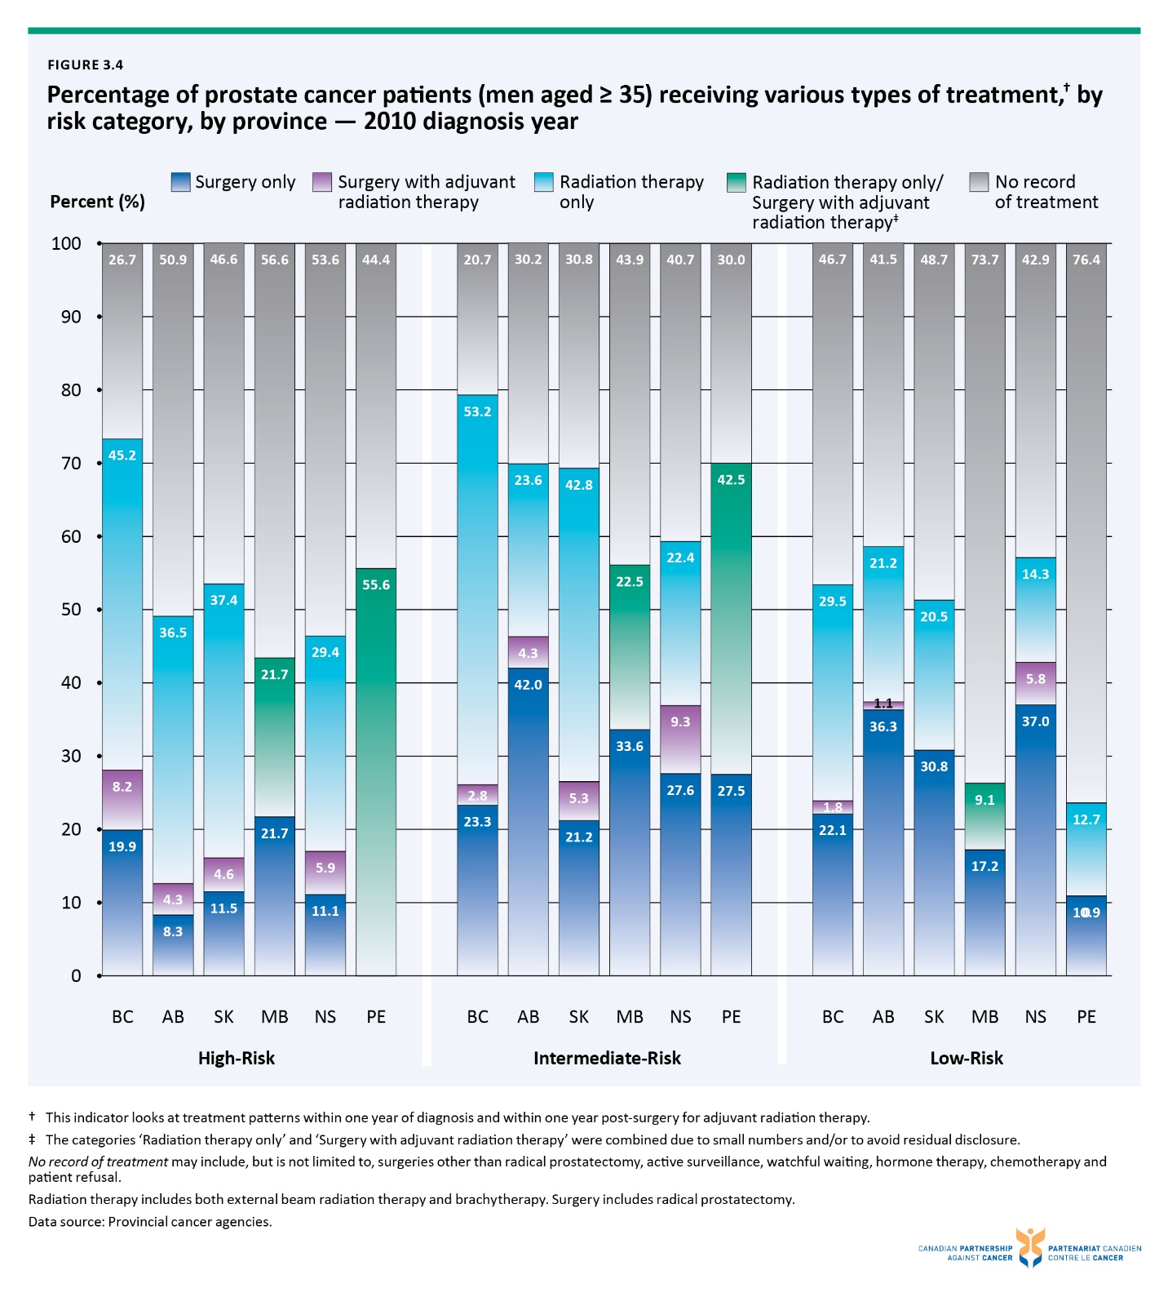

Figure 3.5 Percentage of prostate cancer patients receiving various types of treatment† for men aged 75 or younger, by risk category, by province — 2010 diagnosis year
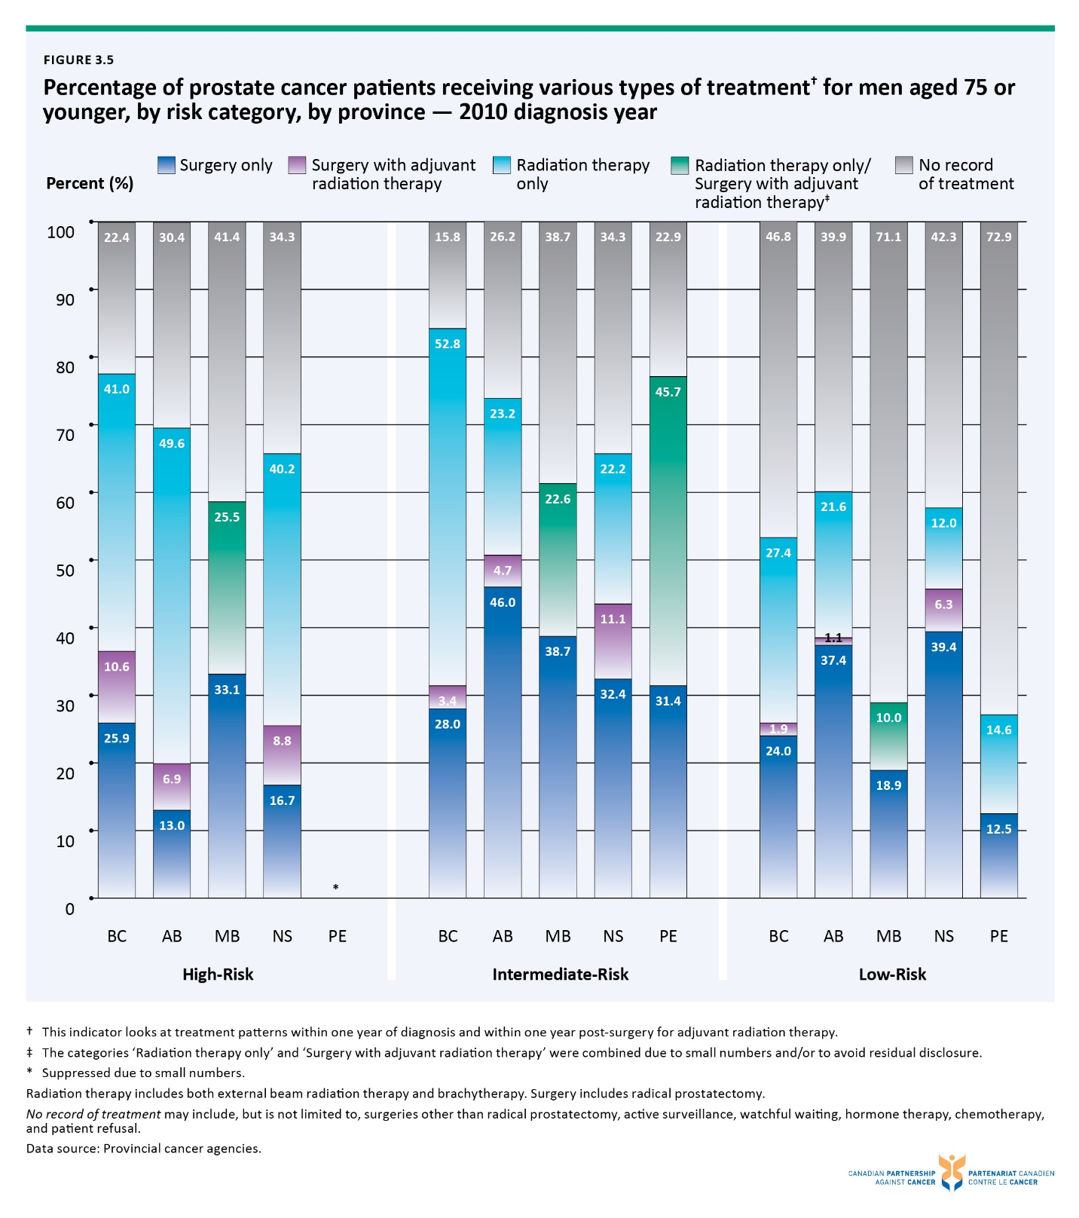

Figure 3.6 Percentage of prostate cancer patients receiving various types of treatment† for men over age 75, by risk category, by province — 2010 diagnosis year
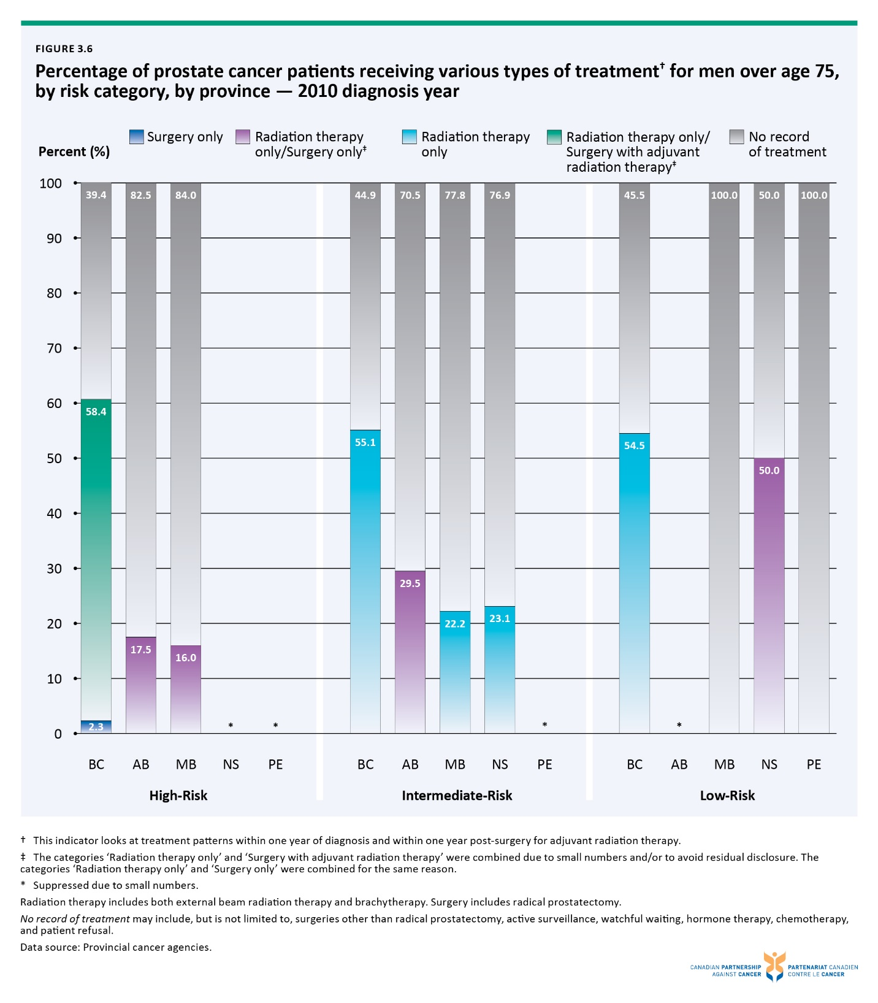

Figure 3.7 Percentage of prostate cancer patients (men aged ≥ 35) receiving various types of radiation therapy,† by risk category, by province — 2010 diagnosis year
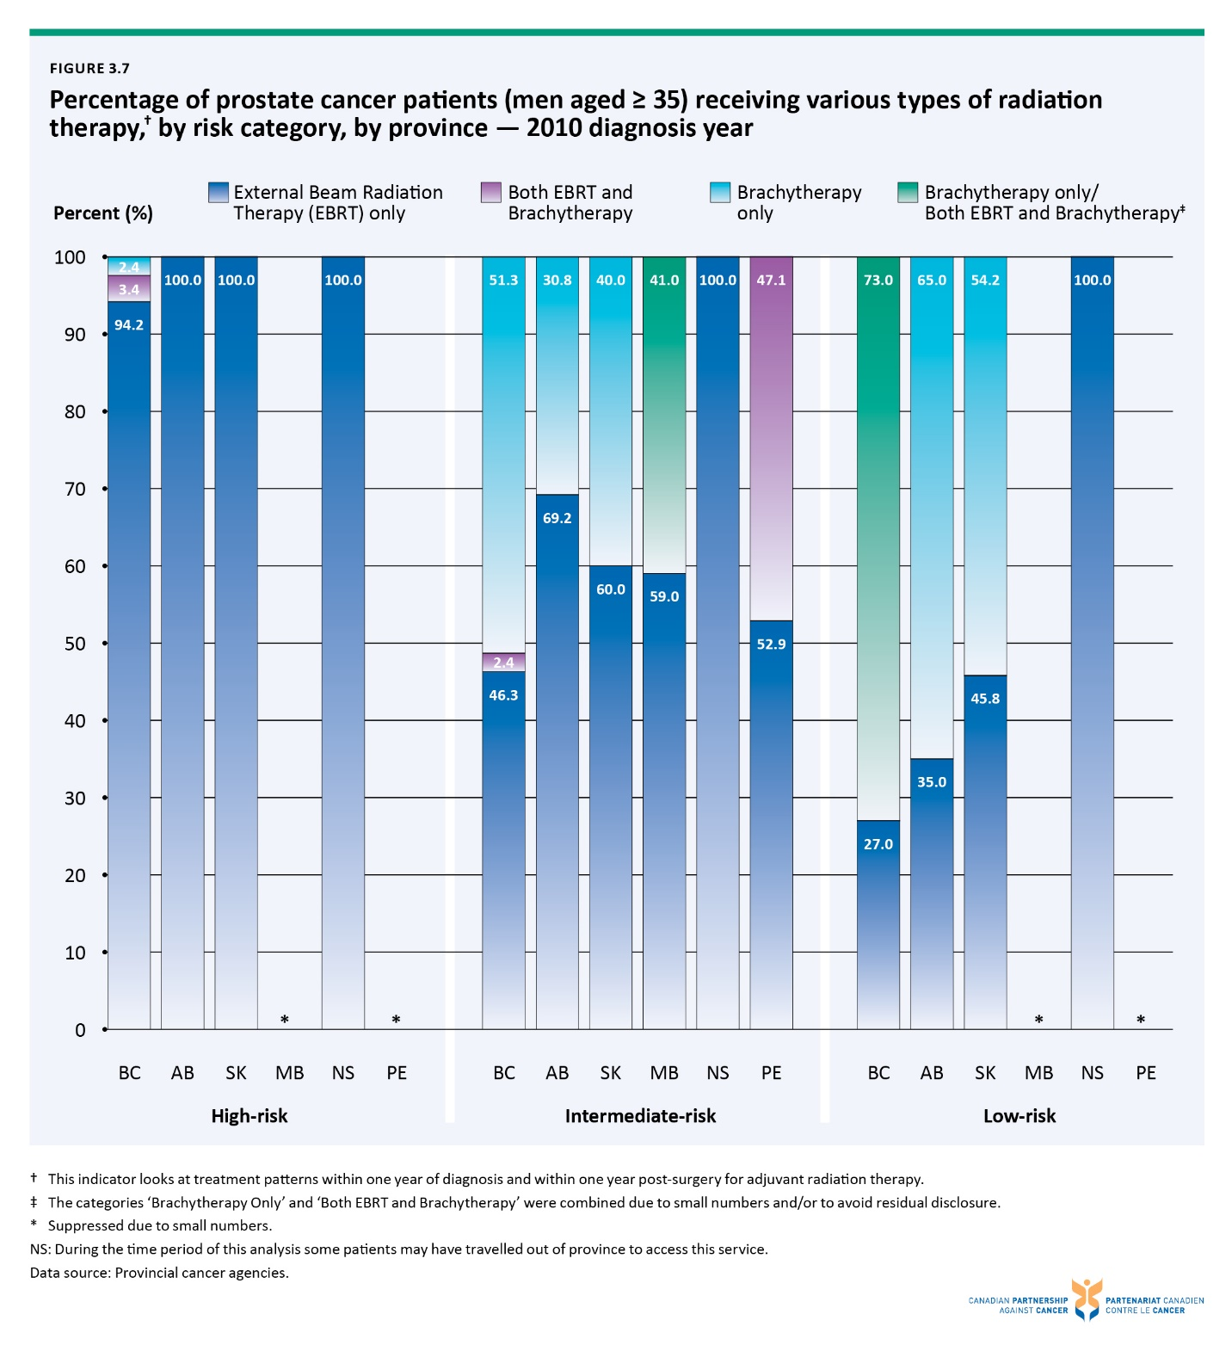

Figure 3.8 Percentage of prostate cancer patients receiving radical prostatectomies, by surgical approach (%), by province — 2013-2014 combined
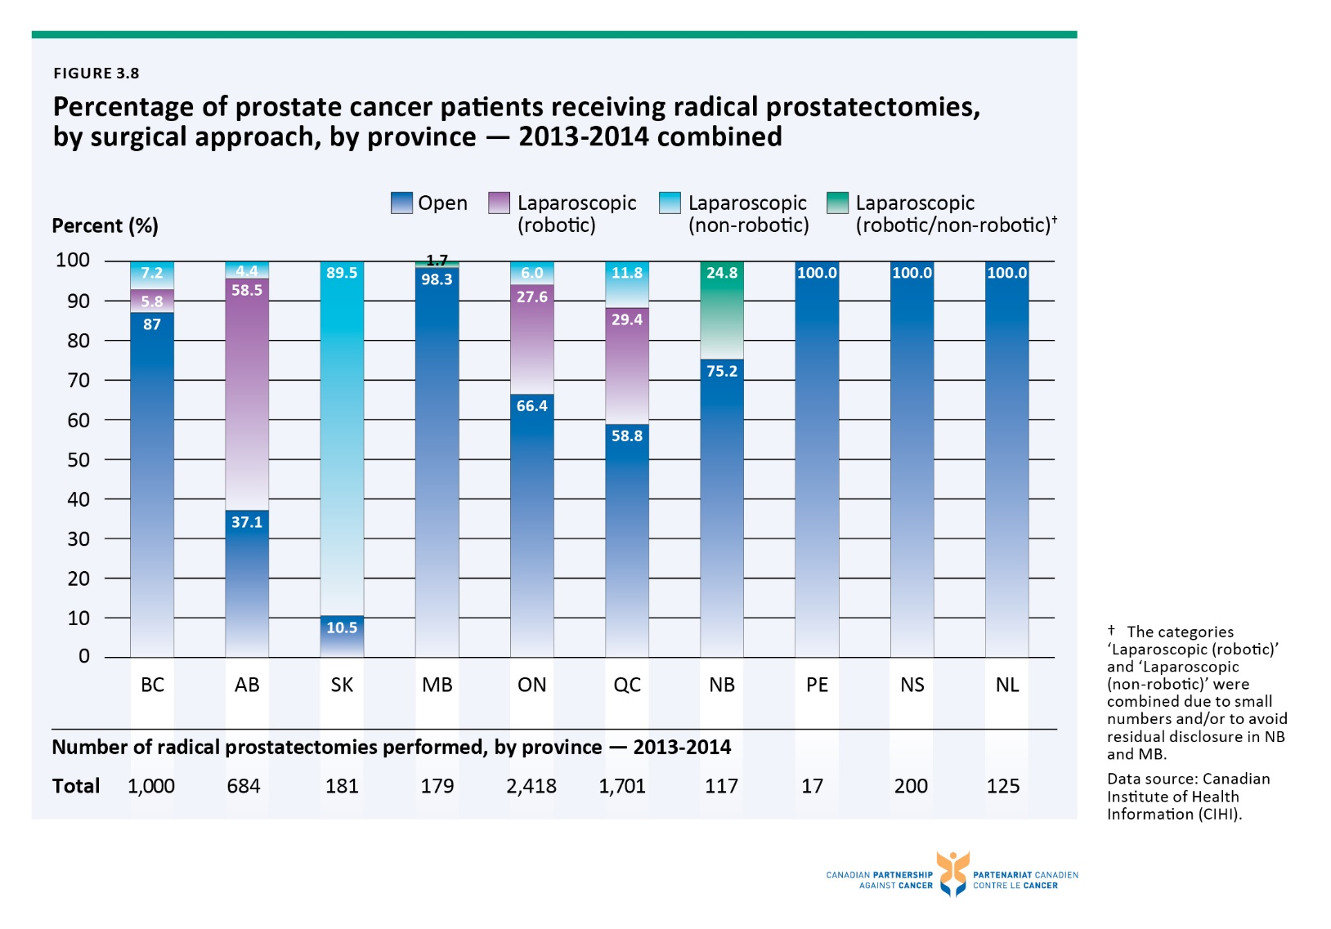

Figure 4.1 Percentage of prostate cancer patients reporting a negative experience rating across dimensions of care, by province – ranging from 2011 to 2013
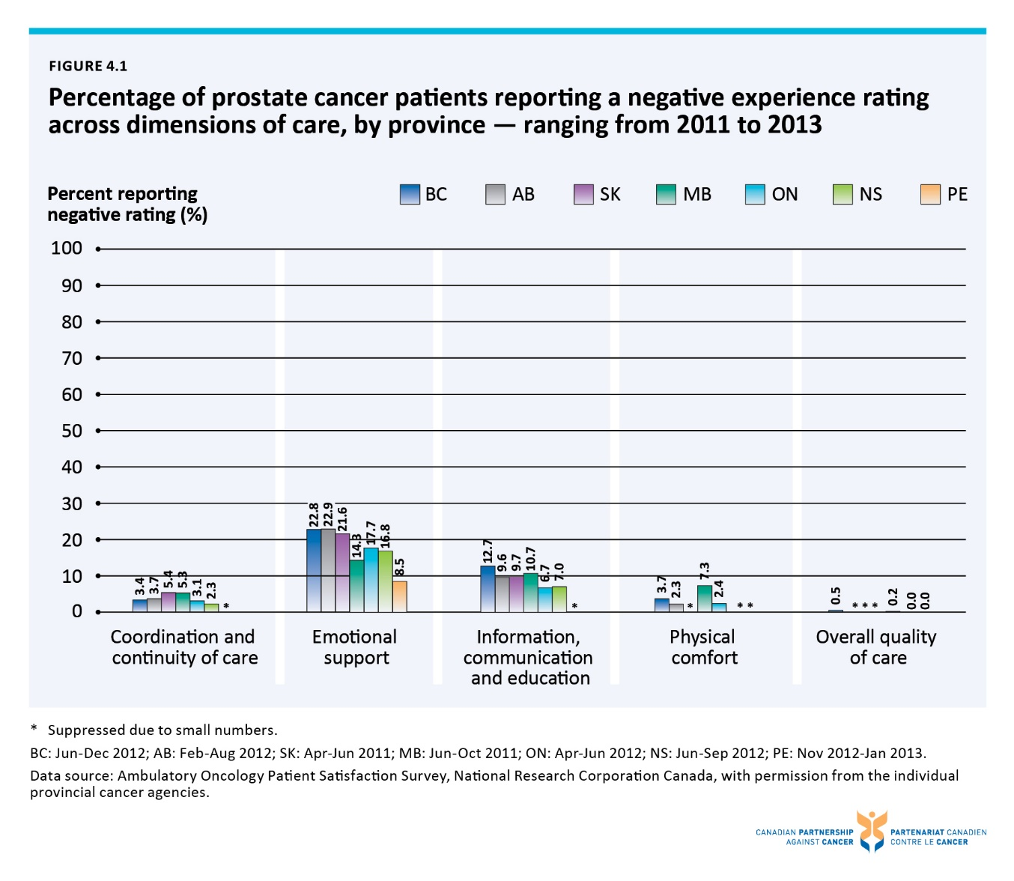

Figure 4.2 Emotional support dimension: Percentage of prostate cancer patients reporting a negative experience rating, by province – ranging from 2011 to 2013
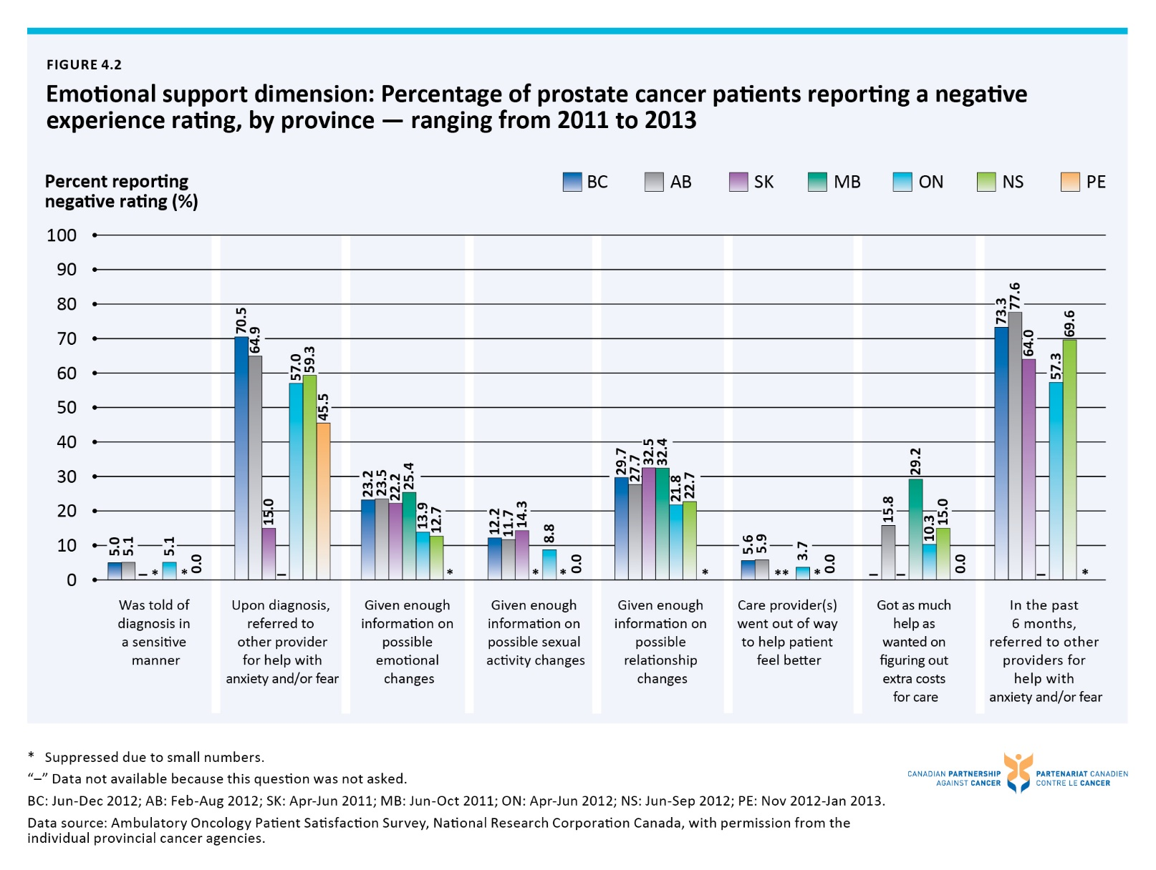

Figure 4.3 Information, communication and education dimension: Percentage of prostate cancer patients reporting a negative experience rating, by province – ranging from 2011 to 2013
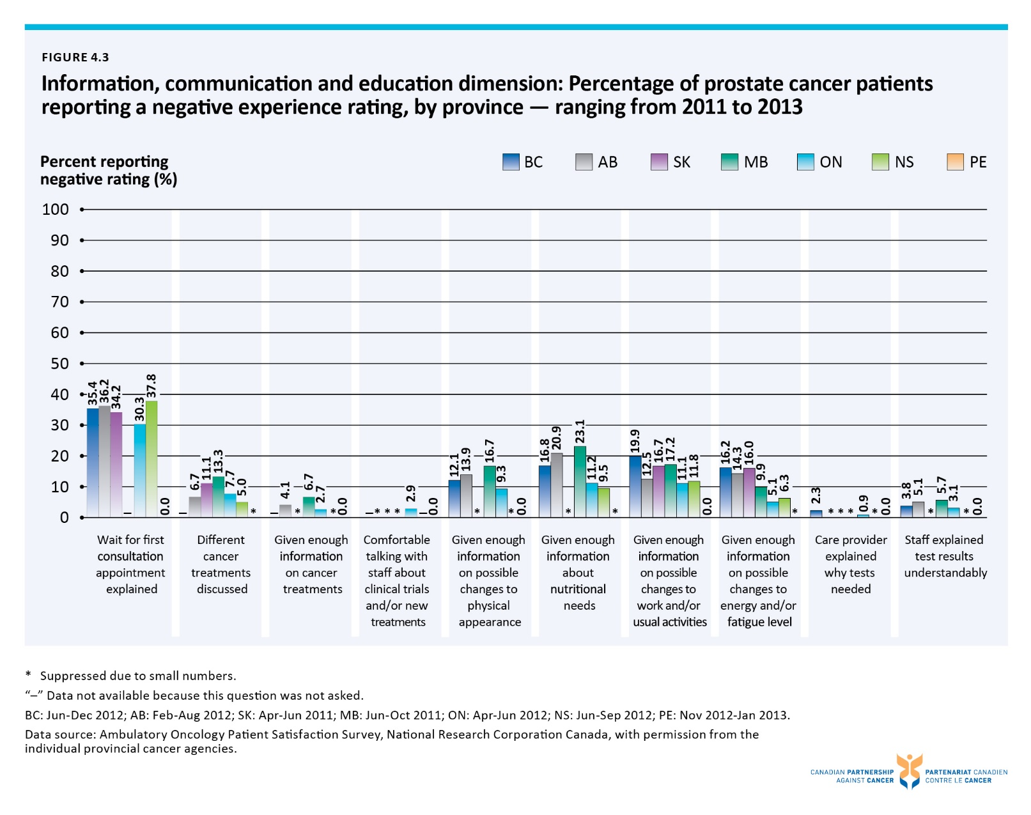

Figure 4.4 Percentage of men with prostate cancer receiving radiation therapy within one year prior to death, by province – 2011
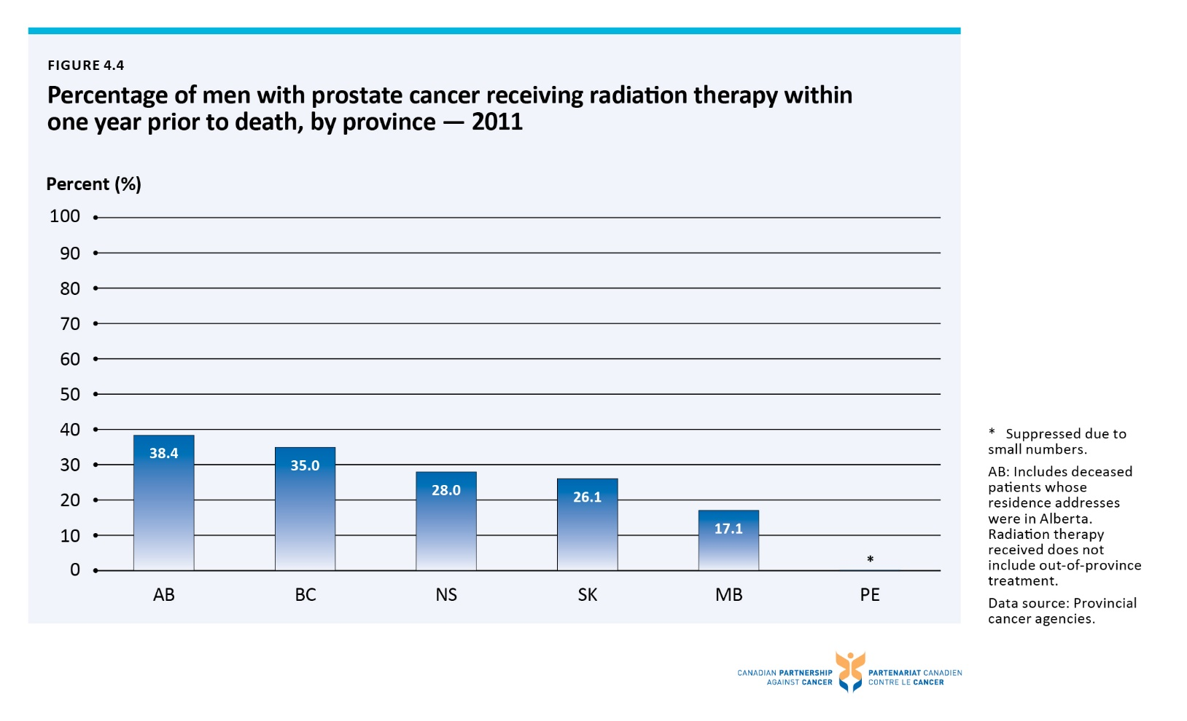

Figure 4.5 Percentage of prostate cancer deaths occurring in hospital, private home or other, by province – 2011
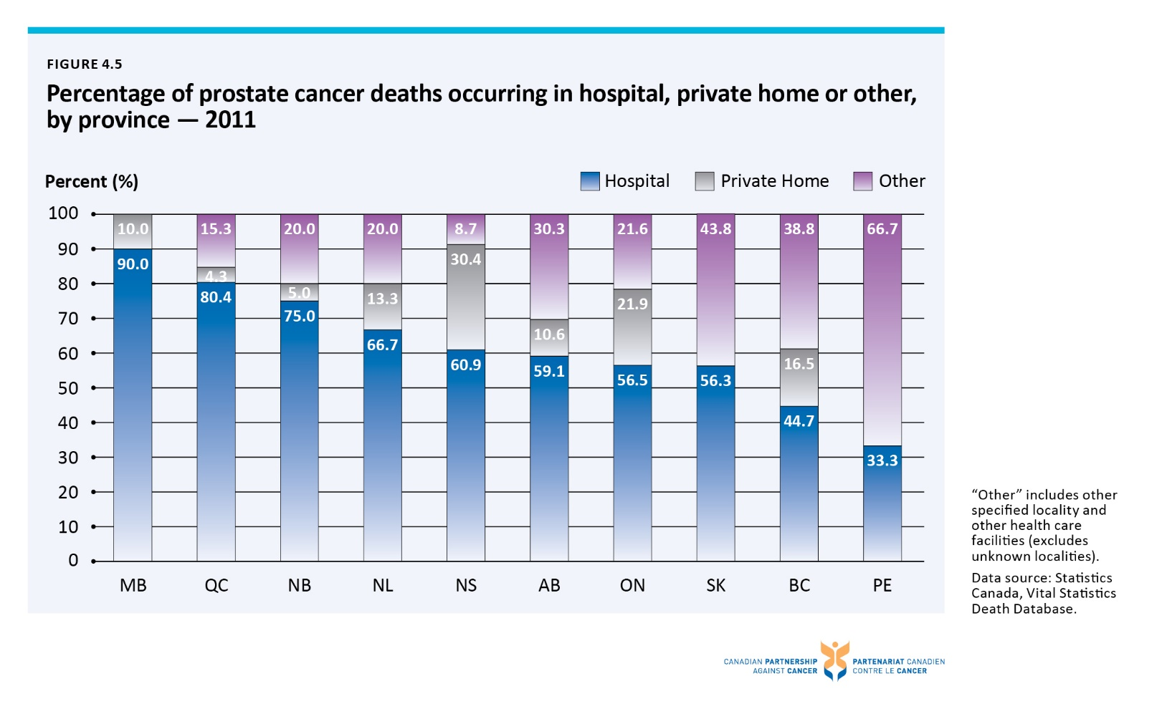

Figure 4.6 Percentage of prostate, breast, lung and colorectal cancer deaths occurring in hospital, private home or other, Canada – 2011
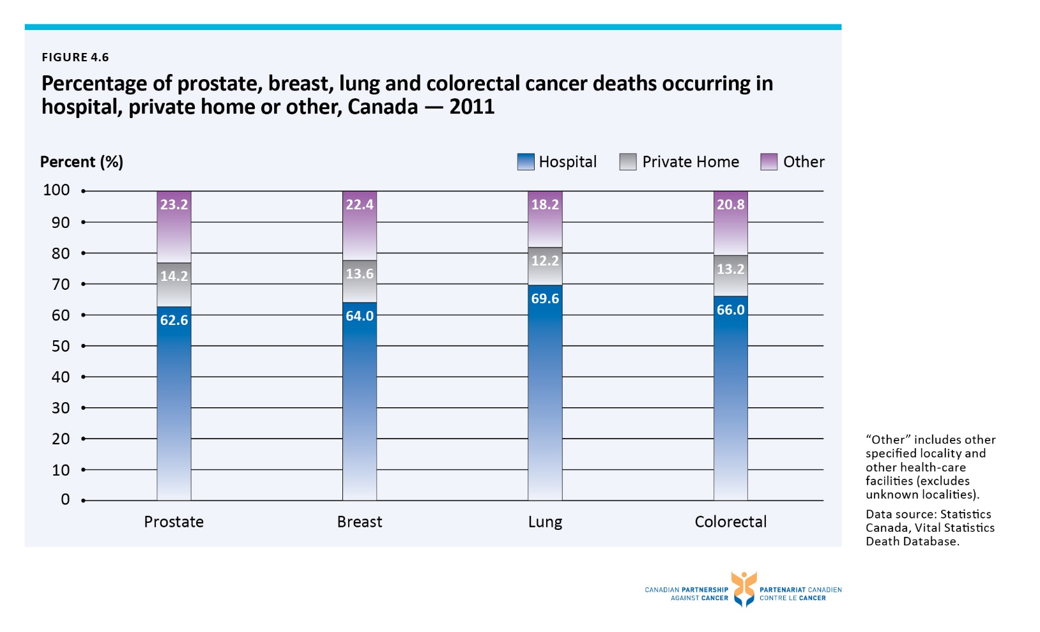

Figure 5.1 Distribution of cancer research investment (2012), new cancer cases (2010) and cancer deaths (2011), by disease site, Canada
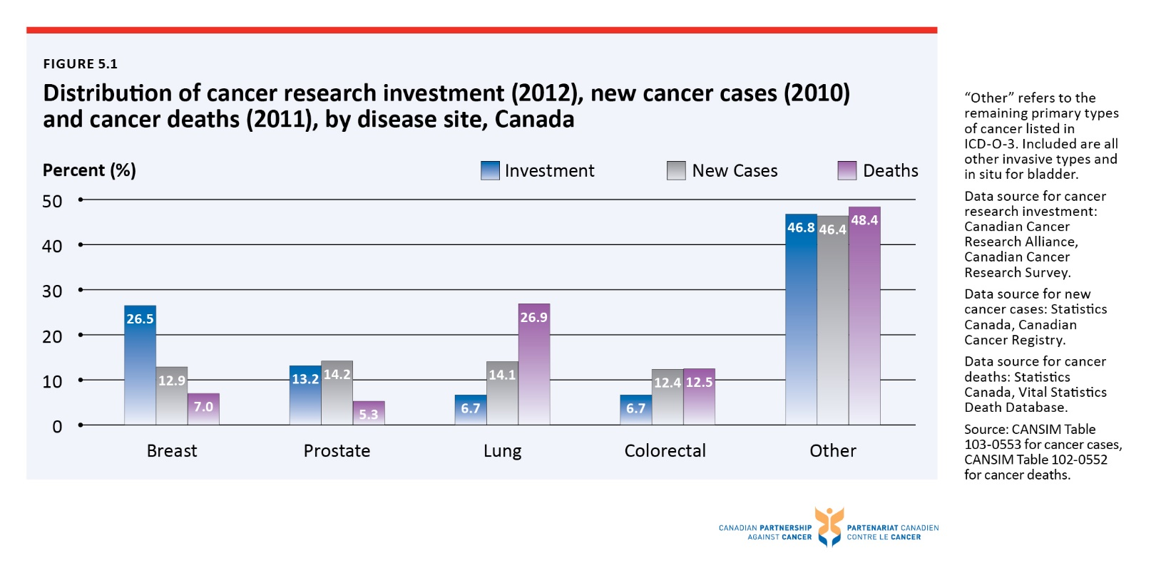

Figure 5.2 Distribution of investment in prostate cancer research across areas of research for top five funders, Canada — 2005 and 2012
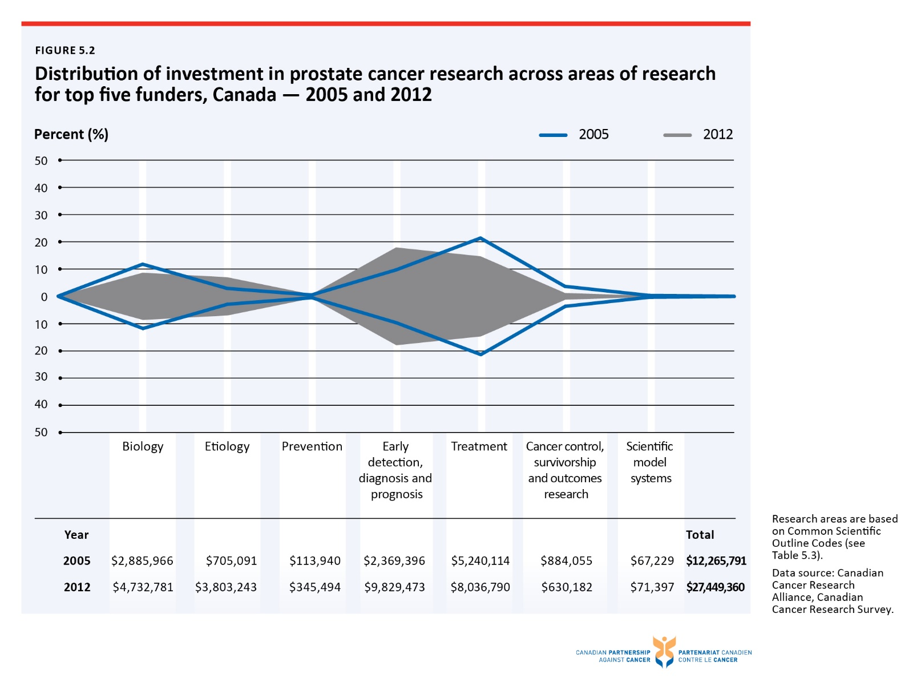

Figure 5.3 Per capita investment (male population) in prostate cancer research, by province — 2005 and 2012
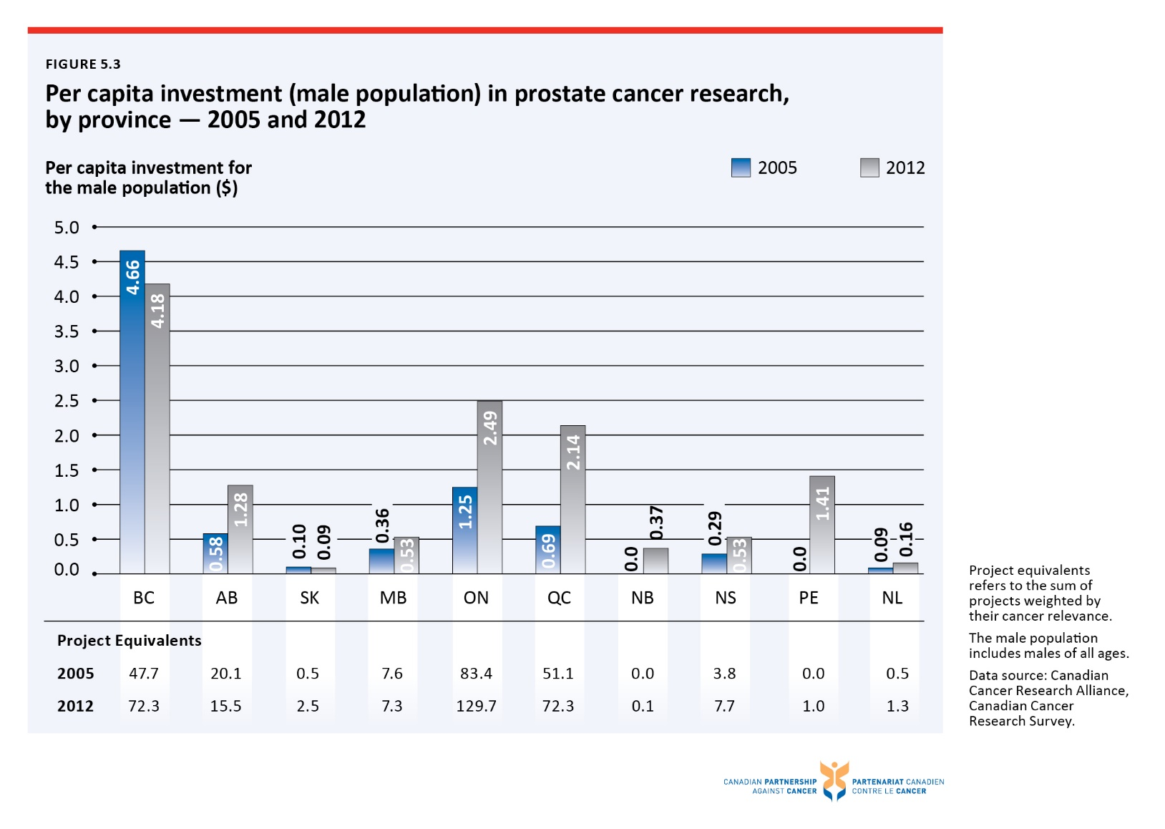

Figure 5.4 Ratio of adult prostate cancer patients enrolled in clinical trials to number of incident cases, by disease site, four most common cancers and all cancers† — 2013 enrolment year
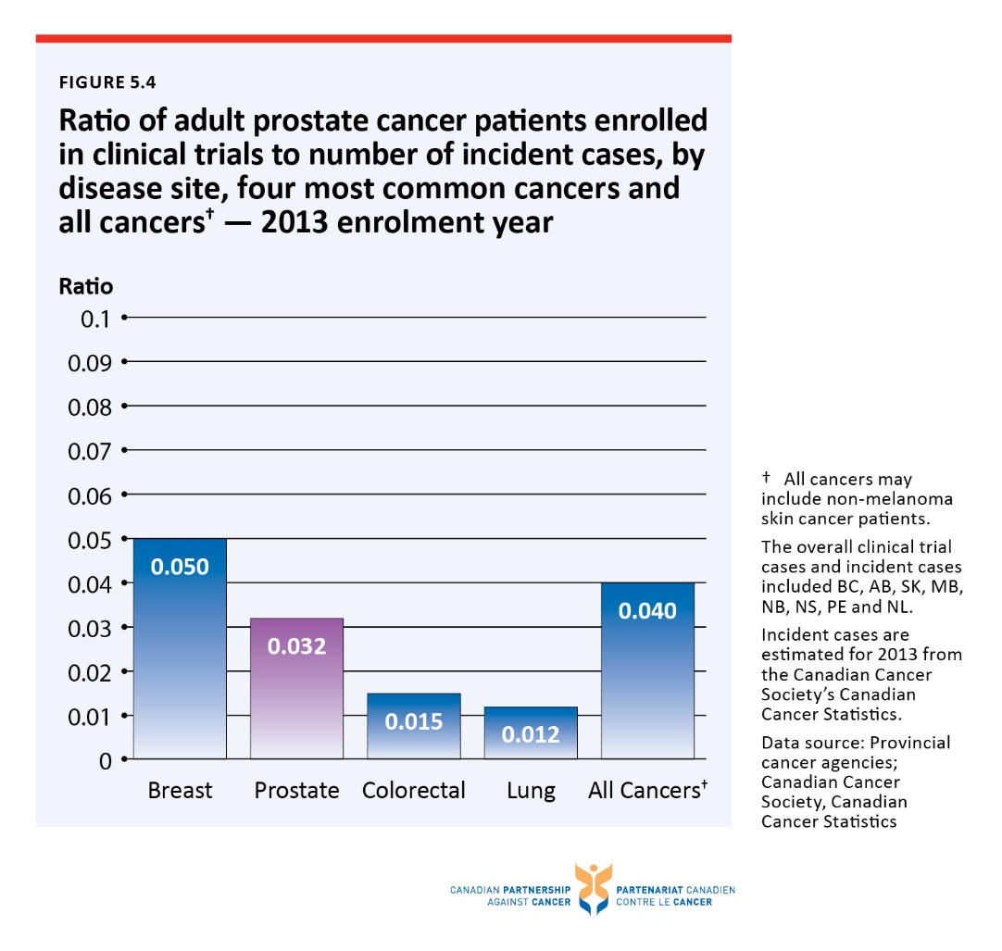

Figure 5.5 Ratio of adult prostate cancer patients enrolled in clinical trial to number of incident cases, by province — 2013 enrolment year
