2015 Cancer System Performance Report – 2015

Hold Ctrl and click on a figure title below to follow the link.
- Figure 1.1 Percentage of population (aged ≥ 12) reporting daily or occasional smoking, by province/territory - 2013 reporting year 5
- Figure 1.2 Percentage of population (aged ≥ 12) by smoking behaviour, by sex, Canada - 2013 reporting year 6
- Figure 1.i Percentage of adults (aged ≥ 18) who reported engaging in active transportation in the past three months, by province/territory - 2013 reporting year 7
- Figure 1.ii Percentage of population who reported engaging in active transportation in the past three months, by age group - 2013 reporting year 8
- Figure 2.1 Percentage† of women (aged 18 to 69) reporting at least one Pap test in the last three years, by province/territory - 2012 and 2013 reporting years 9
- Figure 2.2 Percentage of eligible† women (aged 50 to 69) reporting a screening†† mammogram in the last two years, by province/territory – 2012 and 2013 reporting years 10
- Figure 2.3 Percentage of population (aged 50 to 74) reporting a screeningᶧ fecal test in the last two years and/or screeningᶧ sigmoidoscopy/colonoscopy in the last five years, by province/territory - 2012 and 2013 reporting years 11
- Figure 2.4 Percentage of population (aged 50 to 74) reporting a screeningᶧ fecal test in the last two years, by province/territory - 2012 and 2013 reporting years 12
- Figure 2.5 Percentage of population (aged 50 to 74) reporting a screeningᶧ sigmoidoscopy/colonoscopy in the last five years, by province/territory - 2012 and 2013 reporting years 13
- Figure 2.6 Percentage of population (aged 50 to74) reporting a screeningᶧ fecal test in the last two years and/or screeningᶧ sigmoidoscopy/colonoscopy in the last five years, by age group and sex - 2013 reporting year 14
- Figure 2.i Percentage of women† (aged 21 to 69) reporting at least one Pap test in the last three years, by household income quintile and immigrant status, Canada - 2012 reporting year 15
- Figure 2.ii Percentage of eligible† women (aged 50 to 69) reporting a screening†† mammogram in the last two years, by household income quintile and immigrant status, Canada - 2012 reporting year 16
- Figure 2.iii Percentage of the population (aged 50 to 74) who are up-to-date† on colorectal cancer screening for asymptomatic†† reasons, by household income quintile and immigrant status, Canada - 2012 reporting year 17
- Figure 3.1 Median and 90th percentile wait times for resolution of abnormal breast screen without tissue biopsy for women (aged 50 to 69), by province/territory - 2012 18
- Figure 3.2 Median and 90th percentile wait times for resolution of abnormal breast screen through tissue biopsy for women (aged 50 to 69), by province/territory - 2012 19
- Figure 3.3 Median wait time for resolution of abnormal breast screen without tissue biopsy for women (aged 50 to 69), by province/territory – from 2004 to 2012 20
- Figure 3.4 Median wait time for resolution of abnormal breast screen through tissue biopsy for women (aged 50 to 69), by province/territory – from 2004 to 2012 21
- Figure 3.5 Median and 90th percentile wait times from abnormal fecal test to follow-up colonoscopy, by province - first-round screening tests conducted between January 1, 2011 - December 31, 2012 22
- Figure 3.i Number of positron emission tomography (PET) scanners per province 23
- Figure 3.ii Percentage of non-small cell lung cancer patients who received at least one PET scan within three months before and up to one year after diagnosis, by province - patients diagnosed from 2009 to 2011 24
- Figure 3.iii Percentage of non-small cell lung cancer patients who received at least one PET scan within three months before and up to one year after diagnosis, by province and age group - patients diagnosed from 2009 to 2011 25
- Figure 3.iv Percentage of non-small cell lung cancer patients who received at least one PET scan within three months before and up to one year after diagnosis, by province and stage at diagnosis - patients diagnosed from 2009 to 2011 26
- Figure 3.v Distribution of total diagnostic positron emission tomography (PET) scans among non-small cell lung cancer patients†, by stage at diagnosis, by province - patients diagnosed from 2009 to 2011 27
- Figure 4.1 Percentage of colon resections with 12 or more lymph nodes removed and examined, by province – patients diagnosed from 2008 to 2011 28
- Figure 4.2 Percentage of colon resections with 12 or more lymph nodes removed and examined, by patient age group - patients diagnosed from 2008 to 2011 29
- Figure 4.3 Percentage of colon resections with 12 or more lymph nodes removed and examined, by patient age group and sex - patients diagnosed in 2011 30
- Figure 4.4 Percentage of breast cancer resections that are mastectomies, by province/territory - from 2008/2009 to 2012/2013 fiscal years combined 31
- Figure 4.5 Median and 90th percentile wait times for radiation therapy, all cancers, by province – 2013 treatment year 32
- Figure 4.6 90th percentile wait time for radiation therapy, by disease site, by province - 2013 treatment year 33
- Figure 4.7 Percentage of Stage II or III rectal cancer patients who received radiation therapy before surgery, by province – patients diagnosed in 2008 to 2011 34
- Figure 4.8 Percentage of Stage II or III rectal cancer patients who received radiation therapy before surgery, by patient age group – patients diagnosed from 2008 to 2011 35
- Figure 4.9 Percentage of Stage II or III rectal cancer patients who received radiation therapy before surgery, by patient age group, by sex – patients diagnosed in 2011 36
- Figure 4.10 Percentage of Stage II or IIIA non-small cell lung cancer patients who received chemotherapy following surgical resection, by province – patients diagnosed from 2009 to 2011 37
- Figure 4.11 Percentage of Stage II or IIIA non-small cell lung cancer patients who received chemotherapy following surgical resection, by patient age group – patients diagnosed from 2009 to 2011 38
- Figure 4.12 Percentage of Stage II or IIIA non-small cell lung cancer patients who received chemotherapy following surgical resection, by patient age group, by sex – patients diagnosed in 2011 39
- Figure 5.1 Edmonton Symptom Assessment System (ESAS) Screening Tool and the Canadian Problem Checklist 40
- Figure 6.1 Ratio of adult patients enrolled in clinical trials to number of incident cases, by province, all cancers – 2013 enrolment year 41
- Figure 6.2 Ratio of adult patients enrolled in clinical trials to number of incident cases, by disease site, four most common cancers and all cancers combined - 2013 enrolment year 42
- Figure 7.1 Percentage of all self-reported screening† mammograms performed within and outside of guideline-recommended age groups (50 to 74 years), by province/territory - 2012 reporting year 43
- Figure 7.2 Percentage of breast cancer mastectomies done as day surgery, by province/territory - from 2007/2008 to 2011/2012 fiscal years combined 44
- Figure 8.1 Incidence and mortality rates for breast cancer in women, Canada, age-standardized to the 2011 population - from 1992 to 2011 45
- Figure 8.2 Incidence rates for breast cancer in women, by province, age-standardized to the 2011 population - 2008-2010 combined 46
- Figure 8.3 Incidence rates for breast cancer in women, by stage at diagnosis, by province, age-standardized to the 2011 population - 2010-2012 diagnosis years combined 47
- Figure 8.4 Mortality rates for breast cancer in women, by province, age-standardized to the 2011 population - 2009-2011 combined 48
- Figure 8.5 Five-year relative survival ratios for breast cancer, both sexes combined, by province, age-standardizedᶧ - 2006-2008 combined 49
- Figure 8.6 Five-year relative survival ratios for breast cancer, both sexes combined, Canada,ᶧ age-standardizedᶧᶧ - 1992-1994 combined vs. 2006-2008 combined 50
- Figure 8.7 Incidence and mortality rates for lung cancer, by sex, Canada, age-standardized to the 2011 population - from 1992 to 2011 51
- Figure 8.8 Incidence rates for lung cancer, by sex, by province, age-standardized to the 2011 population - 2008-2010 combined 52
- Figure 8.9 Incidence rates for lung cancer, by stage at diagnosis, by province, age-standardized to the 2011 population - 2010-2012 diagnosis years combined 53
- Figure 8.10 Mortality rates for lung cancer, by province, age-standardized to the 2011 population - 2009-2011 combined 54
- Figure 8.11 Five-year relative survival ratios for lung cancer, by province, age-standardizedᶧ - 2006-2008 combined 55
- Figure 8.12 Five-year relative survival ratios for lung cancer, Canada,ᶧ age-standardizedᶧᶧ - 1992-1994 combined vs. 2006-2008 combined 56
- Figure 8.13 Incidence and mortality rates for colorectal cancer, by sex, Canada, age-standardized to the 2011 population - from 1992 to 2011 57
- Figure 8.14 Incidence rates for colorectal cancer, by sex, by province, age-standardized to the 2011 population - 2008-2010 combined 58
- Figure 8.15 Incidence rates for colorectal cancer,ᶧ by stage at diagnosis, by province, age-standardized to the 2011 population - 2010-2012 diagnosis years combined 59
- Figure 8.16 Mortality rates for colorectal cancer, by province, age-standardized to the 2011 population - 2009-2011 combined 60
- Figure 8.17 Five-year relative survival ratios for colorectal cancer, by province, age-standardizedᶧ - 2006-2008 combined 61
- Figure 8.18 Five-year relative survival ratios for colorectal cancer, Canada,ᶧ age-standardizedᶧᶧ - 1992-1994 combined vs. 2006-2008 combined 62
- Figure 8.19 Incidence and mortality rates for prostate cancer, Canada, age-standardized to the 2011 population - from 1992 to 2011 63
- Figure 8.20 Incidence rates for prostate cancer, by province, age-standardized to the 2011 population - 2008-2010 combined 64
- Figure 8.21 Incidence rates for prostate cancer, by stage at diagnosis, by province, age-standardized to the 2011 population - 2010-2012 diagnosis years combined 65
- Figure 8.22 Mortality rates for prostate cancer, by province, age-standardized to the 2011 population - 2009-2011 combined 66
- Figure 8.23 Incidence and mortality rates for pancreatic cancer, by sex, Canada, age-standardized to the 2011 population - from 1992 to 2011 67
- Figure 8.24 Incidence rates for pancreatic cancer, by province, age-standardized to the 2011 population - 2008-2010 combined 68
- Figure 8.25 Mortality rates for pancreatic cancer, by province, age-standardized to the 2011 population - 2009-2011 combined 69
- Figure 8.26 Five-year relative survival ratios for pancreatic cancer, by province, age-standardizedᶧ - 2005-2007 combined 70
- Figure 8.27 Five-year relative survival ratios for pancreatic cancer, Canada,ᶧ age-standardizedᶧᶧ - 1992-1994 combined vs. 2006-2008 combined 71
- Table 1.1 Implementation and immunization uptake of organized human papillomavirus (HPV) vaccination programs for girls, by province/territory 72
- Table 4.1 Percentage of patients treated within the radiation therapy wait time target, four most common cancers and all cancers, by province – 2013 treatment year 73
- Table 5.1 Extent of usage of standardized screening for distress tools across clinics in provincial cancer agencies and programs – 2014 74
- Table 8.1 Percentage of cases for which stage is unknown, by disease site and province - from 2010 to 2012 75

Figure 1.1 Percentage of population (aged ≥ 12) reporting daily or occasional smoking, by province/territory - 2013 reporting year
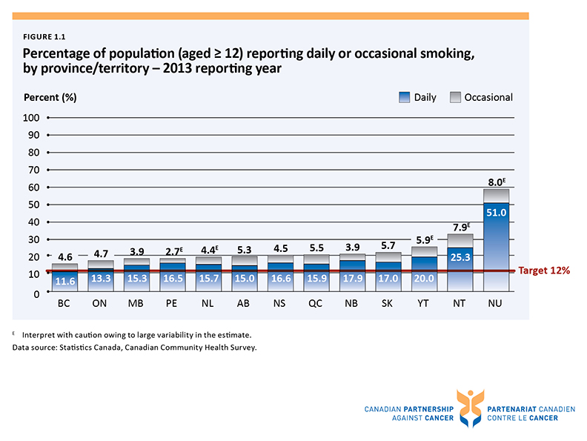

Figure 1.2 Percentage of population (aged ≥ 12) by smoking behaviour, by sex, Canada - 2013 reporting year
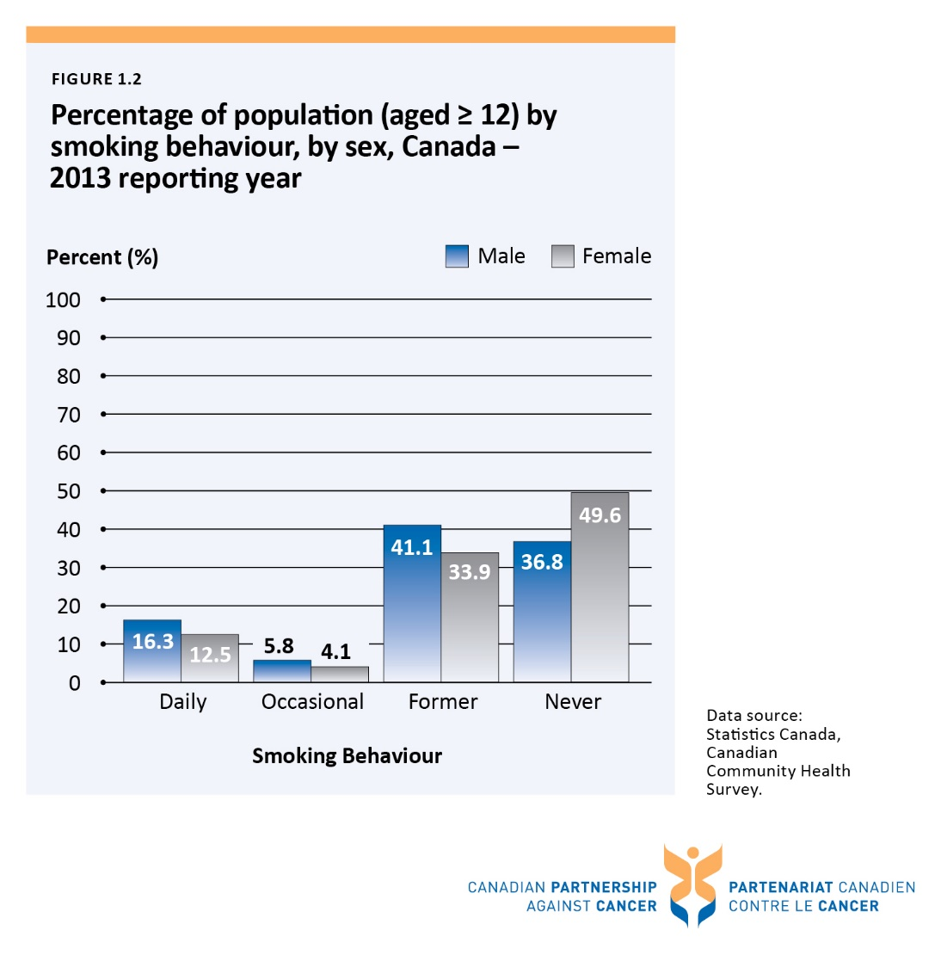

Figure 1.i Percentage of adults (aged ≥ 18) who reported engaging in active transportation in the past three months, by province/territory - 2013 reporting year
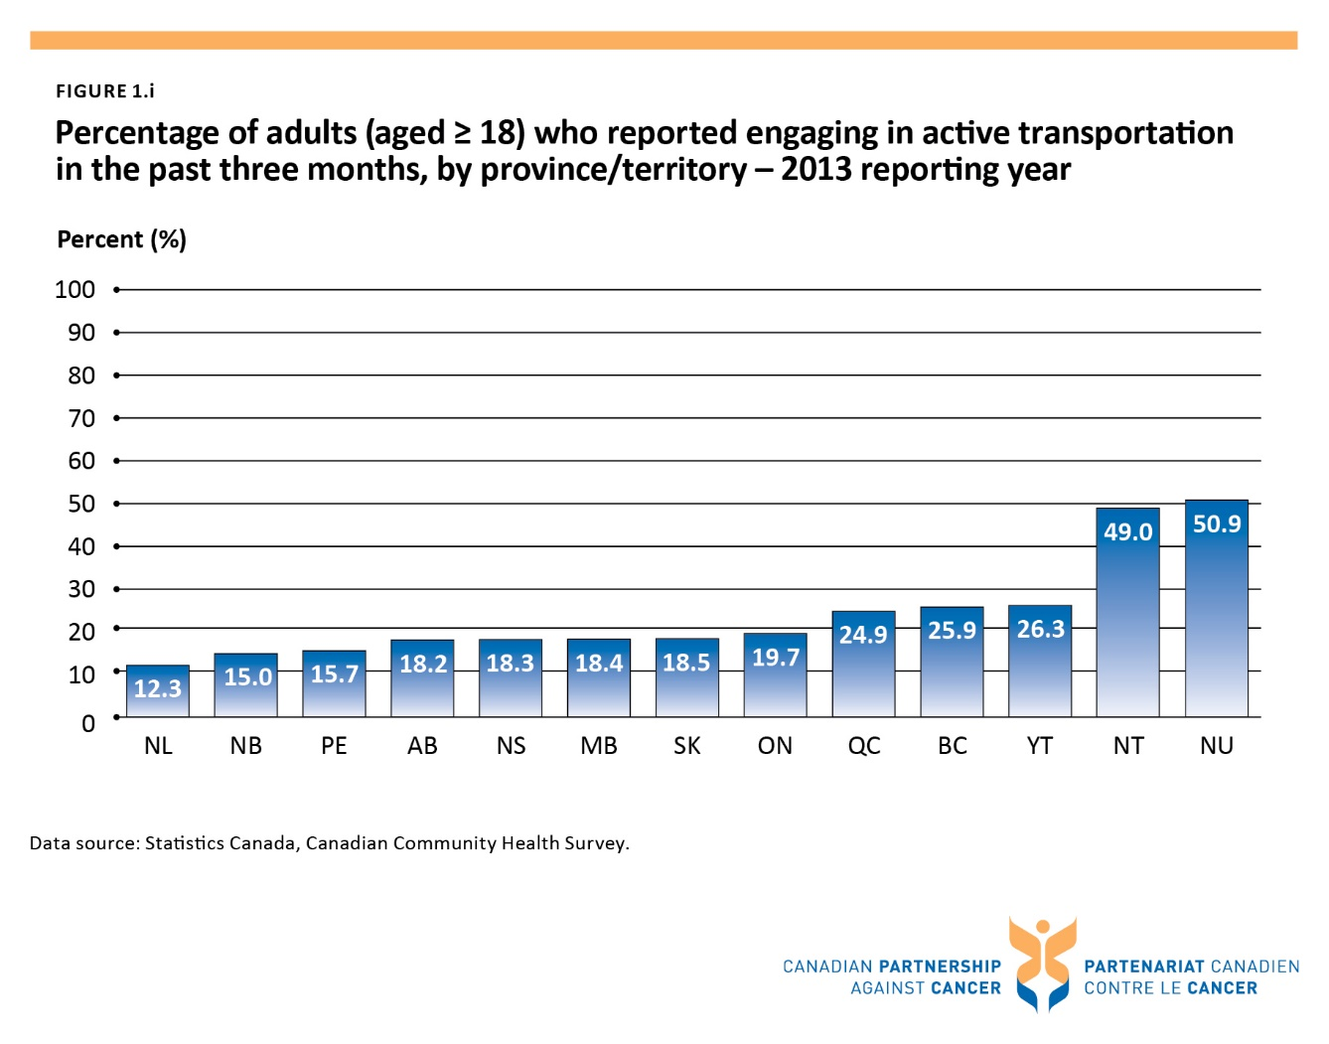

Figure 1.ii Percentage of population who reported engaging in active transportation in the past three months, by age group - 2013 reporting year
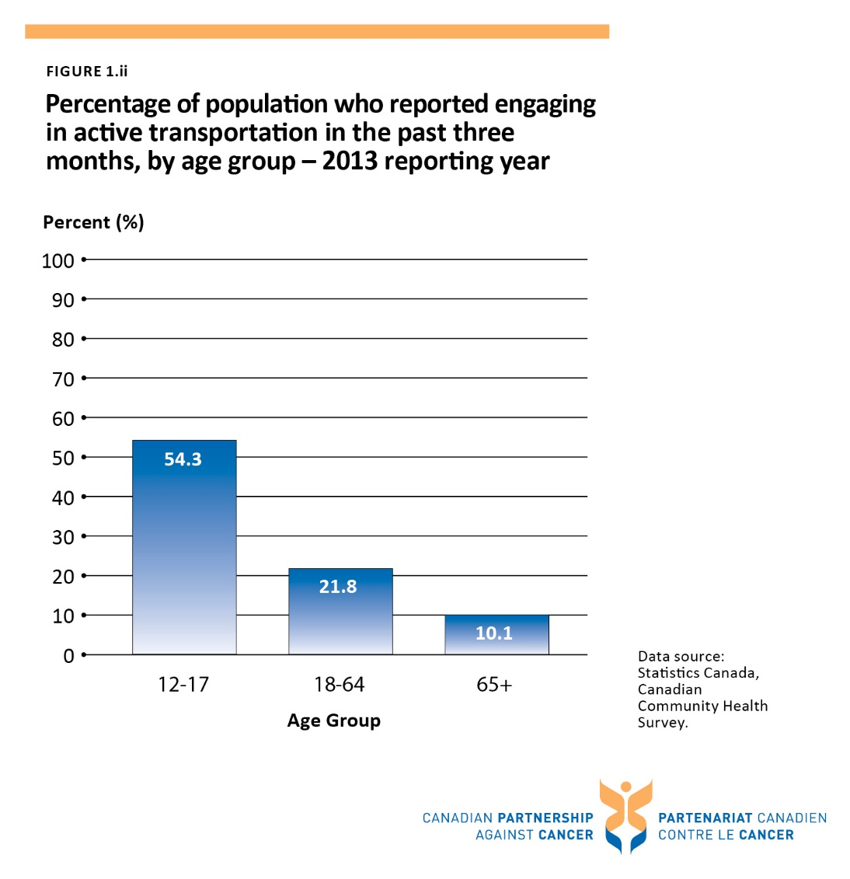

Figure 2.1 Percentage† of women (aged 18 to 69) reporting at least one Pap test in the last three years, by province/territory - 2012 and 2013 reporting years
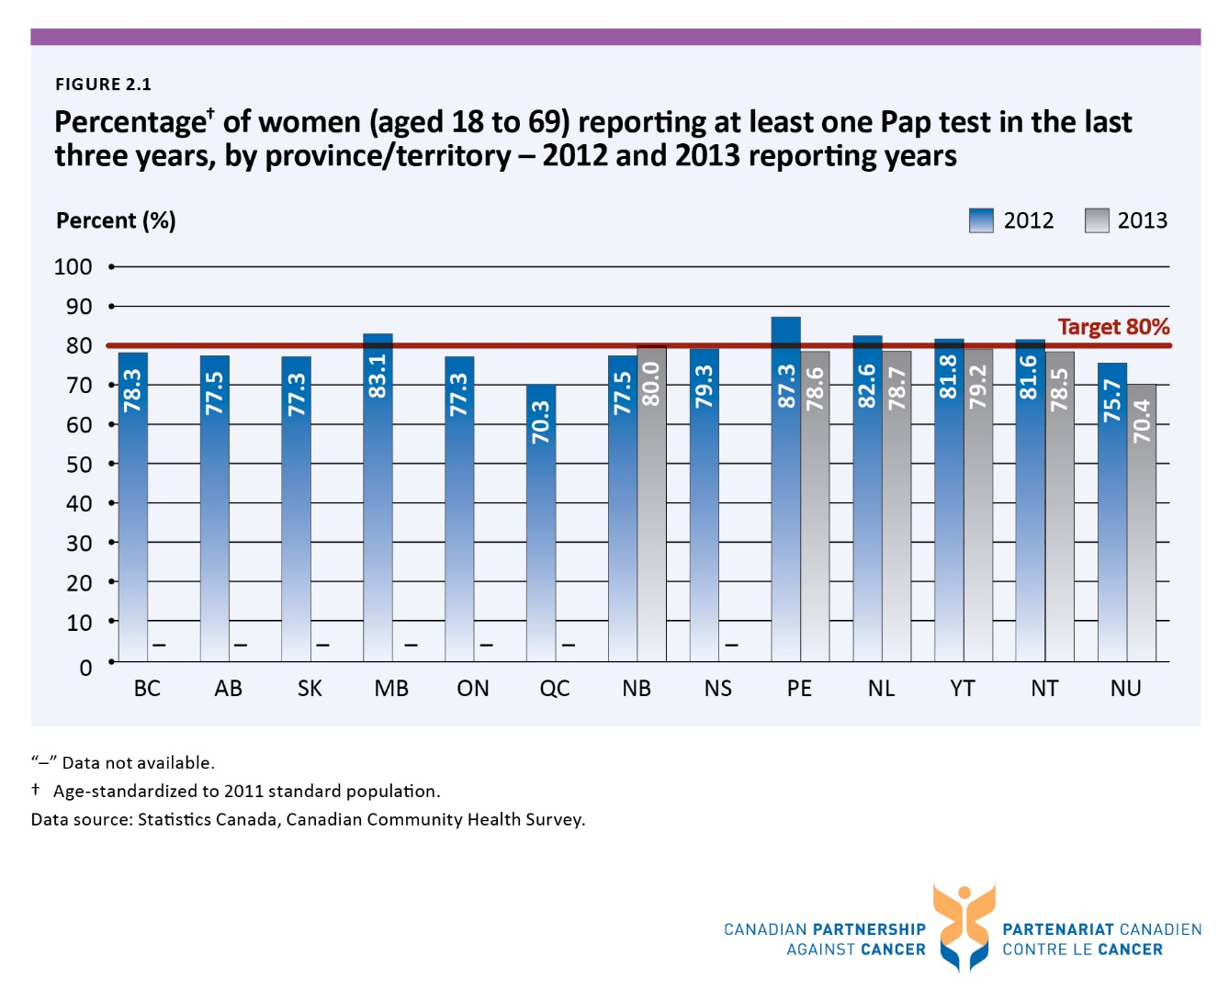

Figure 2.2 Percentage of eligible† women (aged 50 to 69) reporting a screening†† mammogram in the last two years, by province/territory – 2012 and 2013 reporting years
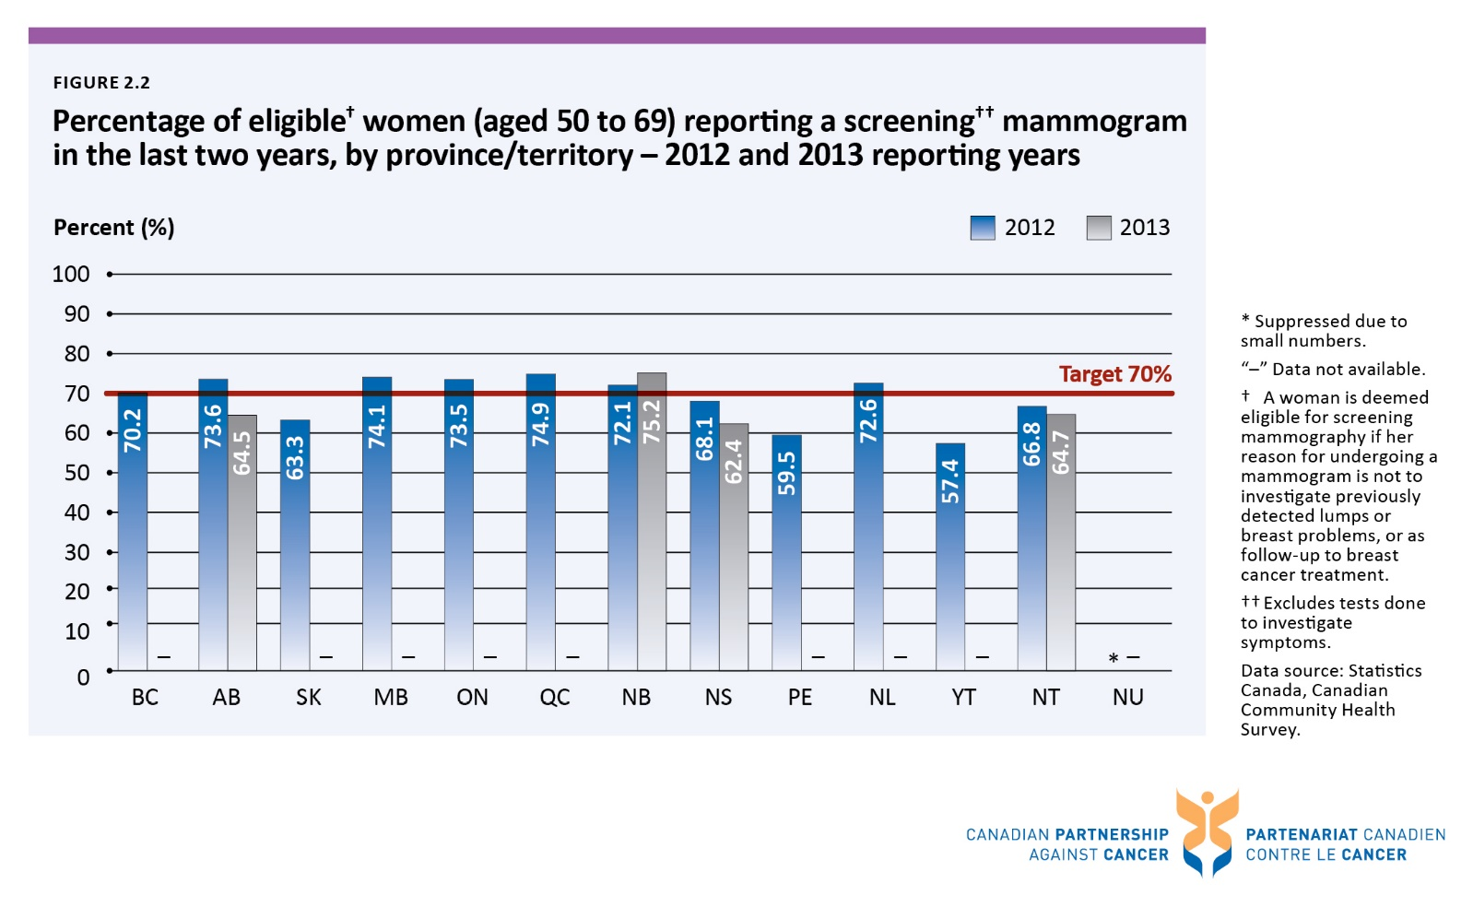

Figure 2.3 Percentage of population (aged 50 to 74) reporting a screeningᶧ fecal test in the last two years and/or screeningᶧ sigmoidoscopy/colonoscopy in the last five years, by province/territory - 2012 and 2013 reporting years
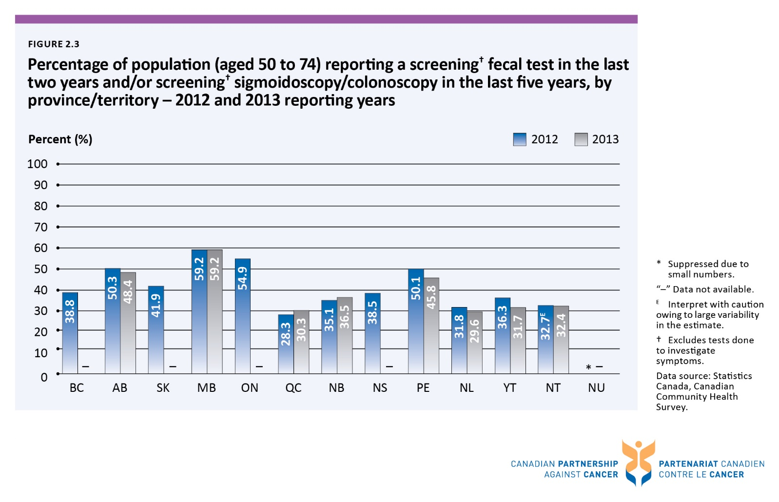

Figure 2.4 Percentage of population (aged 50 to 74) reporting a screeningᶧ fecal test in the last two years, by province/territory - 2012 and 2013 reporting years
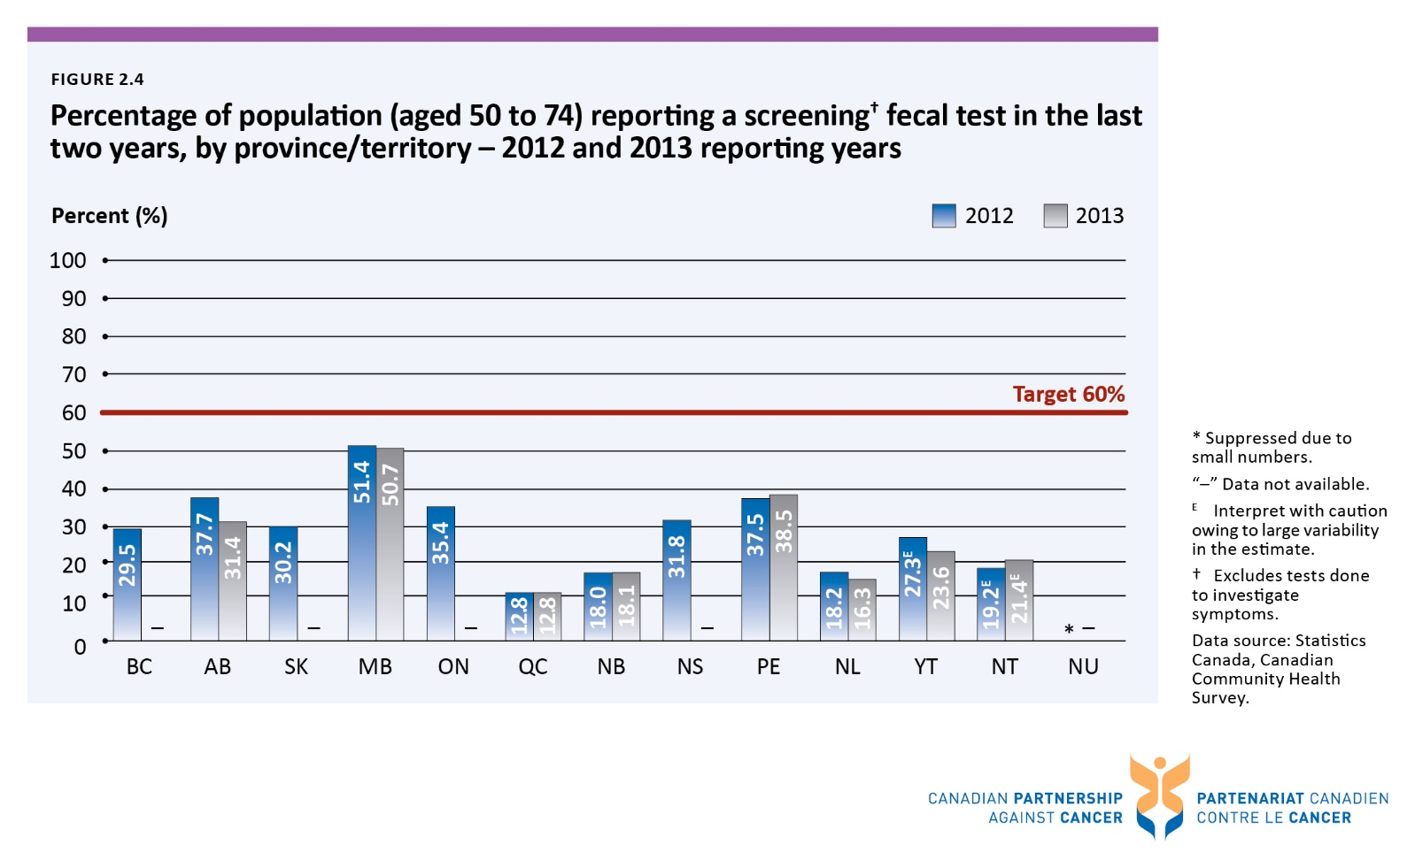

Figure 2.5 Percentage of population (aged 50 to 74) reporting a screeningᶧ sigmoidoscopy/colonoscopy in the last five years, by province/territory - 2012 and 2013 reporting years
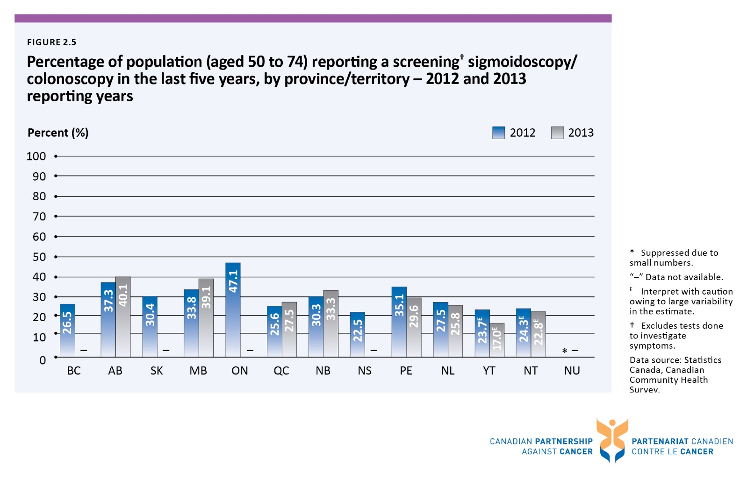

Figure 2.6 Percentage of population (aged 50 to74) reporting a screeningᶧ fecal test in the last two years and/or screeningᶧ sigmoidoscopy/colonoscopy in the last five years, by age group and sex - 2013 reporting year
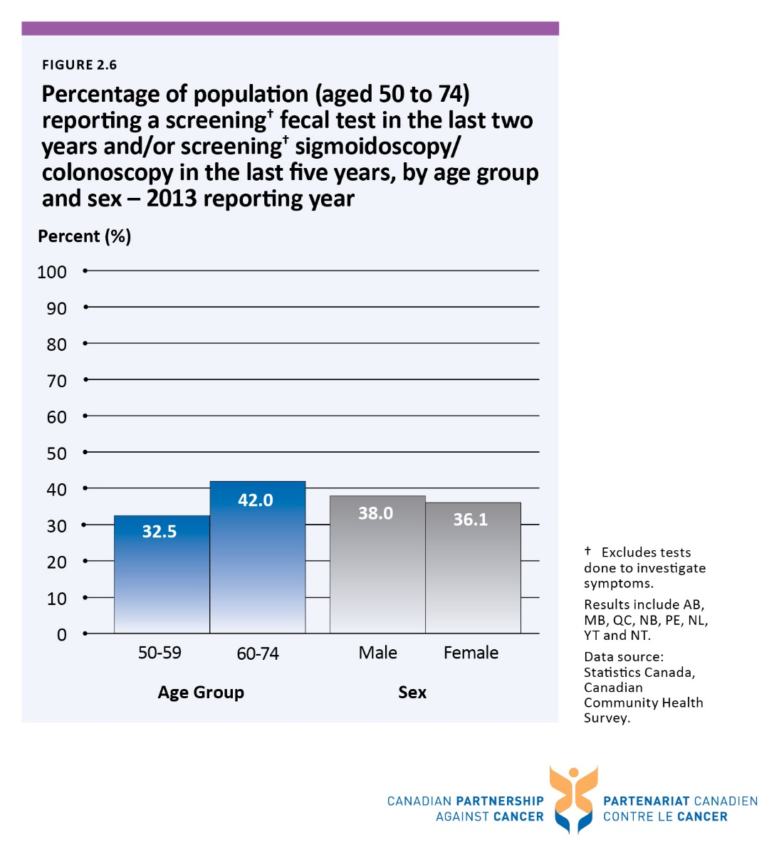

Figure 2.i Percentage of women† (aged 21 to 69) reporting at least one Pap test in the last three years, by household income quintile and immigrant status, Canada - 2012 reporting year
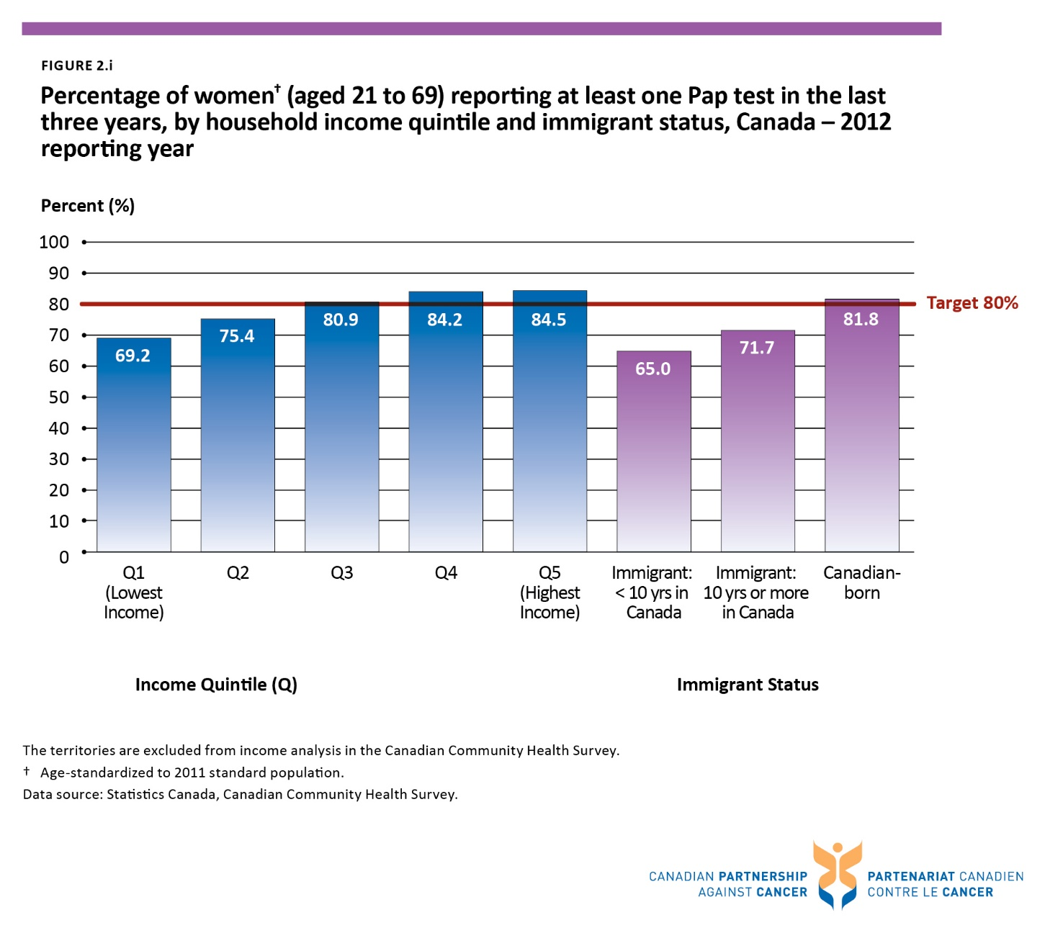

Figure 2.ii Percentage of eligible† women (aged 50 to 69) reporting a screening†† mammogram in the last two years, by household income quintile and immigrant status, Canada - 2012 reporting year
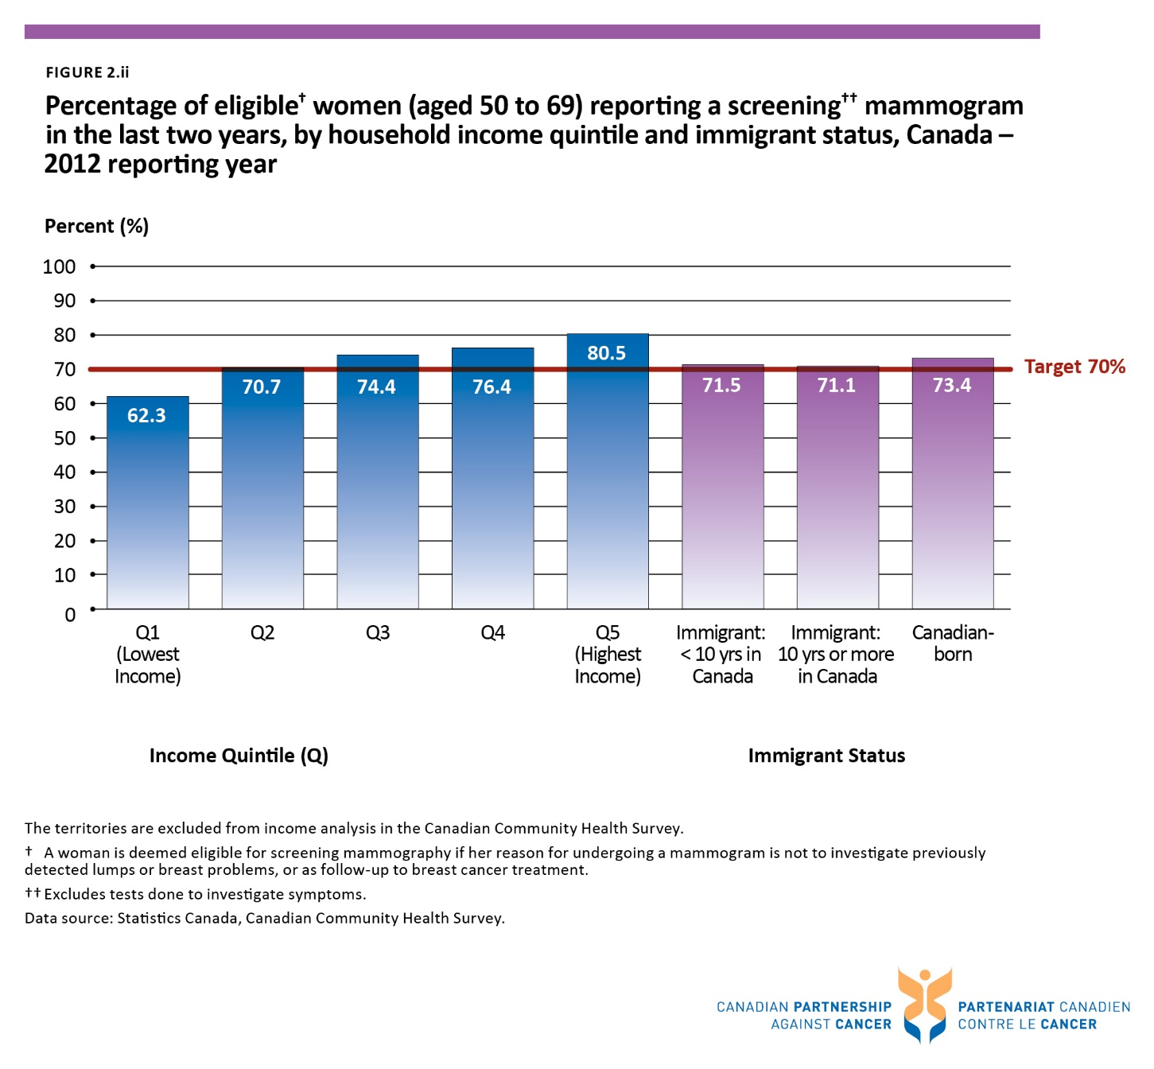

Figure 2.iii Percentage of the population (aged 50 to 74) who are up-to-date† on colorectal cancer screening for asymptomatic†† reasons, by household income quintile and immigrant status, Canada - 2012 reporting year

Figure 3.1 Median and 90th percentile wait times for resolution of abnormal breast screen without tissue biopsy for women (aged 50 to 69), by province/territory - 2012
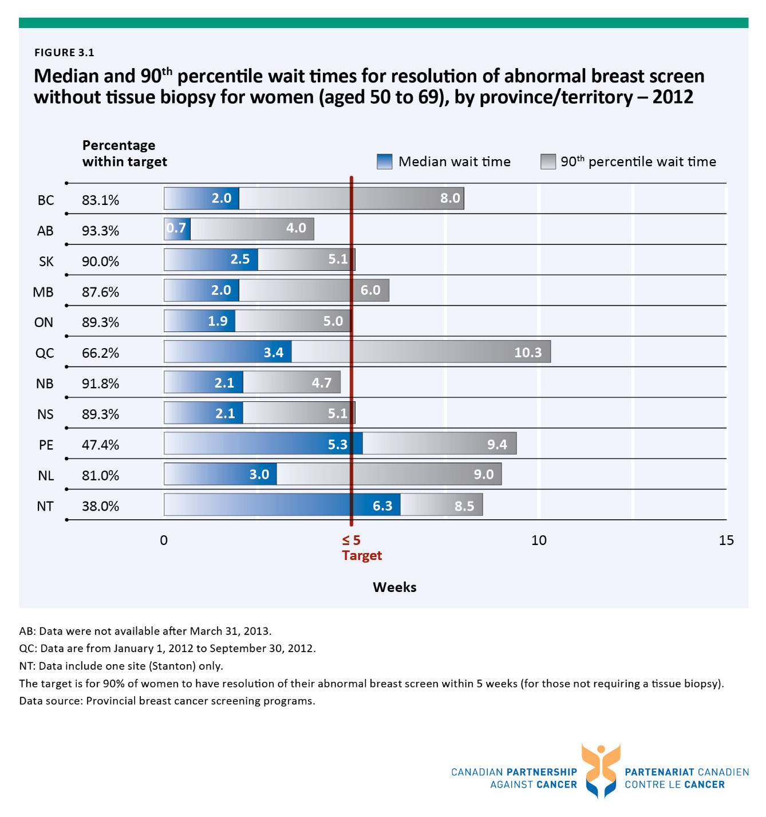

Figure 3.2 Median and 90th percentile wait times for resolution of abnormal breast screen through tissue biopsy for women (aged 50 to 69), by province/territory - 2012
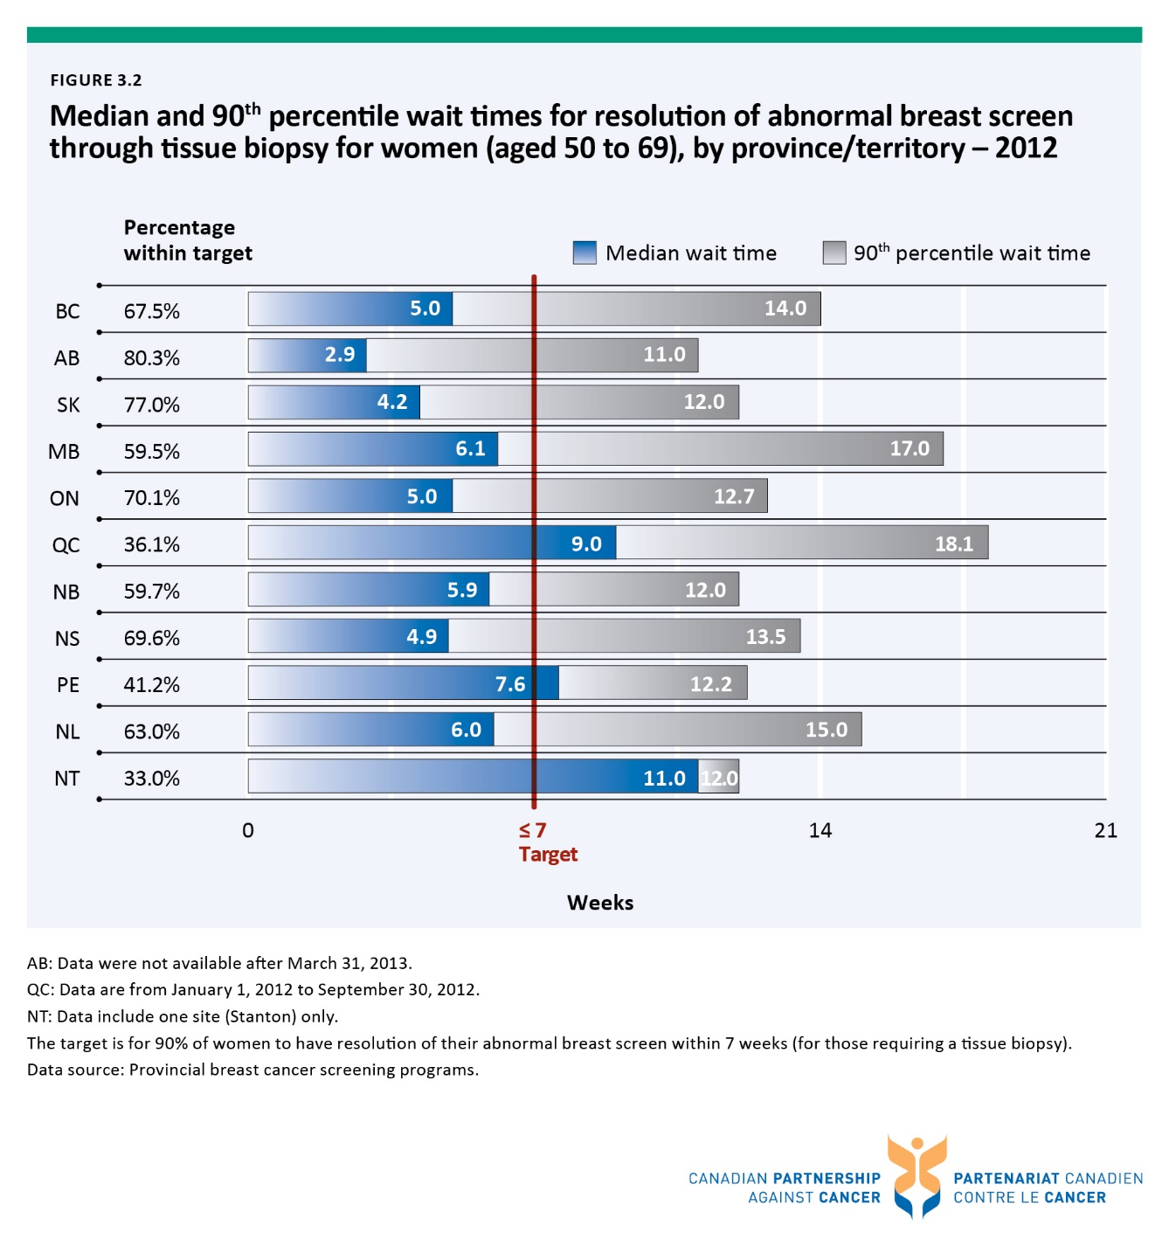

Figure 3.3 Median wait time for resolution of abnormal breast screen without tissue biopsy for women (aged 50 to 69), by province/territory – from 2004 to 2012
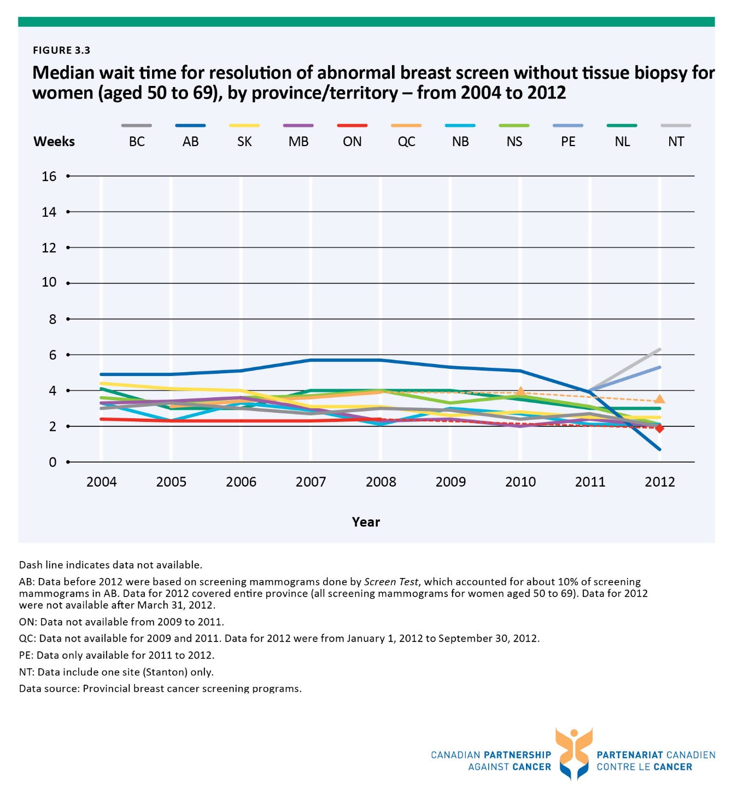

Figure 3.4 Median wait time for resolution of abnormal breast screen through tissue biopsy for women (aged 50 to 69), by province/territory – from 2004 to 2012
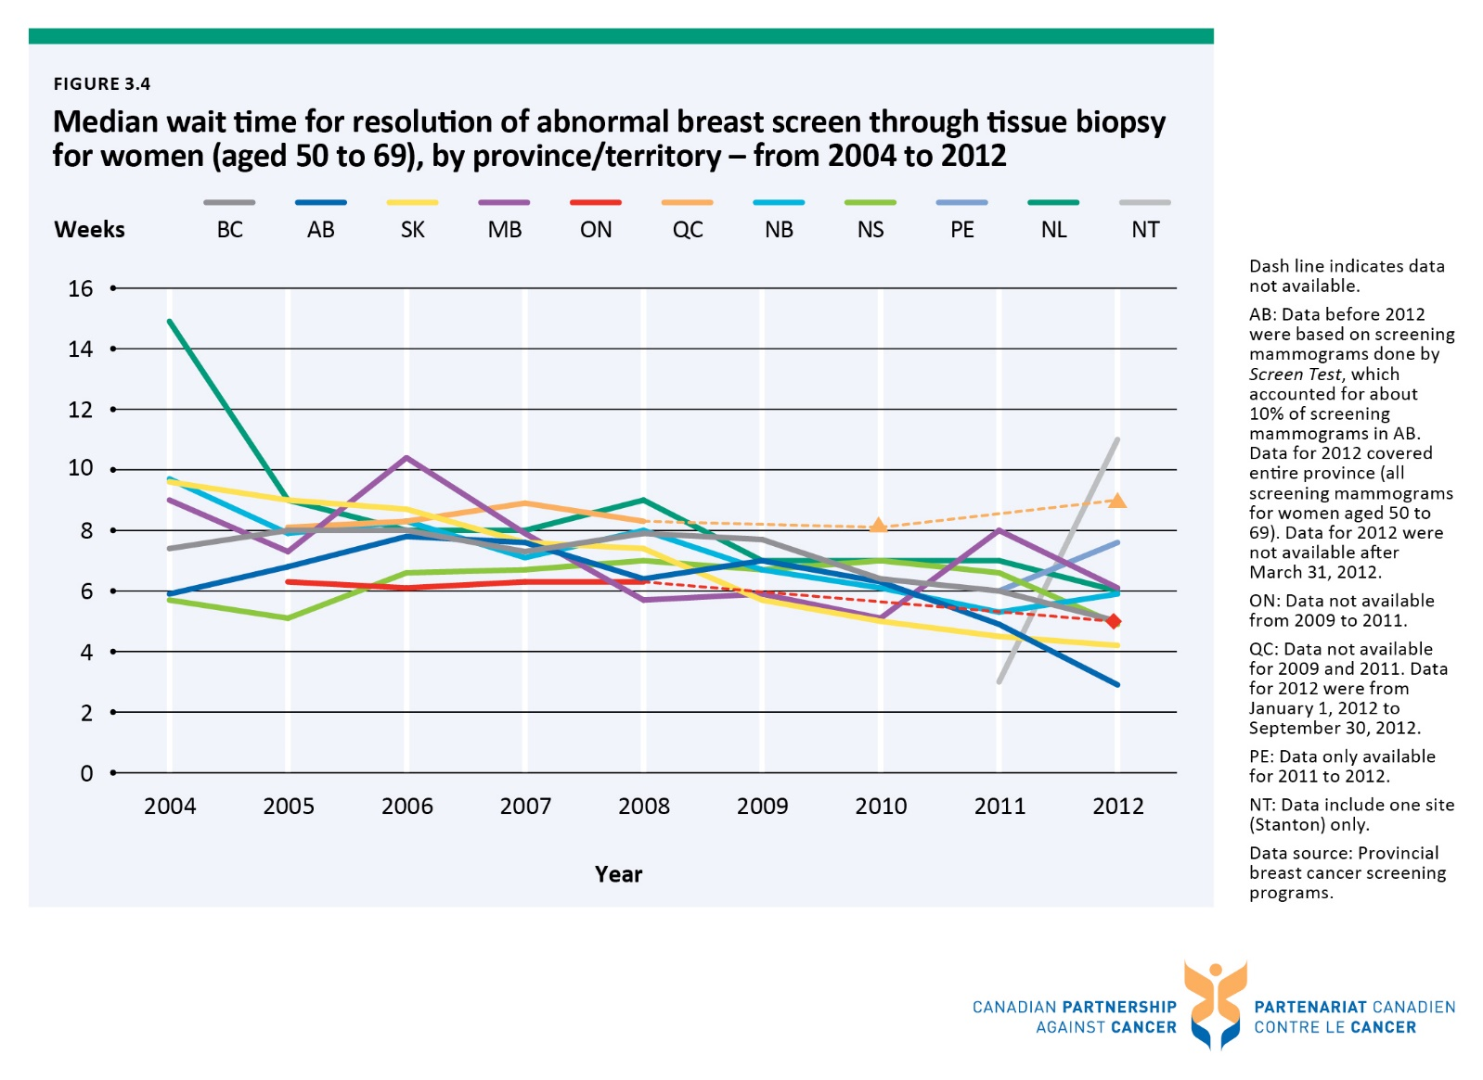

Figure 3.5 Median and 90th percentile wait times from abnormal fecal test to follow-up colonoscopy, by province - first-round screening tests conducted between January 1, 2011 - December 31, 2012
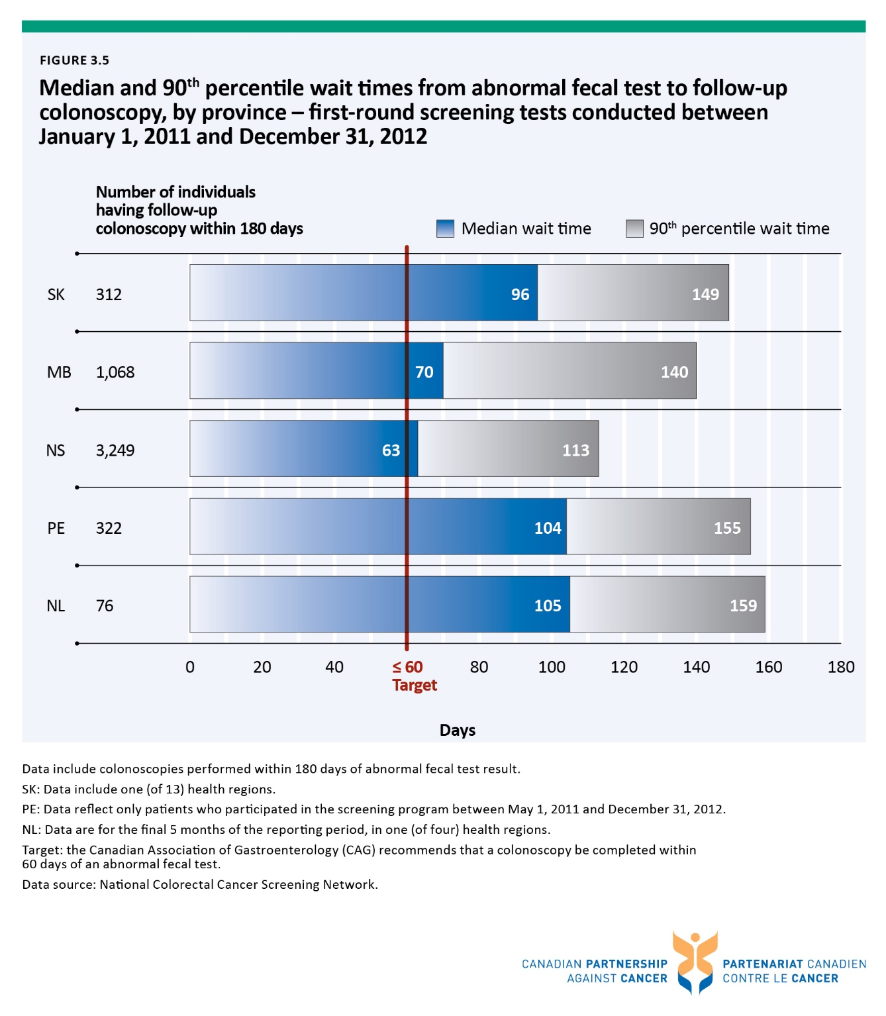

Figure 3.i Number of positron emission tomography (PET) scanners per province
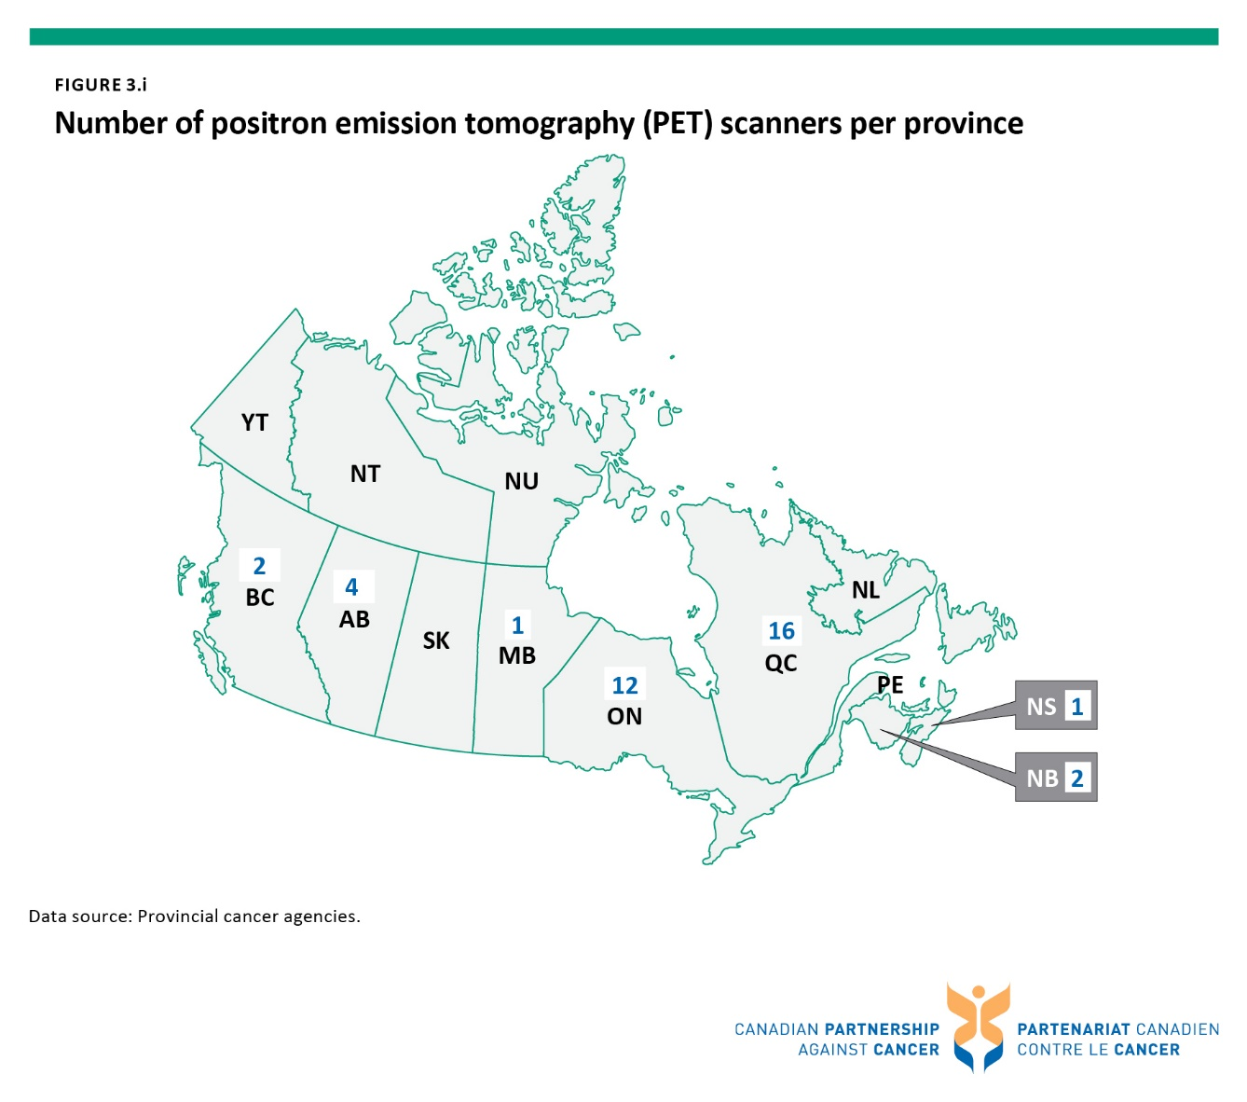

Figure 3.ii Percentage of non-small cell lung cancer patients who received at least one PET scan within three months before and up to one year after diagnosis, by province - patients diagnosed from 2009 to 2011
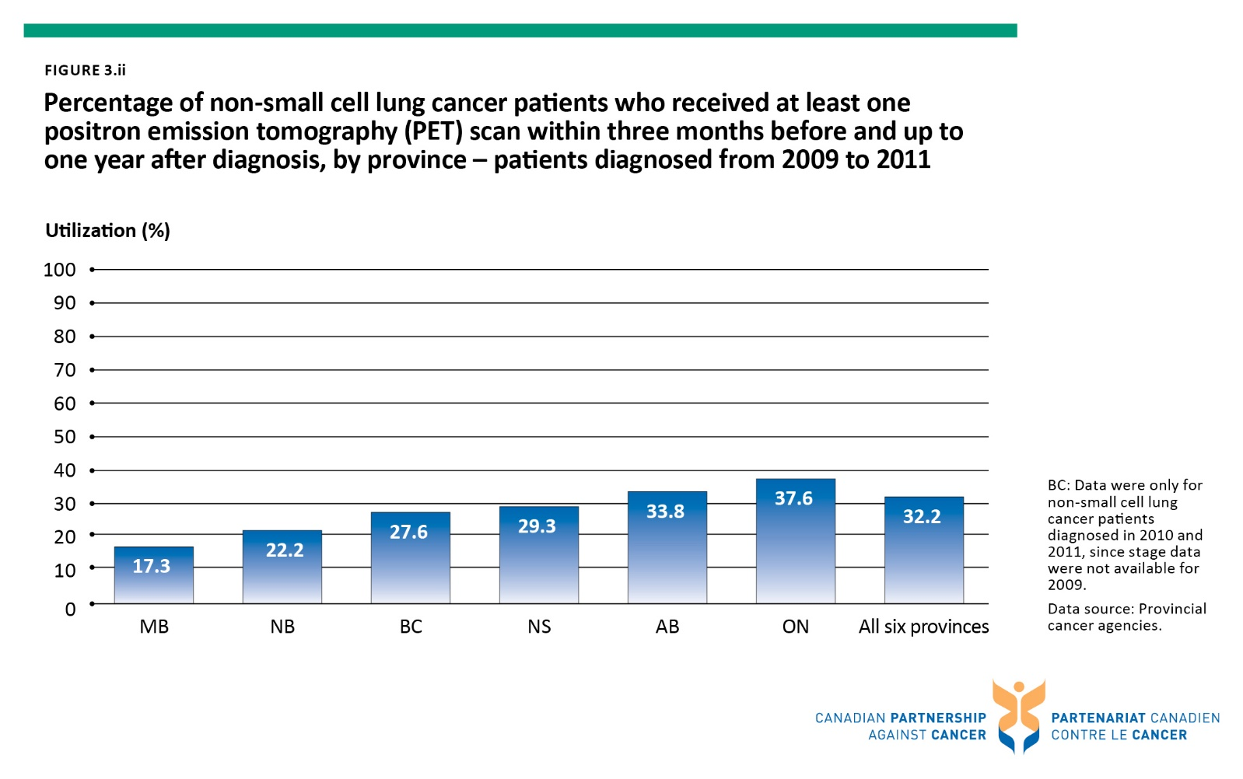

Figure 3.iii Percentage of non-small cell lung cancer patients who received at least one PET scan within three months before and up to one year after diagnosis, by province and age group - patients diagnosed from 2009 to 2011
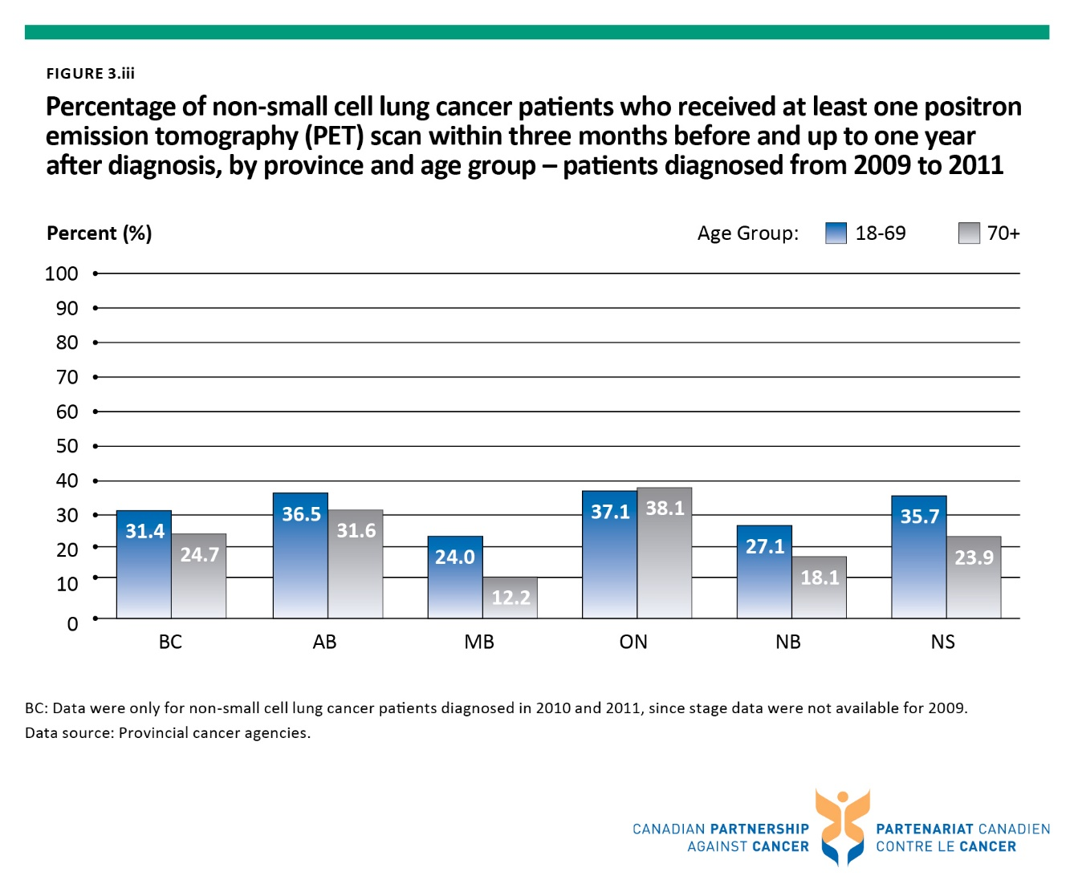

Figure 3.iv Percentage of non-small cell lung cancer patients who received at least one PET scan within three months before and up to one year after diagnosis, by province and stage at diagnosis - patients diagnosed from 2009 to 2011
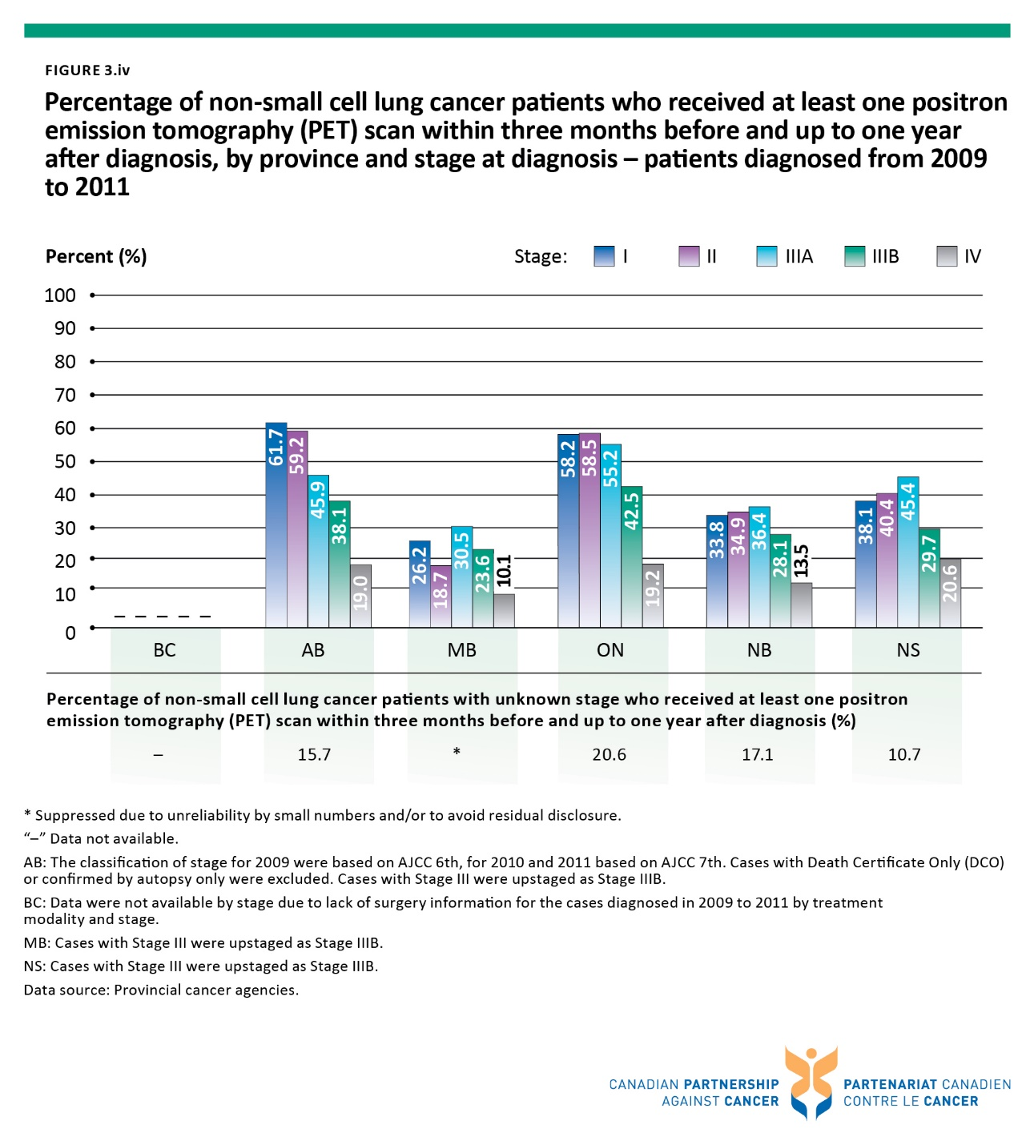

Figure 3.v Distribution of total diagnostic positron emission tomography (PET) scans among non-small cell lung cancer patients†, by stage at diagnosis, by province - patients diagnosed from 2009 to 2011
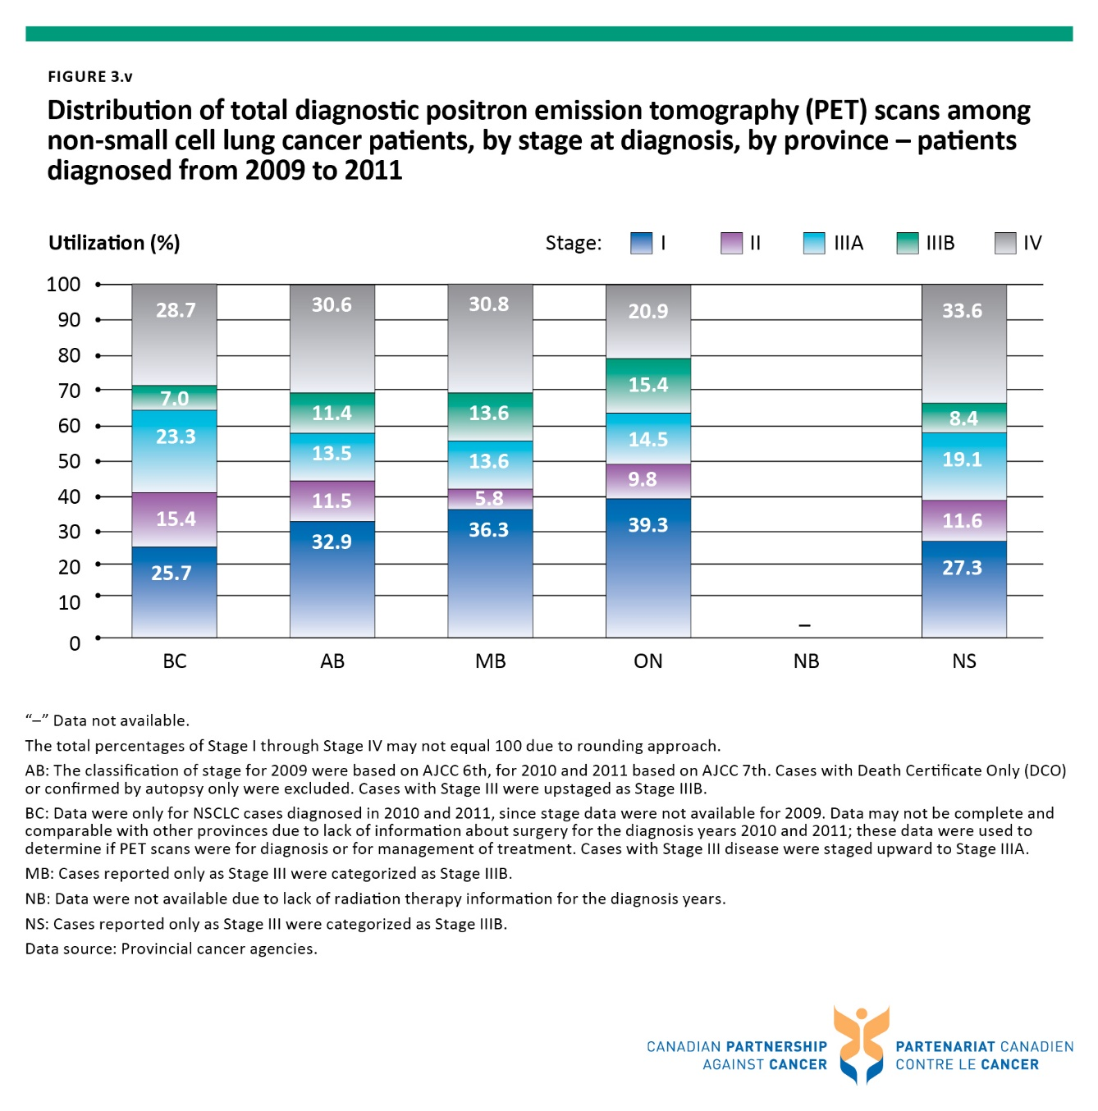

Figure 4.1 Percentage of colon resections with 12 or more lymph nodes removed and examined, by province – patients diagnosed from 2008 to 2011
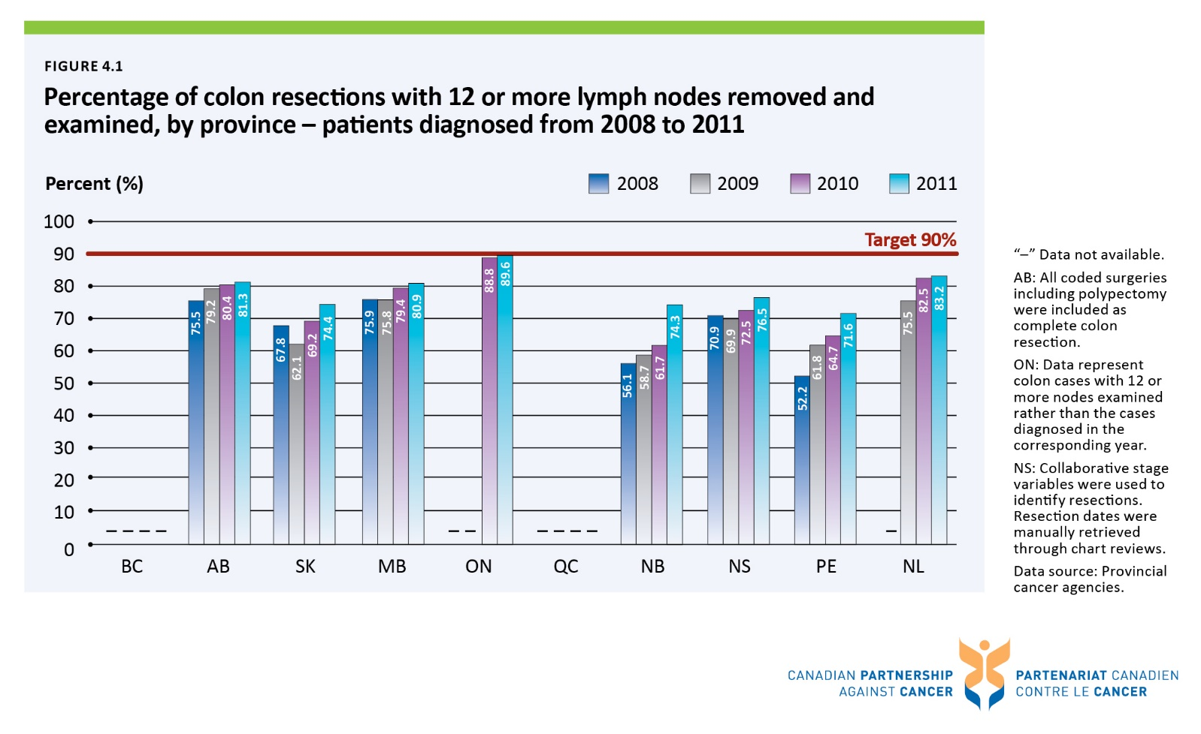

Figure 4.2 Percentage of colon resections with 12 or more lymph nodes removed and examined, by patient age group - patients diagnosed from 2008 to 2011
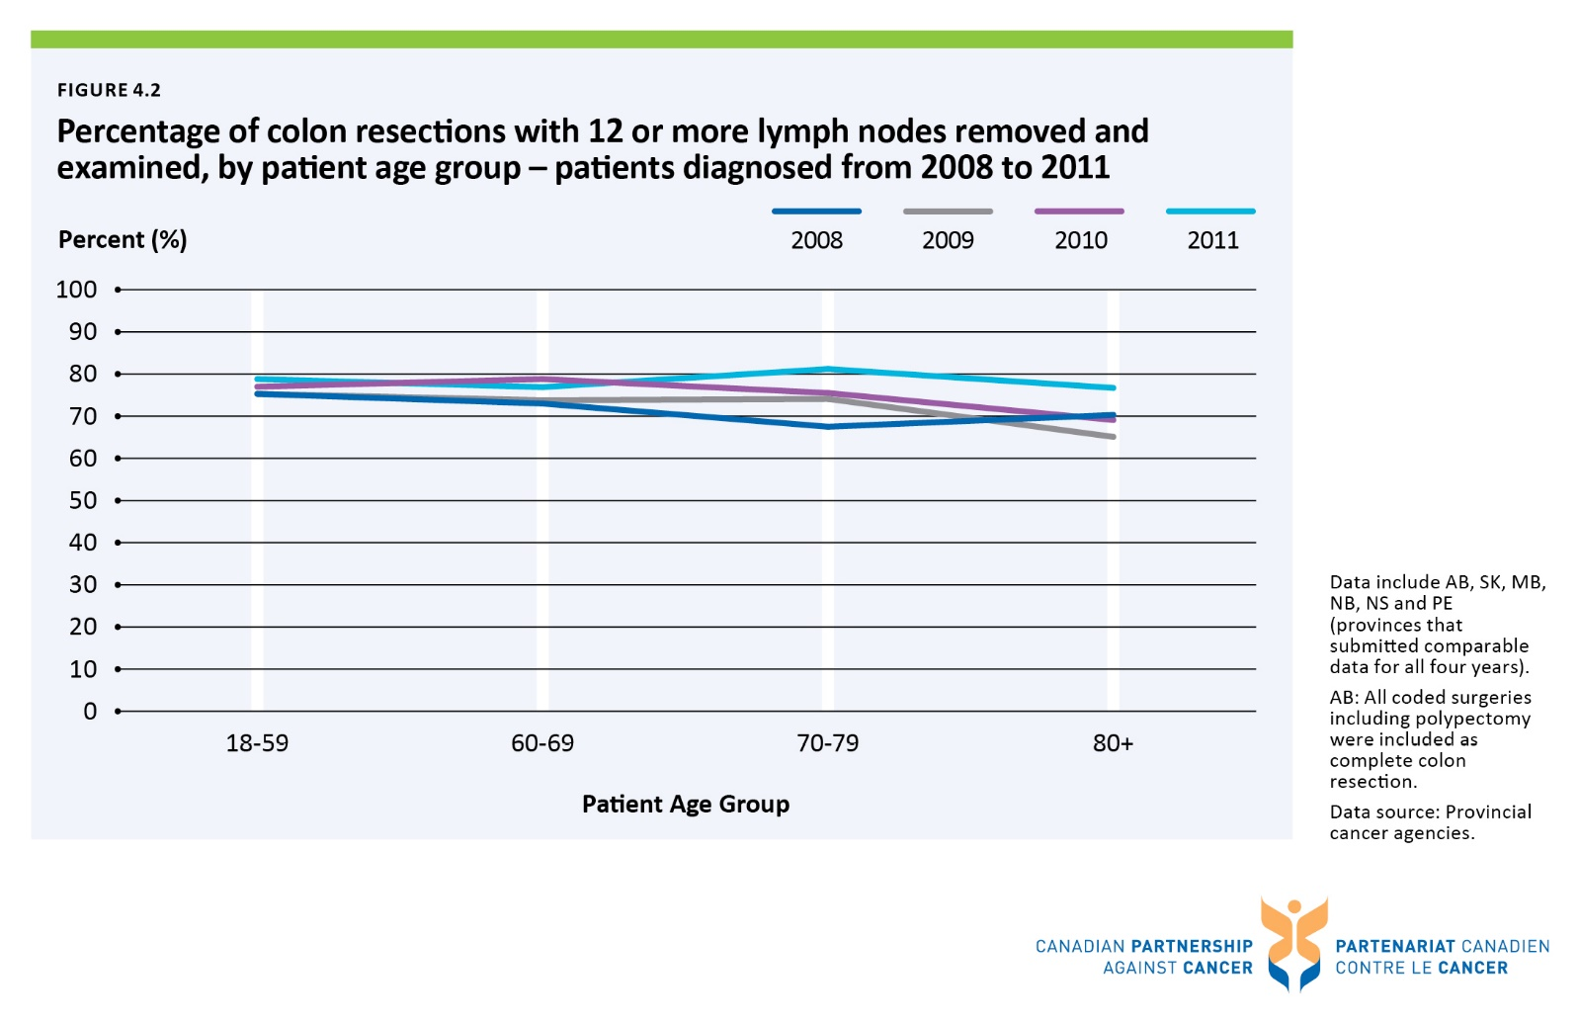

Figure 4.3 Percentage of colon resections with 12 or more lymph nodes removed and examined, by patient age group and sex - patients diagnosed in 2011
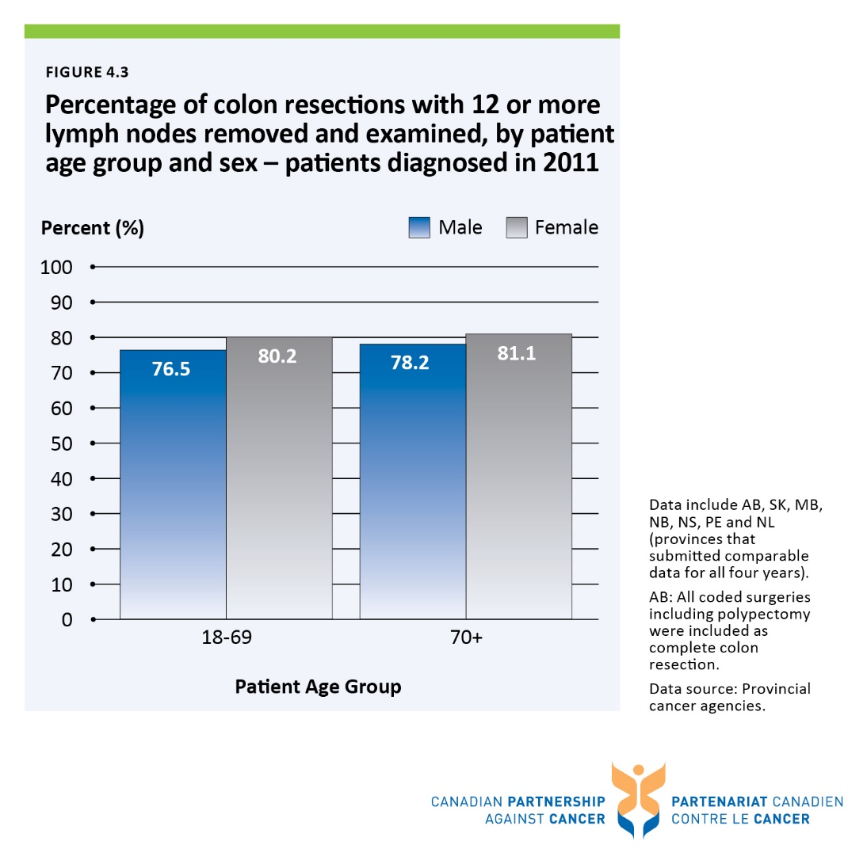

Figure 4.4 Percentage of breast cancer resections that are mastectomies, by province/territory - from 2008/2009 to 2012/2013 fiscal years combined
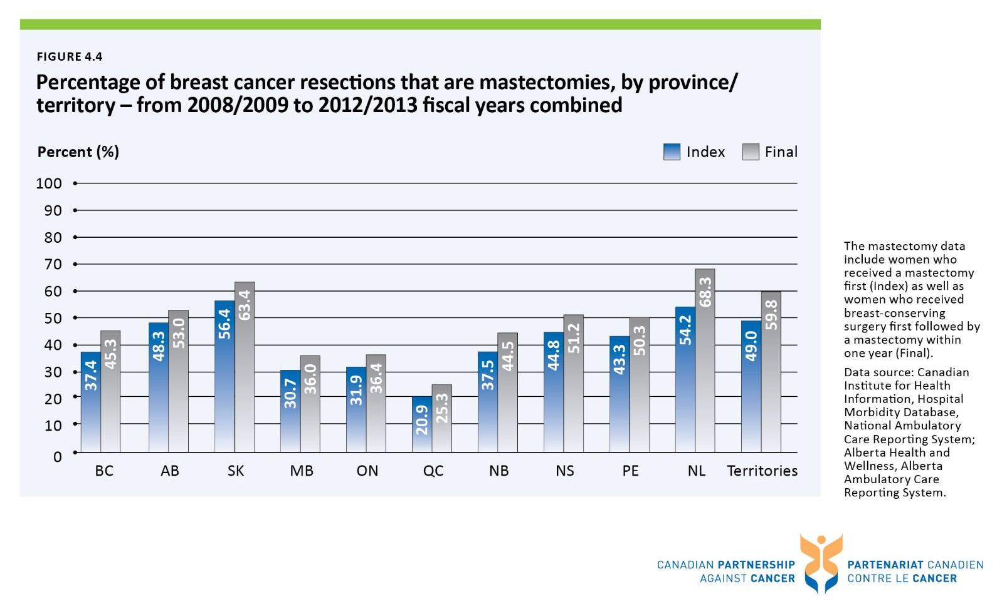

Figure 4.5 Median and 90th percentile wait times for radiation therapy, all cancers, by province – 2013 treatment year
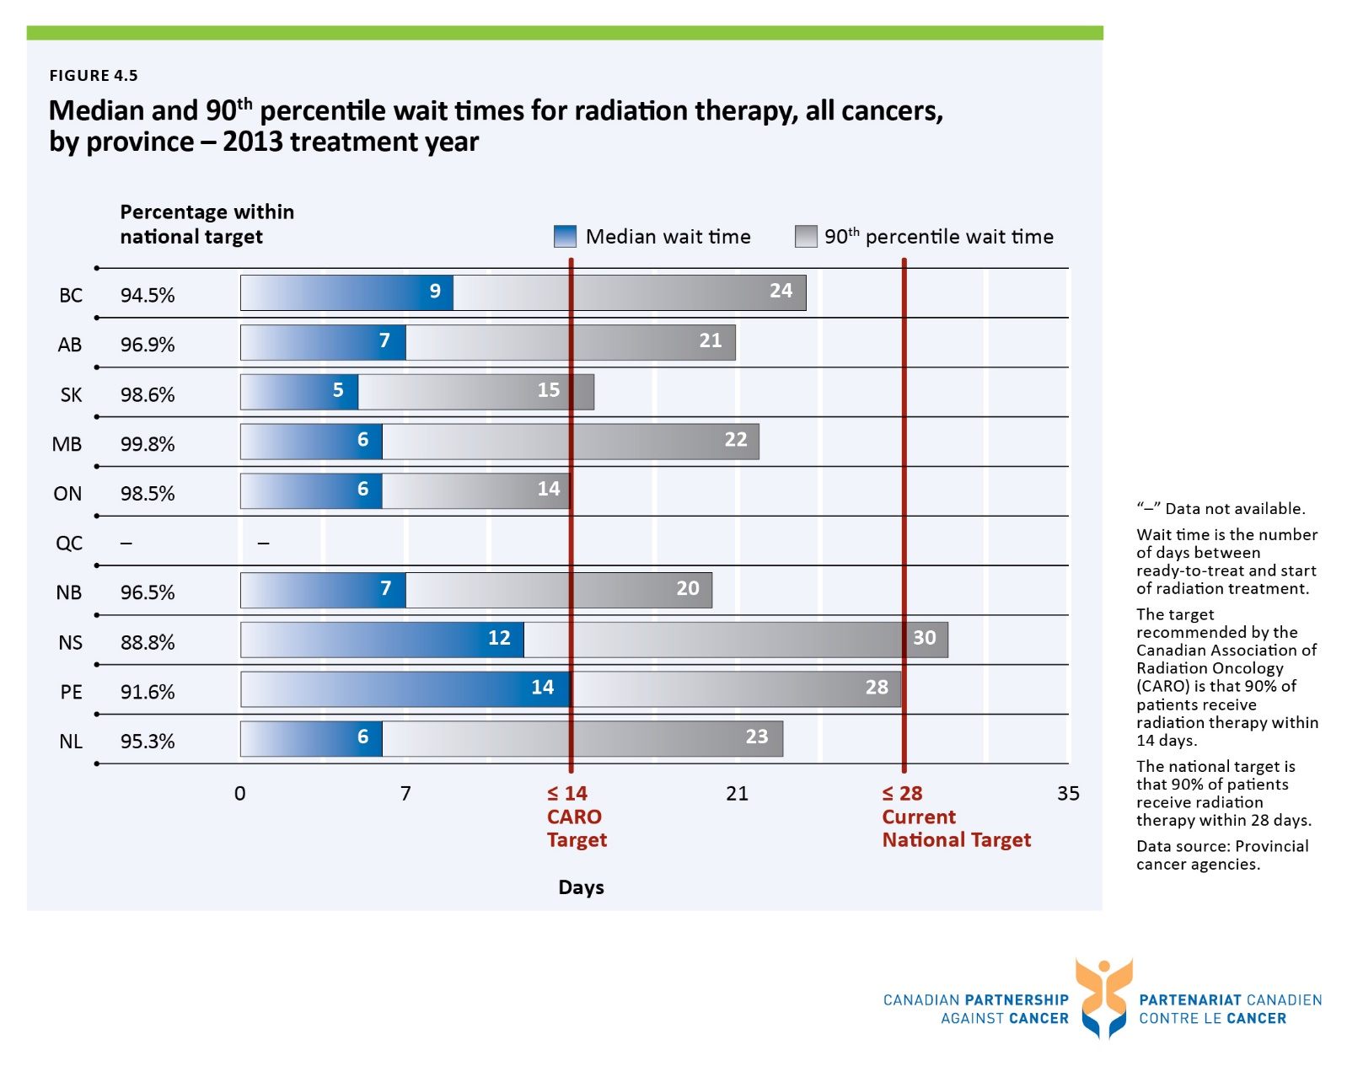

Figure 4.6 90th percentile wait time for radiation therapy, by disease site, by province - 2013 treatment year
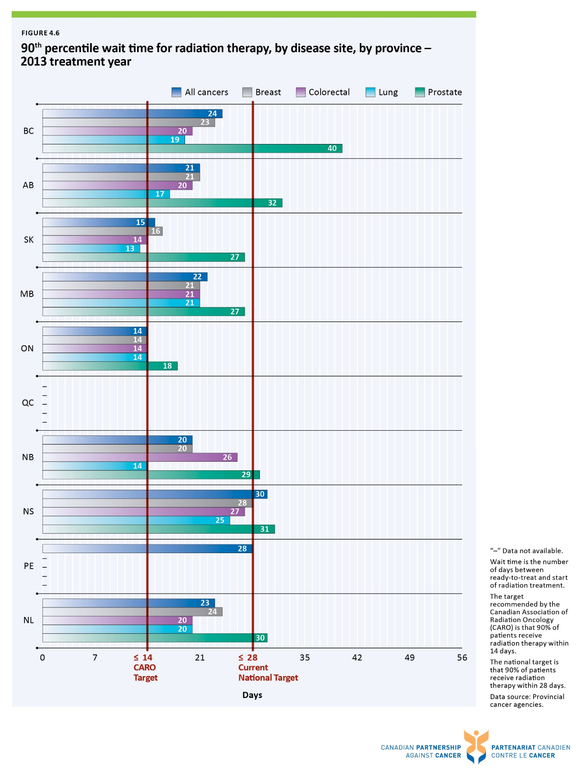

Figure 4.7 Percentage of Stage II or III rectal cancer patients who received radiation therapy before surgery, by province – patients diagnosed in 2008 to 2011
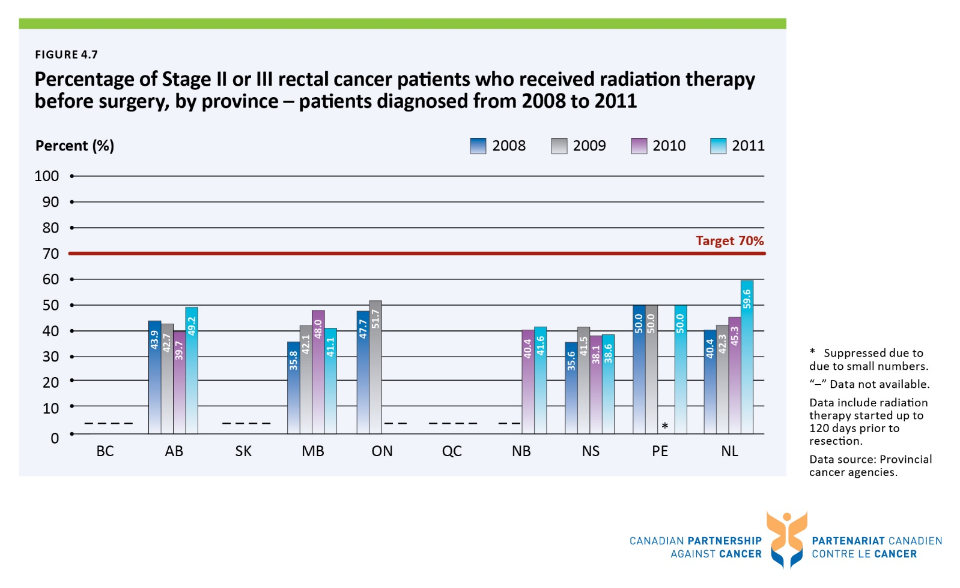

Figure 4.8 Percentage of Stage II or III rectal cancer patients who received radiation therapy before surgery, by patient age group – patients diagnosed from 2008 to 2011
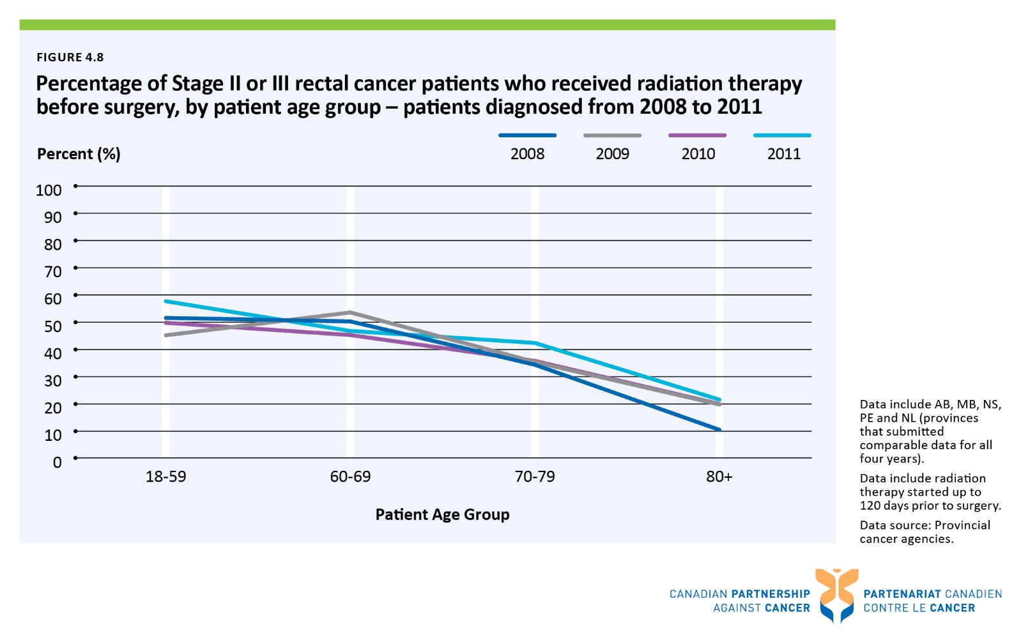

Figure 4.9 Percentage of Stage II or III rectal cancer patients who received radiation therapy before surgery, by patient age group, by sex – patients diagnosed in 2011
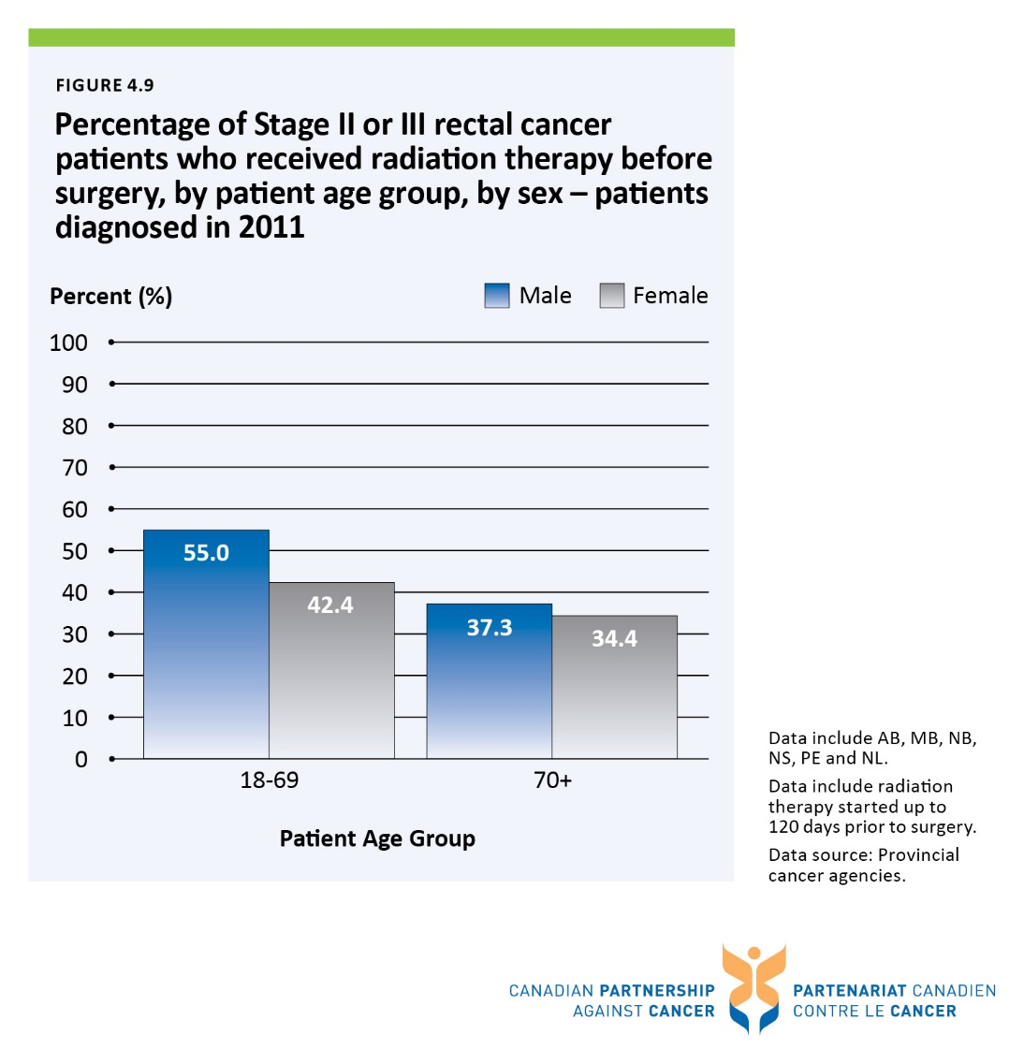

Figure 4.10 Percentage of Stage II or IIIA non-small cell lung cancer patients who received chemotherapy following surgical resection, by province – patients diagnosed from 2009 to 2011
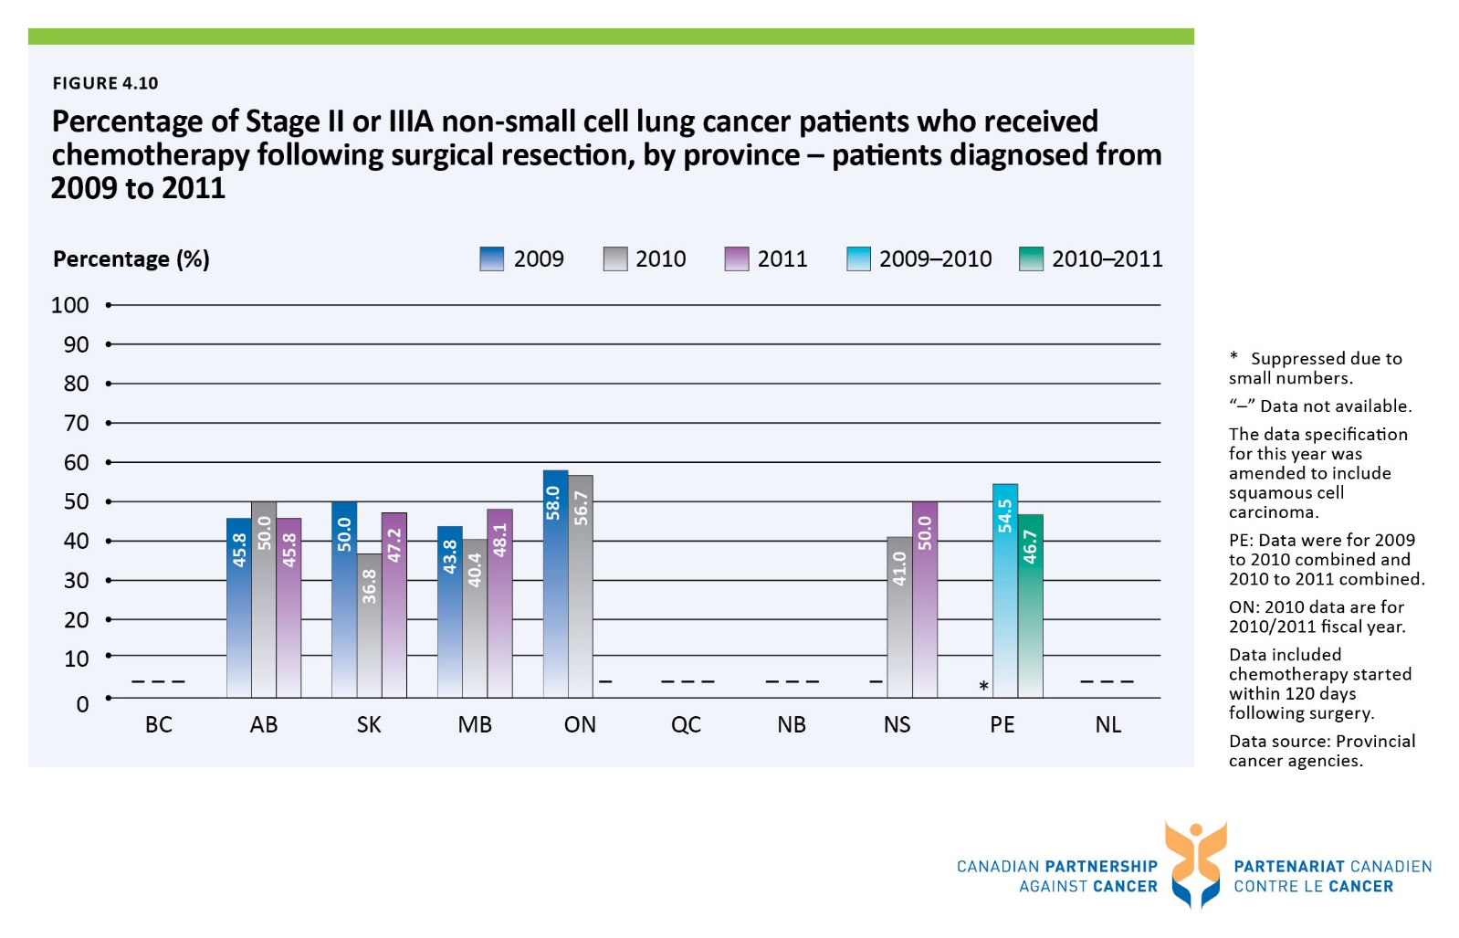

Figure 4.11 Percentage of Stage II or IIIA non-small cell lung cancer patients who received chemotherapy following surgical resection, by patient age group – patients diagnosed from 2009 to 2011
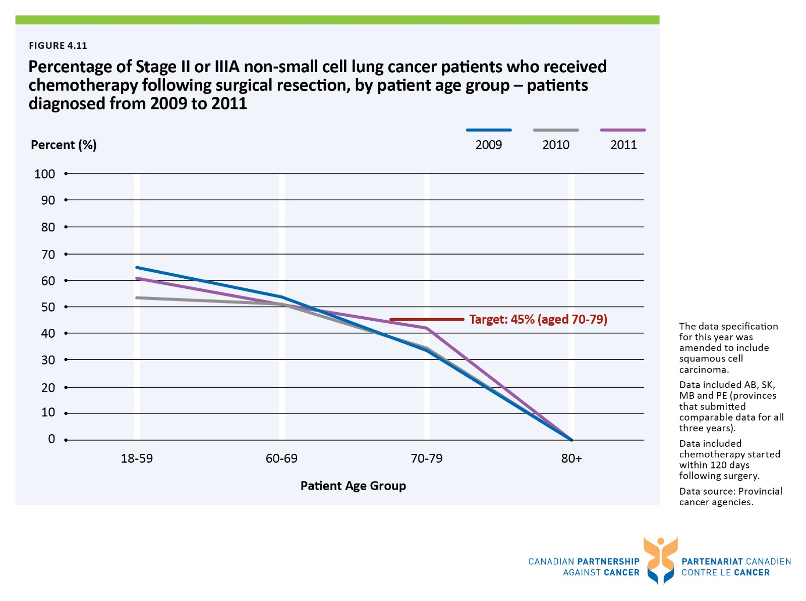

Figure 4.12 Percentage of Stage II or IIIA non-small cell lung cancer patients who received chemotherapy following surgical resection, by patient age group, by sex – patients diagnosed in 2011
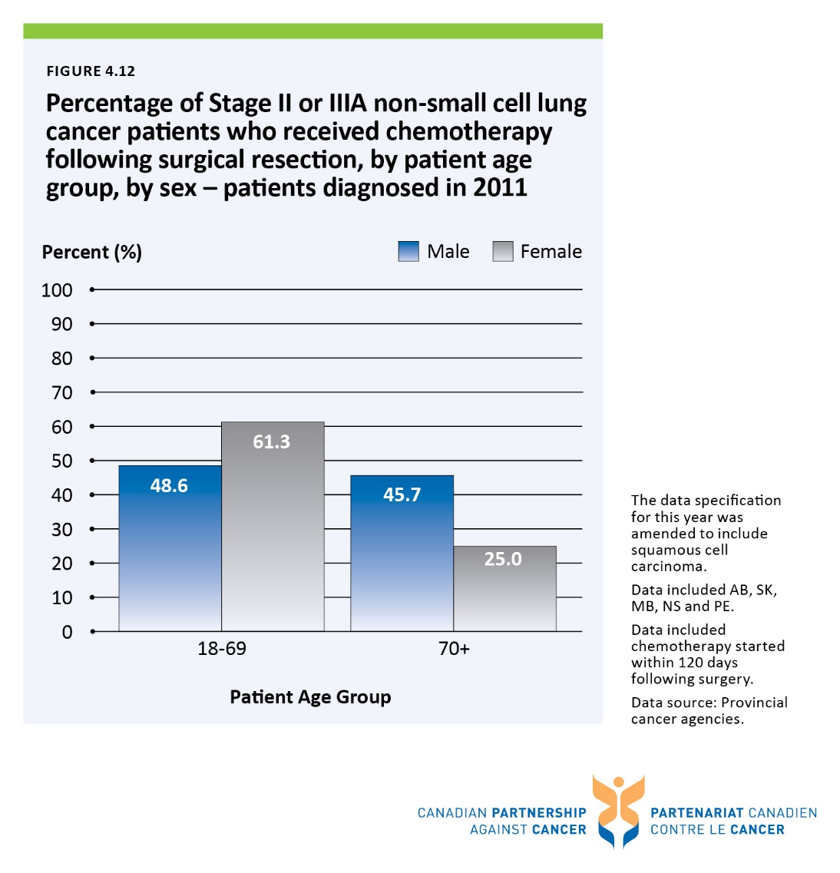

Figure 5.1 Edmonton Symptom Assessment System (ESAS) Screening Tool and the Canadian Problem Checklist
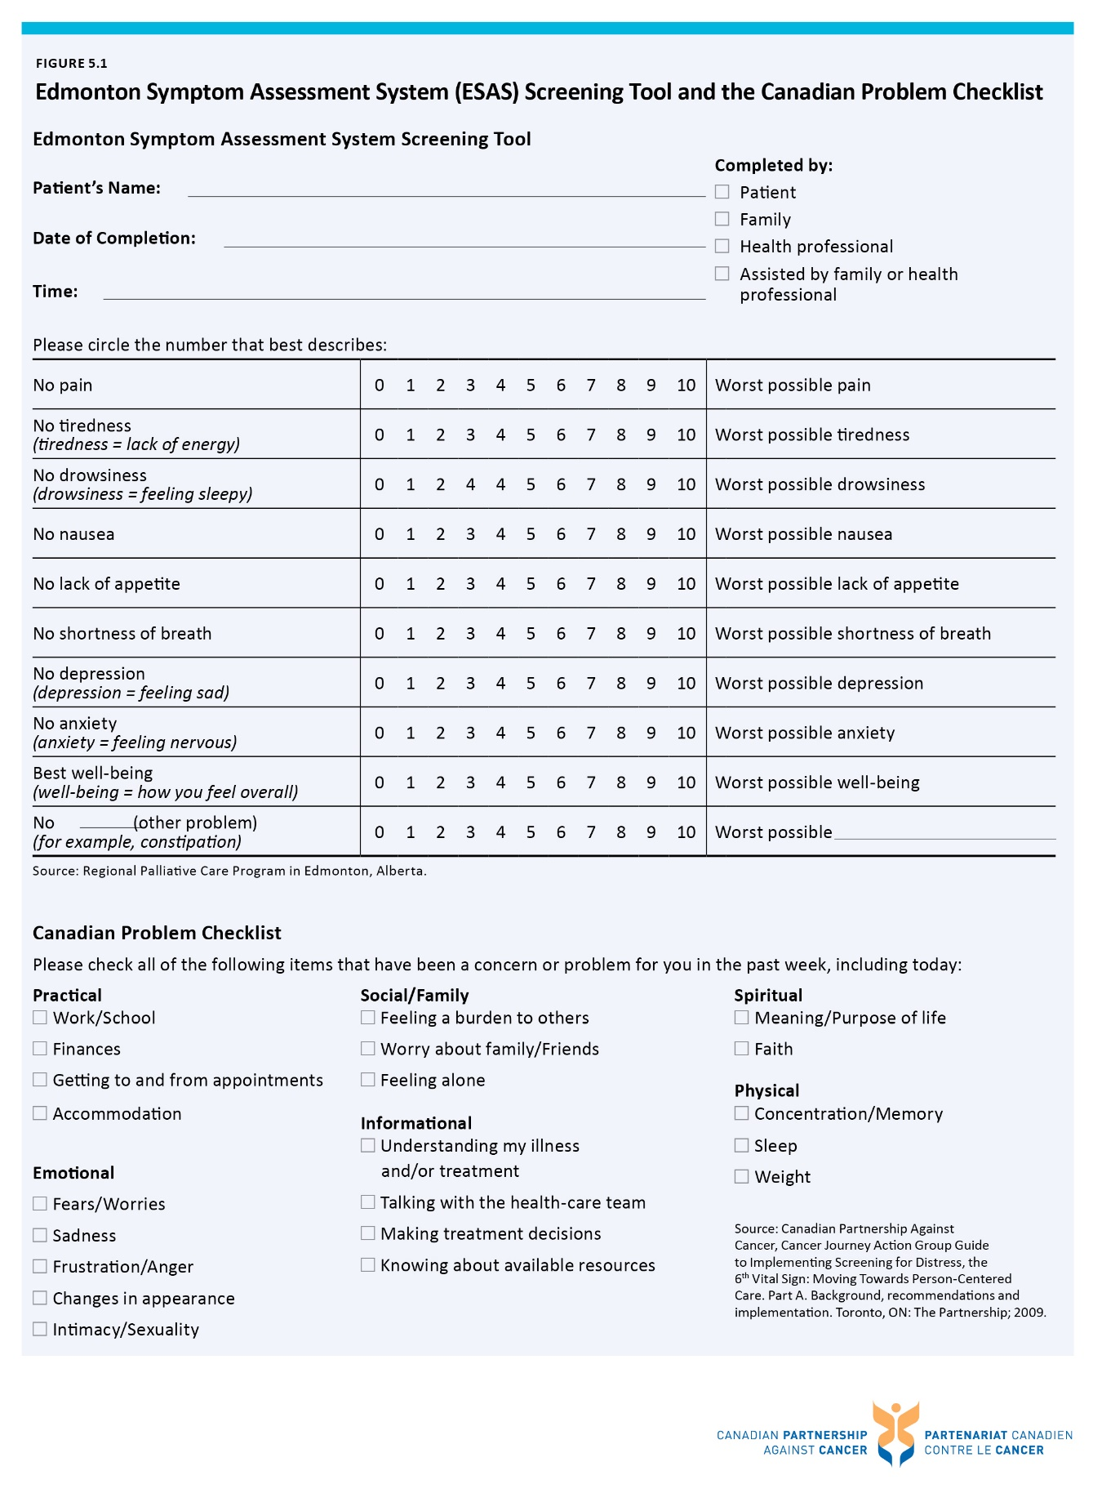

Figure 6.1 Ratio of adult patients enrolled in clinical trials to number of incident cases, by province, all cancers – 2013 enrolment year
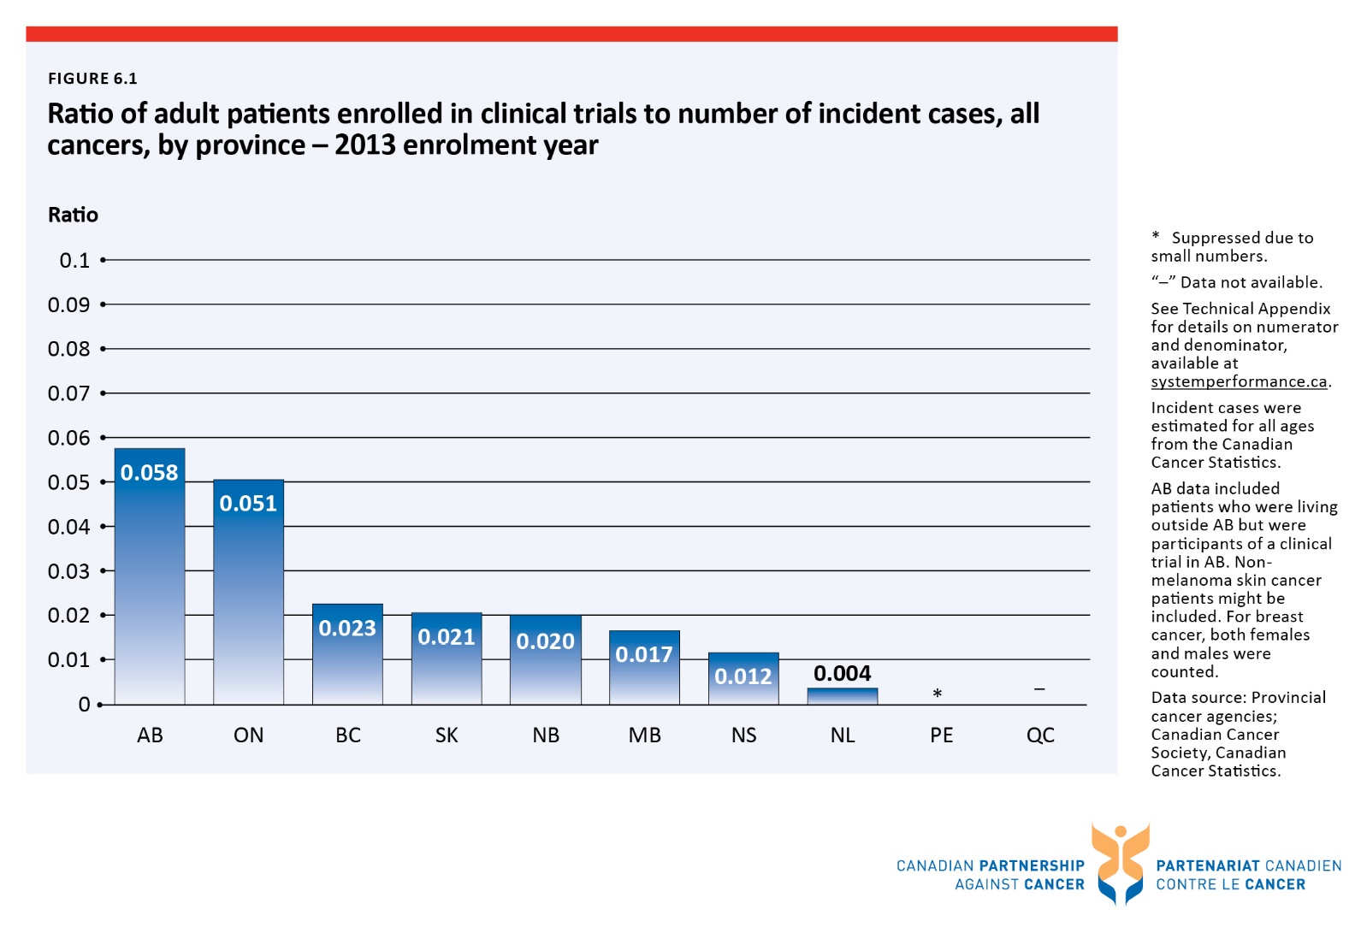

Figure 6.2 Ratio of adult patients enrolled in clinical trials to number of incident cases, by disease site, four most common cancers and all cancers combined - 2013 enrolment year
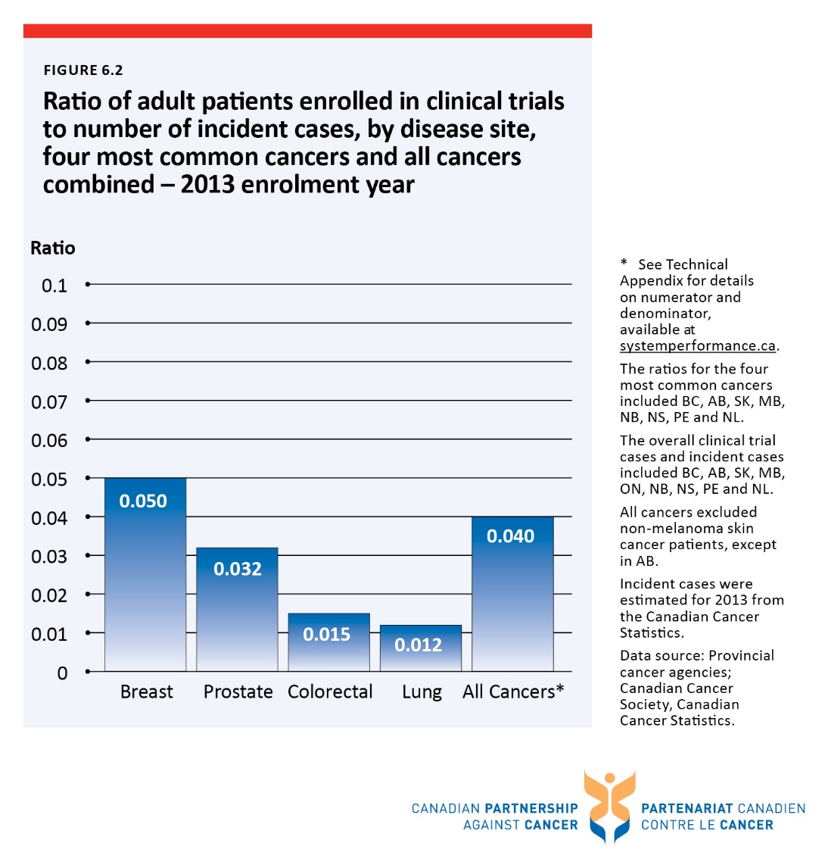

Figure 7.1 Percentage of all self-reported screening† mammograms performed within and outside of guideline-recommended age groups (50 to 74 years), by province/territory - 2012 reporting year
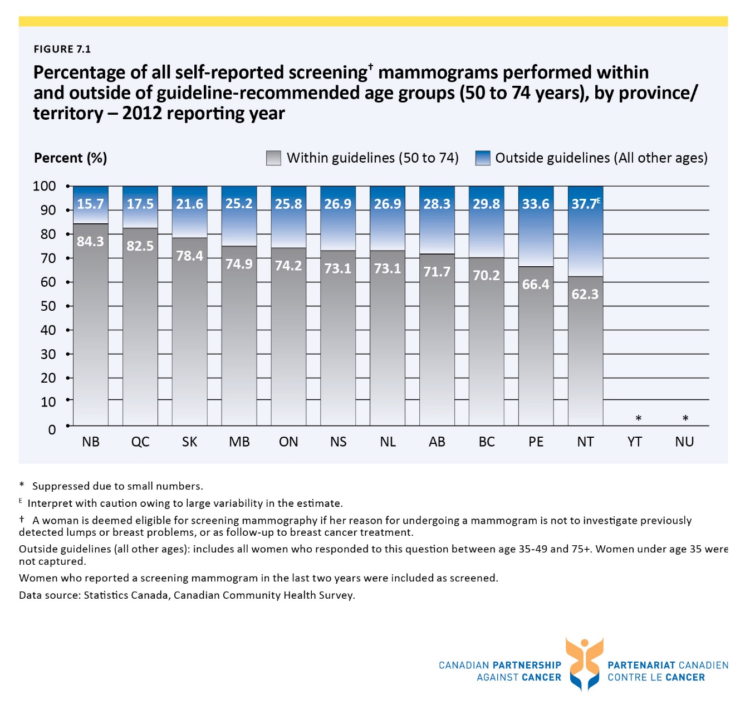

Figure 7.2 Percentage of breast cancer mastectomies done as day surgery, by province/territory - from 2007/2008 to 2011/2012 fiscal years combined
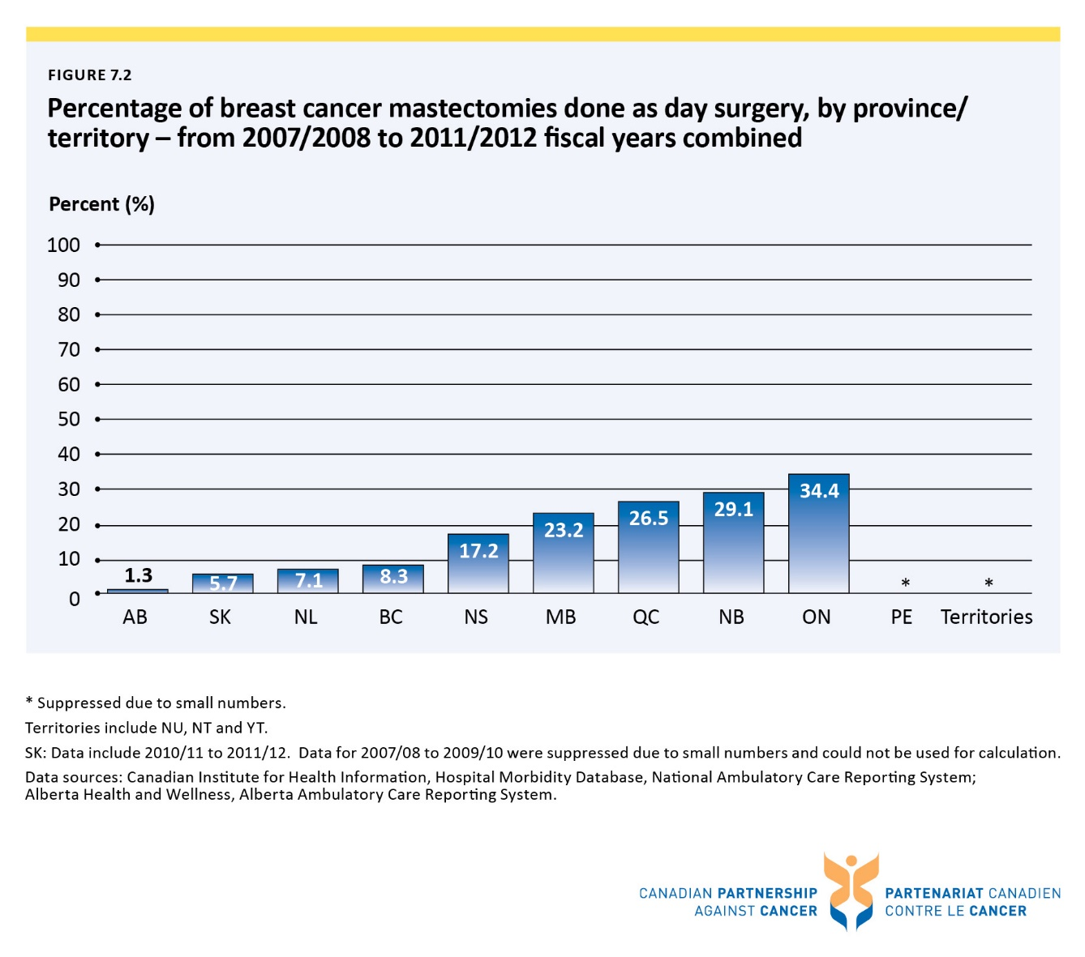

Figure 8.1 Incidence and mortality rates for breast cancer in women, Canada, age-standardized to the 2011 population - from 1992 to 2011
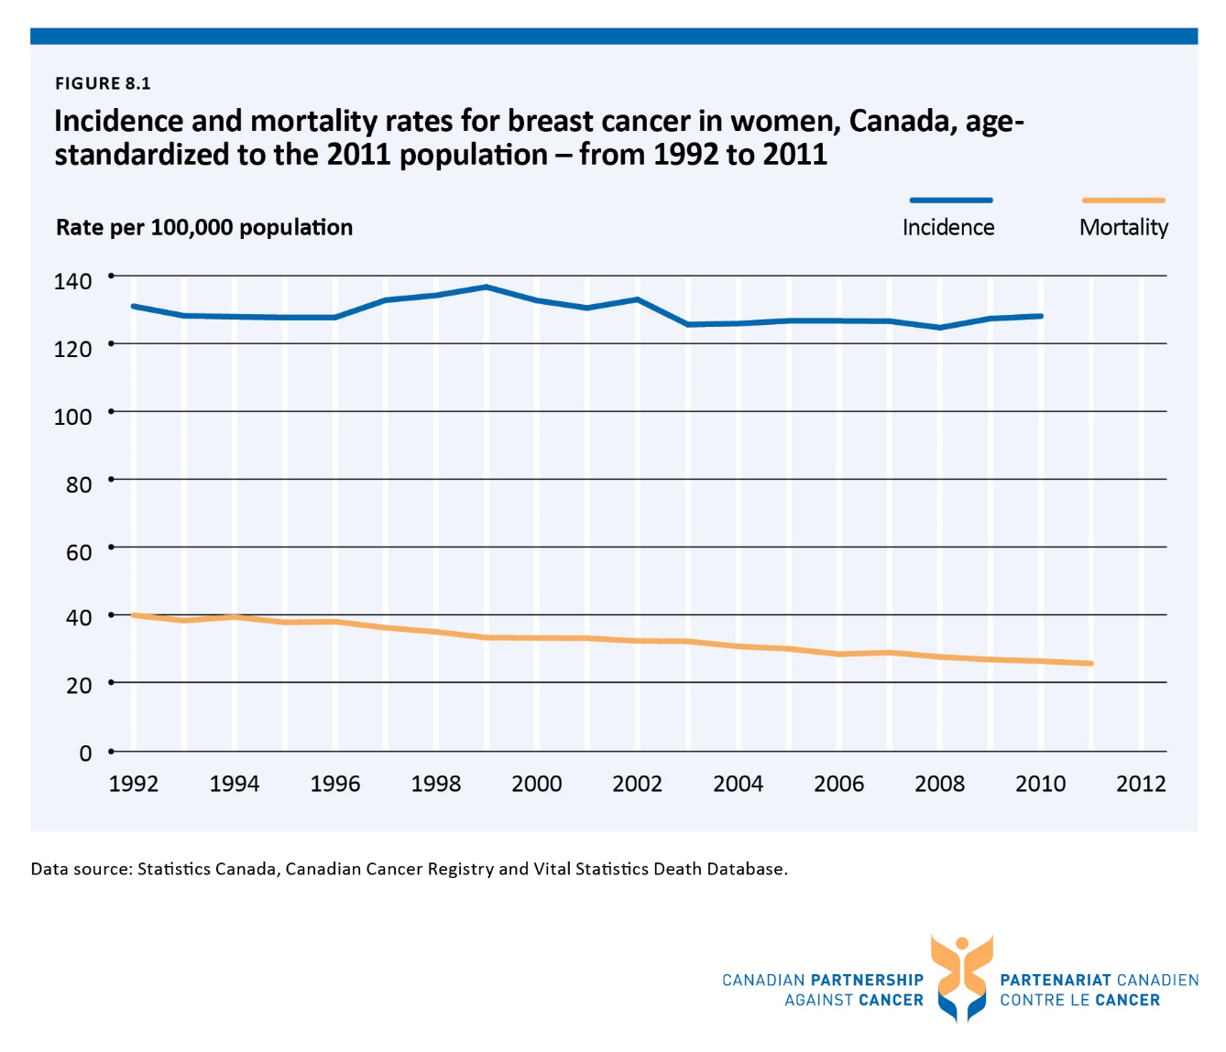

Figure 8.2 Incidence rates for breast cancer in women, by province, age-standardized to the 2011 population - 2008-2010 combined
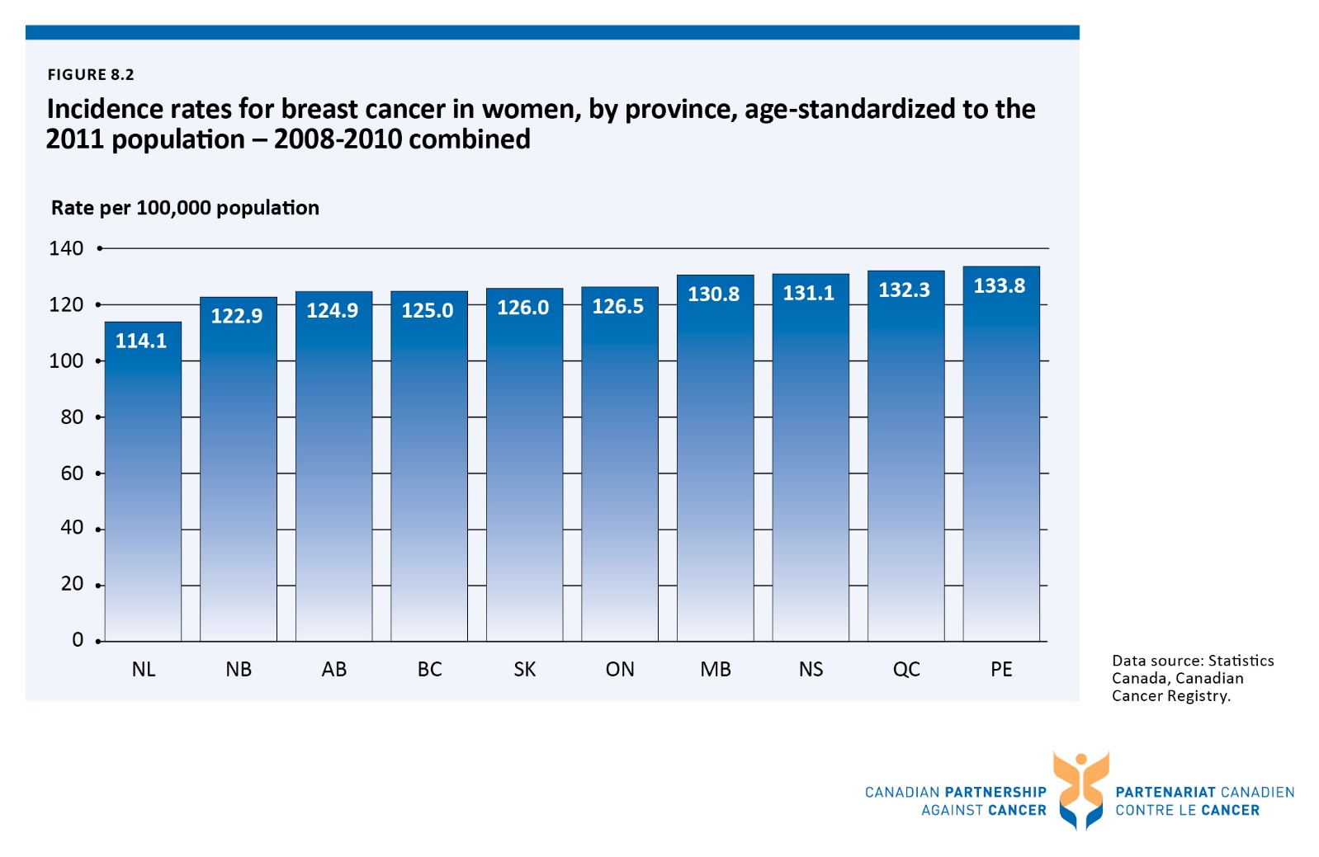

Figure 8.3 Incidence rates for breast cancer in women, by stage at diagnosis, by province, age-standardized to the 2011 population - 2010-2012 diagnosis years combined
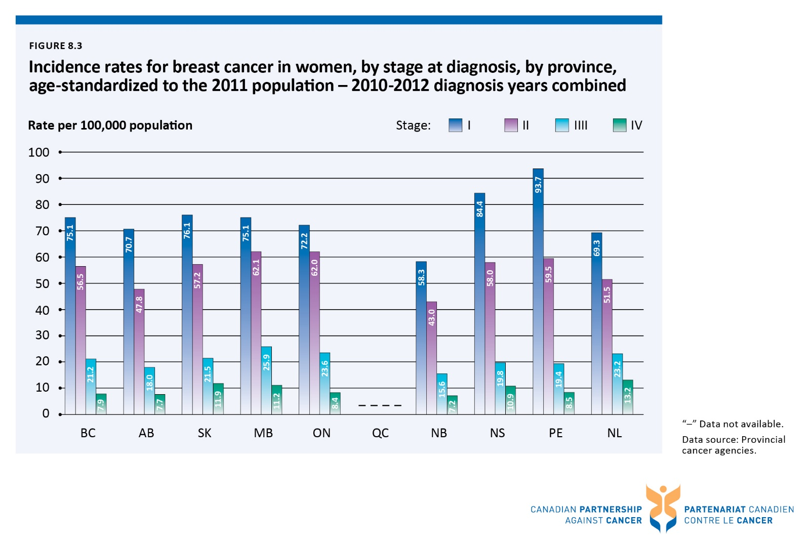

Figure 8.4 Mortality rates for breast cancer in women, by province, age-standardized to the 2011 population - 2009-2011 combined
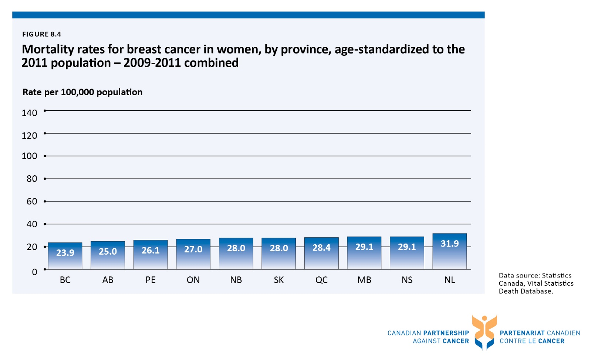

Figure 8.5 Five-year relative survival ratios for breast cancer, both sexes combined, by province, age-standardizedᶧ - 2006-2008 combined

Figure 8.6 Five-year relative survival ratios for breast cancer, both sexes combined, Canada,ᶧ age-standardizedᶧᶧ - 1992-1994 combined vs. 2006-2008 combined
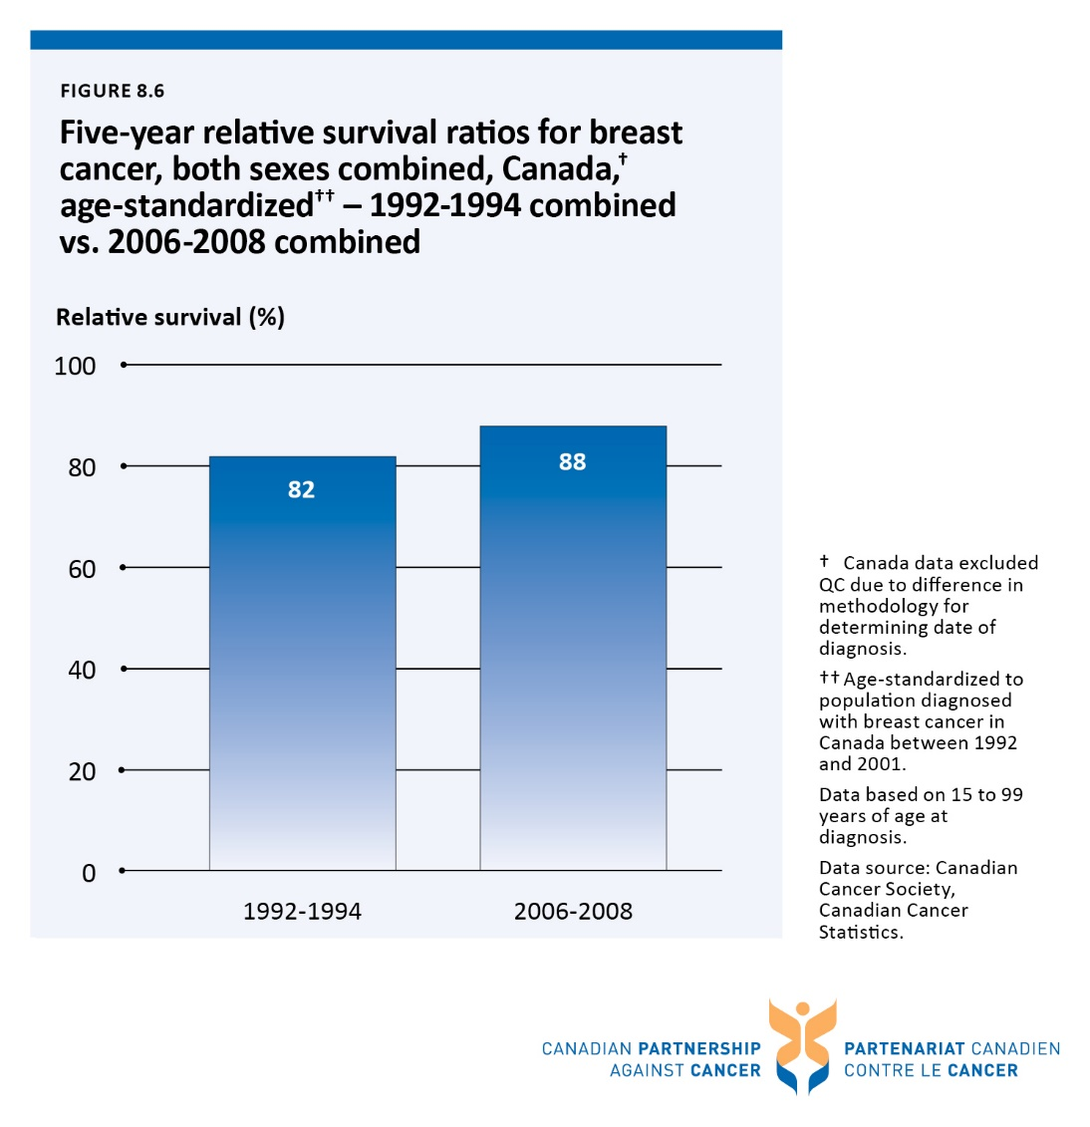

Figure 8.7 Incidence and mortality rates for lung cancer, by sex, Canada, age-standardized to the 2011 population - from 1992 to 2011
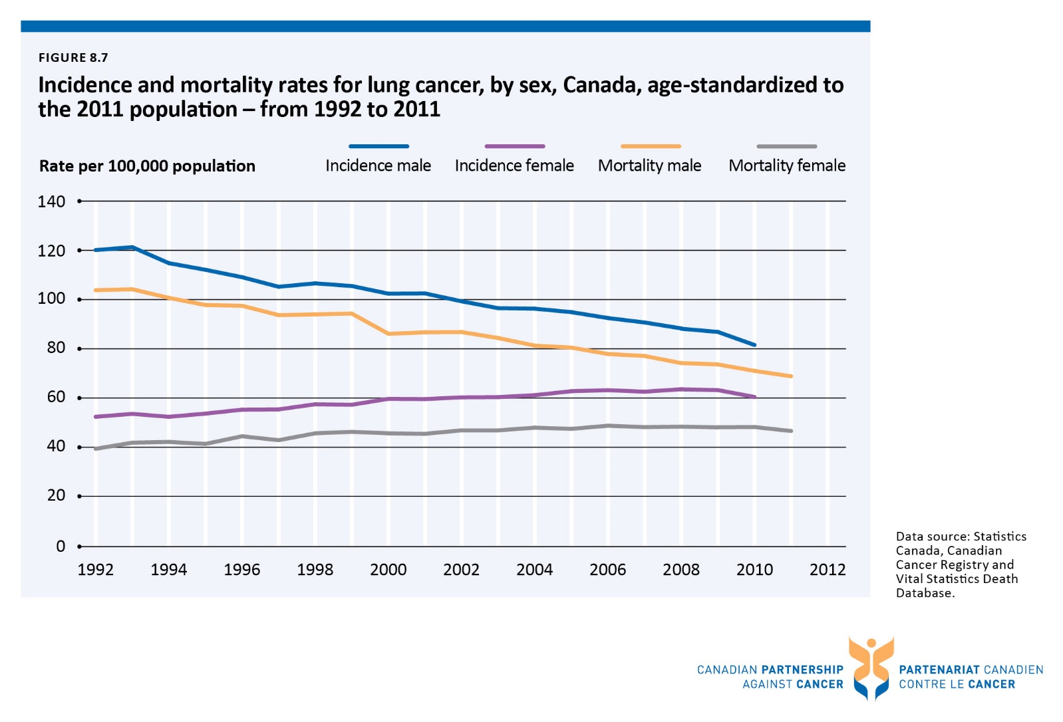

Figure 8.8 Incidence rates for lung cancer, by sex, by province, age-standardized to the 2011 population - 2008-2010 combined
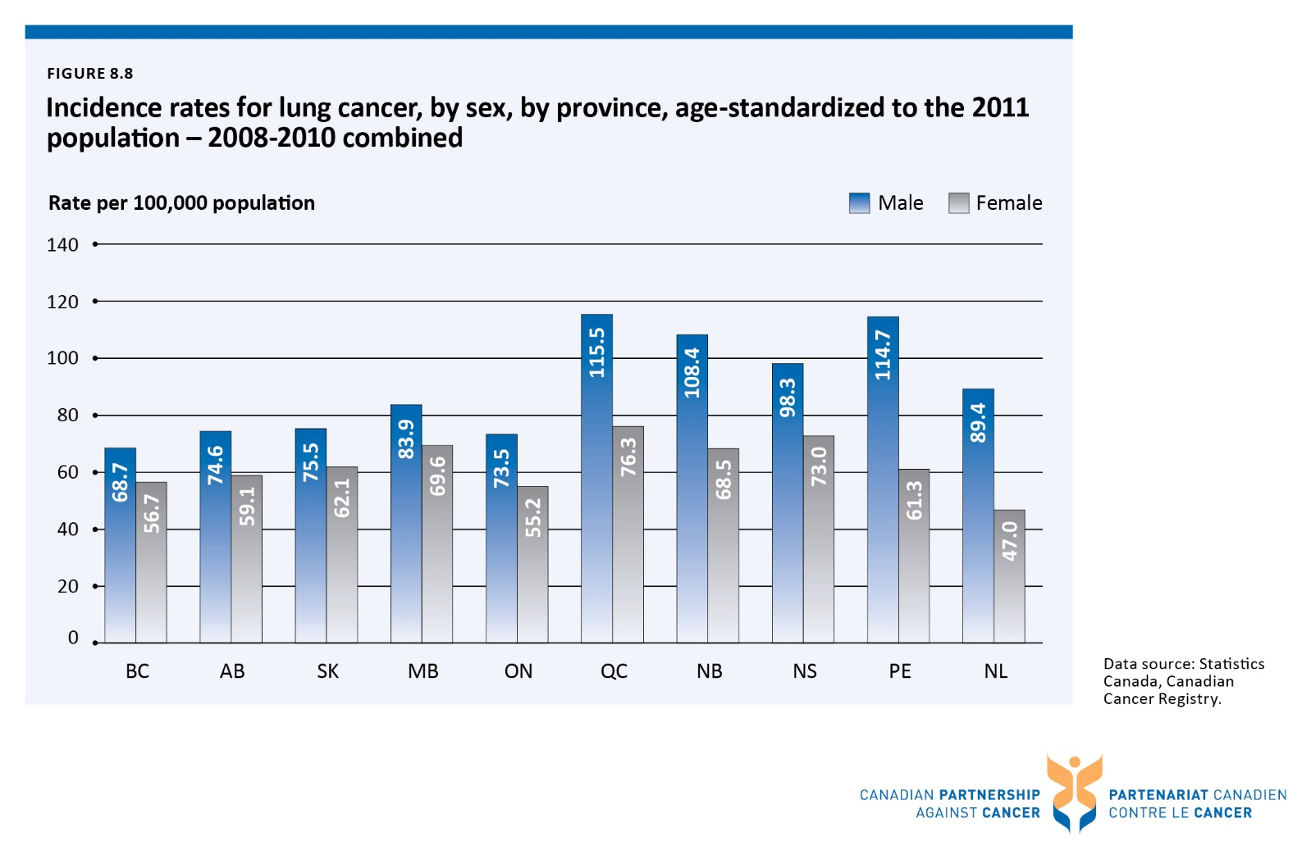

Figure 8.9 Incidence rates for lung cancer, by stage at diagnosis, by province, age-standardized to the 2011 population - 2010-2012 diagnosis years combined
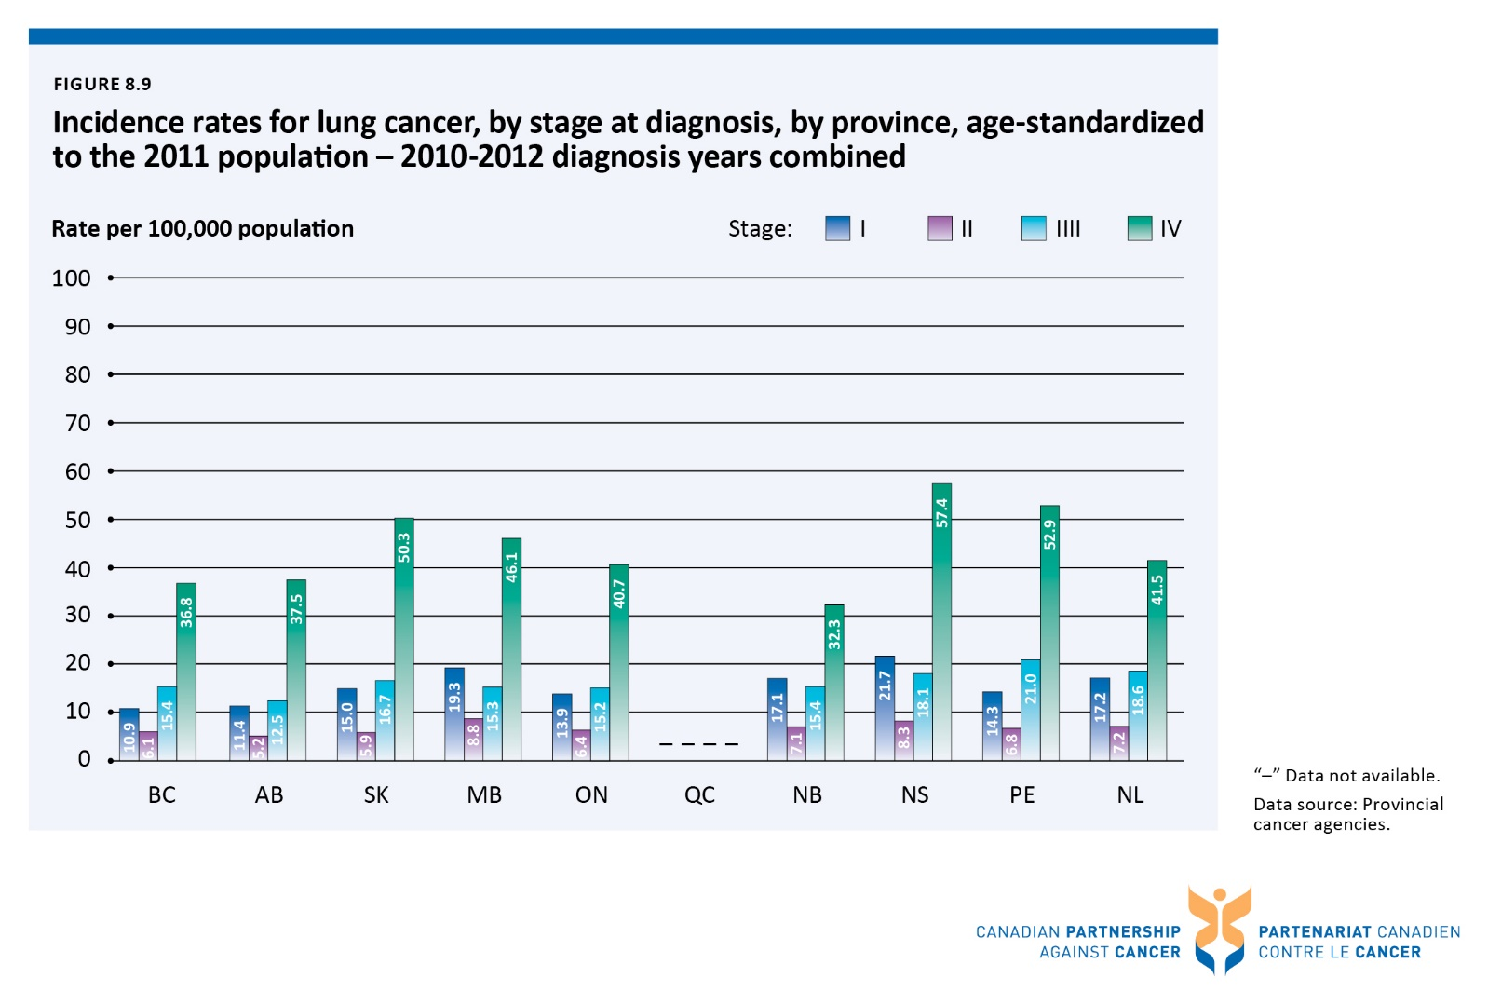

Figure 8.10 Mortality rates for lung cancer, by province, age-standardized to the 2011 population - 2009-2011 combined
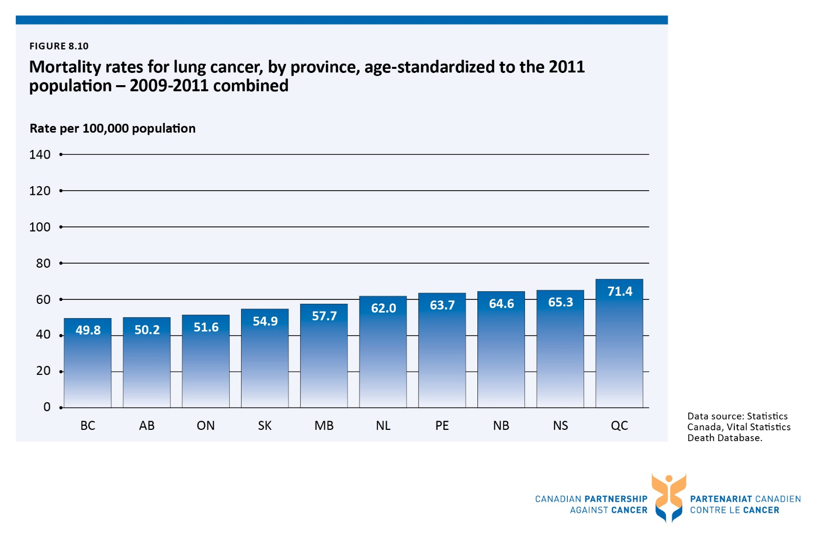

Figure 8.11 Five-year relative survival ratios for lung cancer, by province, age-standardizedᶧ - 2006-2008 combined
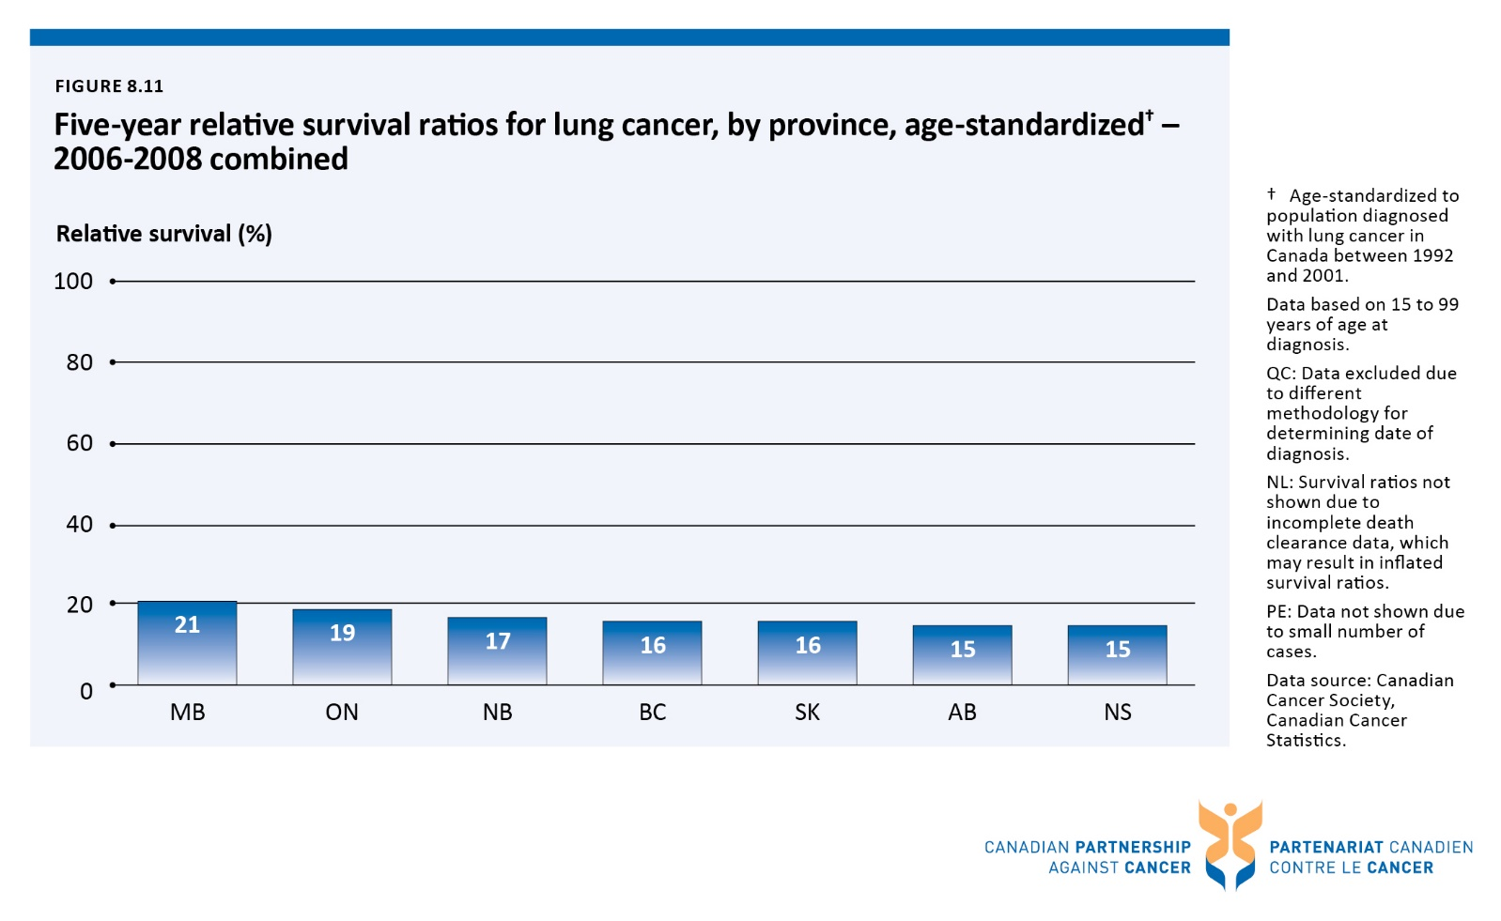

Figure 8.12 Five-year relative survival ratios for lung cancer, Canada,ᶧ age-standardizedᶧᶧ - 1992-1994 combined vs. 2006-2008 combined
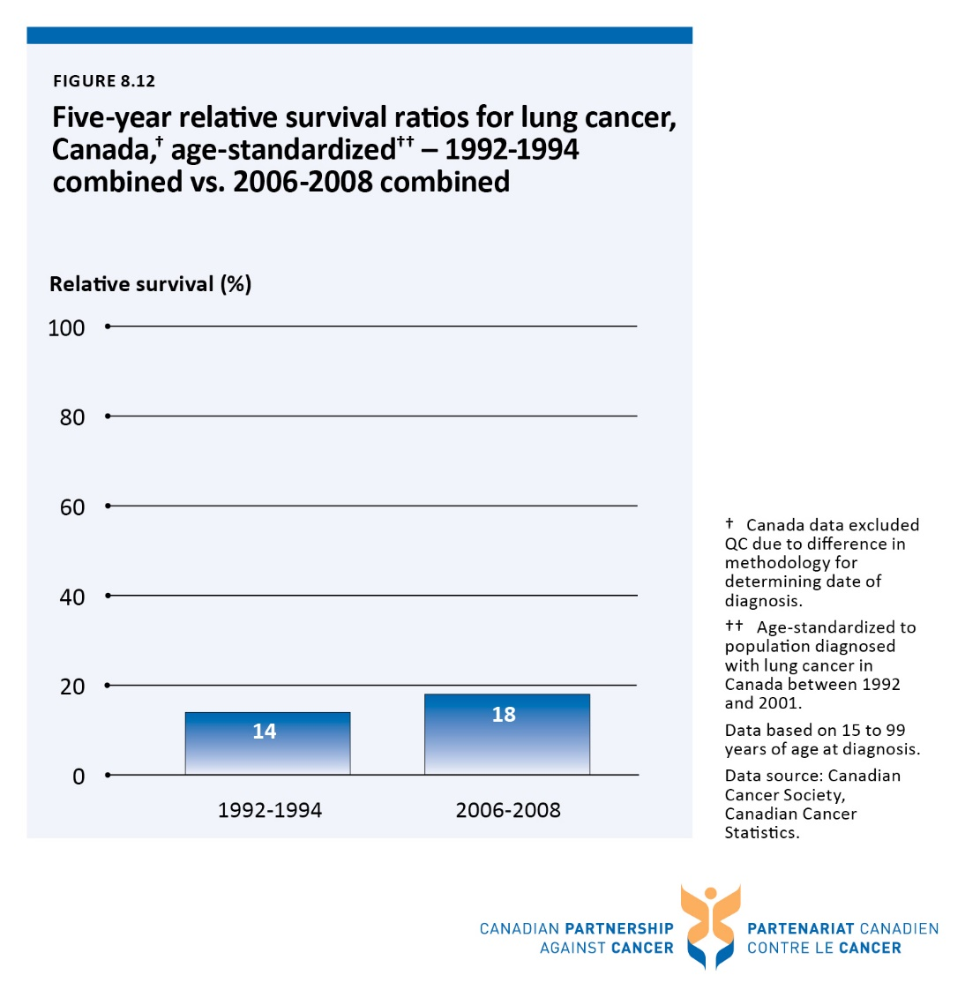

Figure 8.13 Incidence and mortality rates for colorectal cancer, by sex, Canada, age-standardized to the 2011 population - from 1992 to 2011
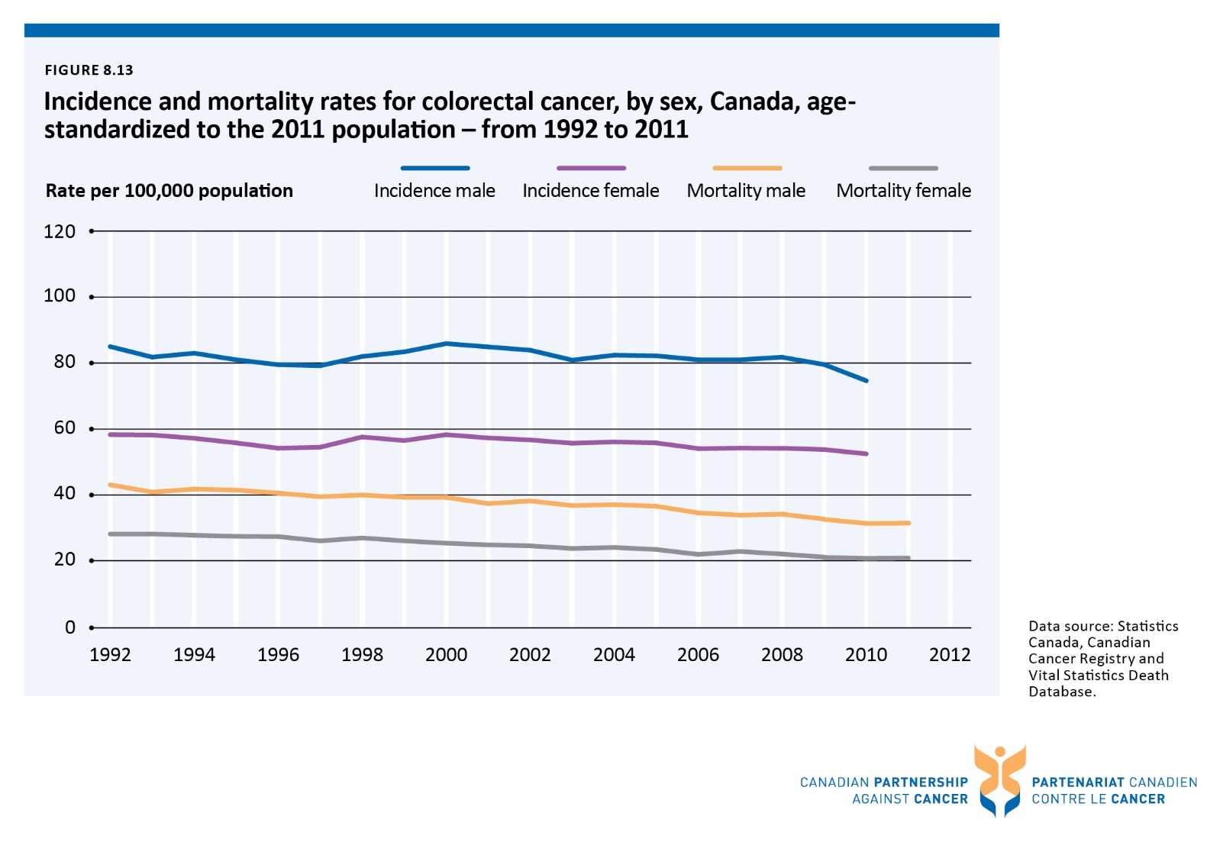

Figure 8.14 Incidence rates for colorectal cancer, by sex, by province, age-standardized to the 2011 population - 2008-2010 combined
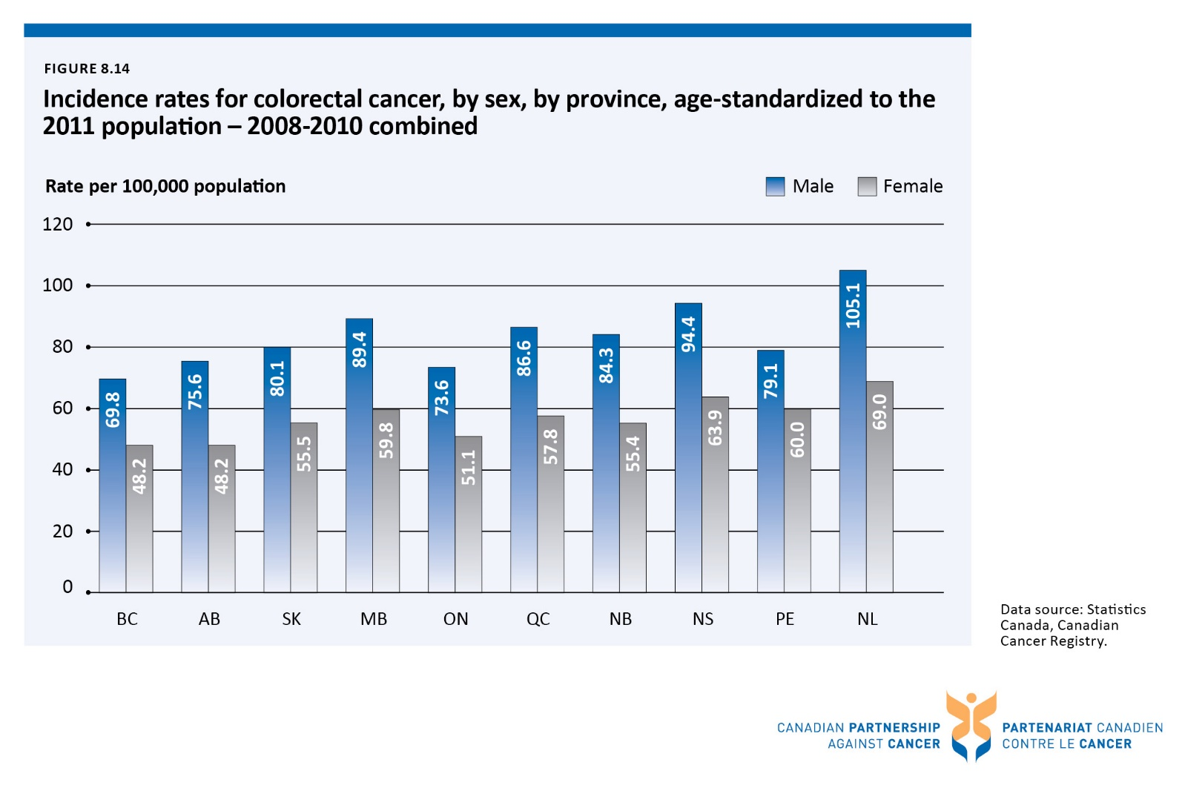

Figure 8.15 Incidence rates for colorectal cancer,ᶧ by stage at diagnosis, by province, age-standardized to the 2011 population - 2010-2012 diagnosis years combined
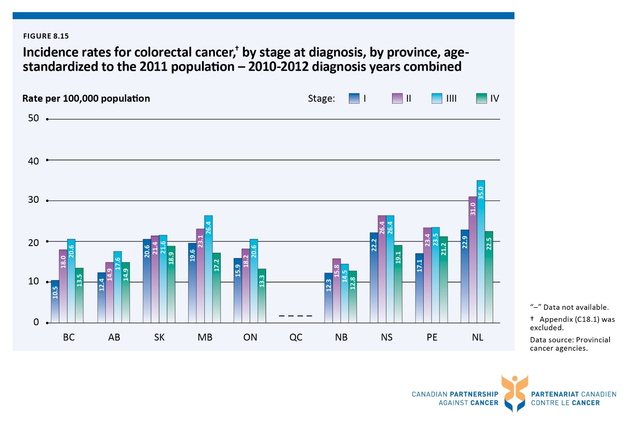

Figure 8.16 Mortality rates for colorectal cancer, by province, age-standardized to the 2011 population - 2009-2011 combined
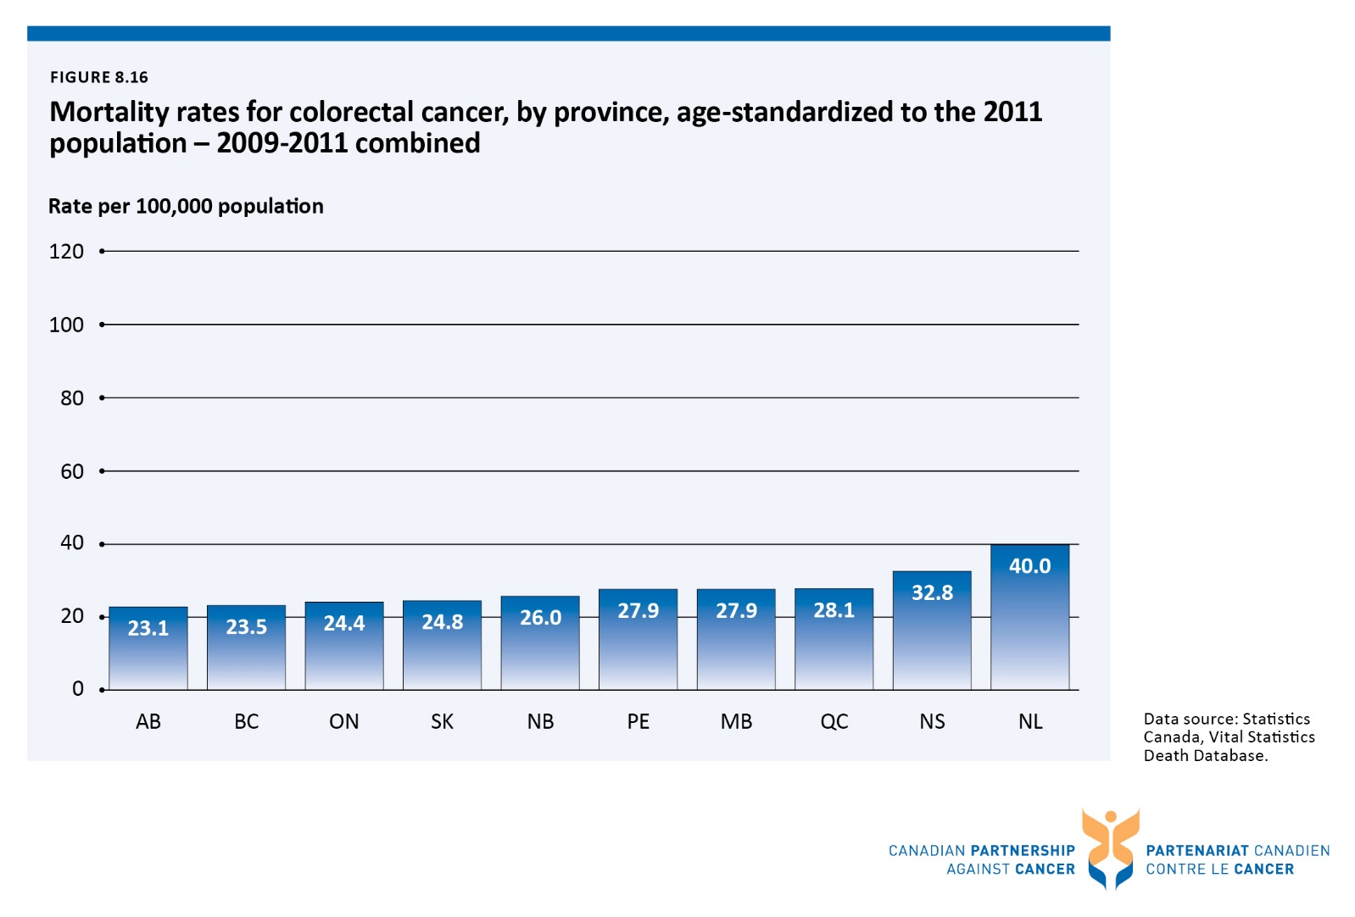

Figure 8.17 Five-year relative survival ratios for colorectal cancer, by province, age-standardizedᶧ - 2006-2008 combined
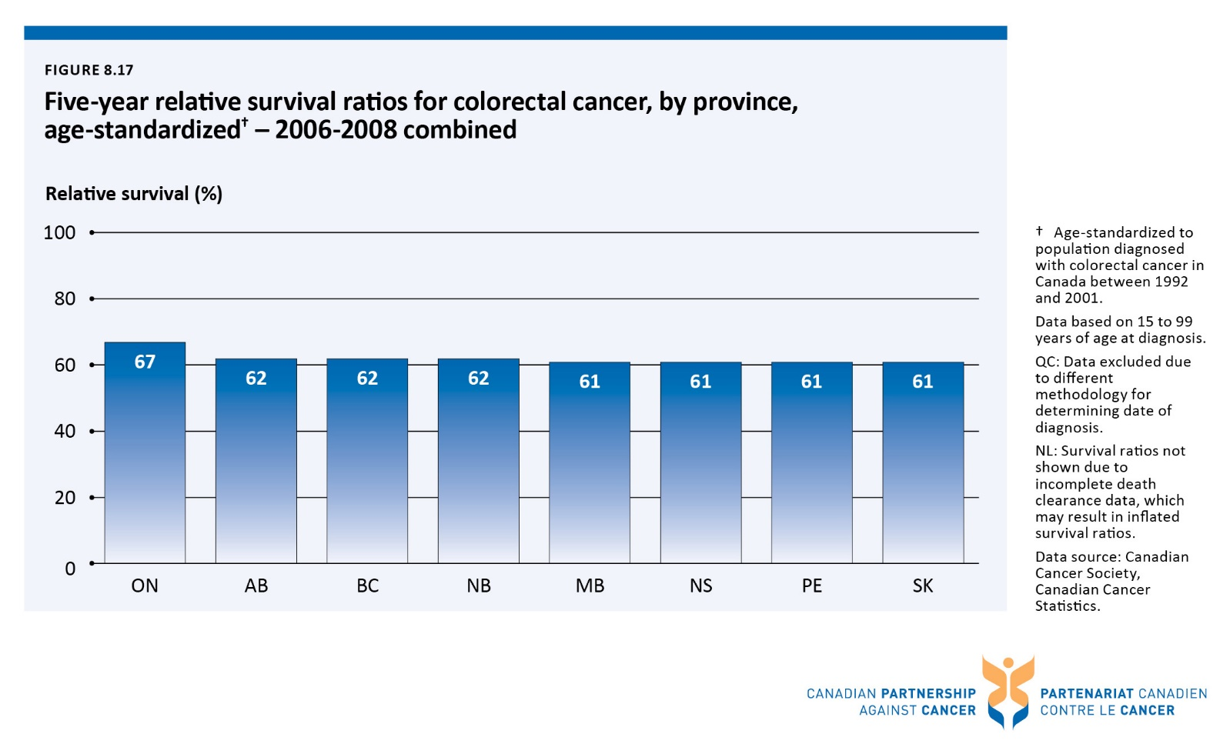

Figure 8.18 Five-year relative survival ratios for colorectal cancer, Canada,ᶧ age-standardizedᶧᶧ - 1992-1994 combined vs. 2006-2008 combined
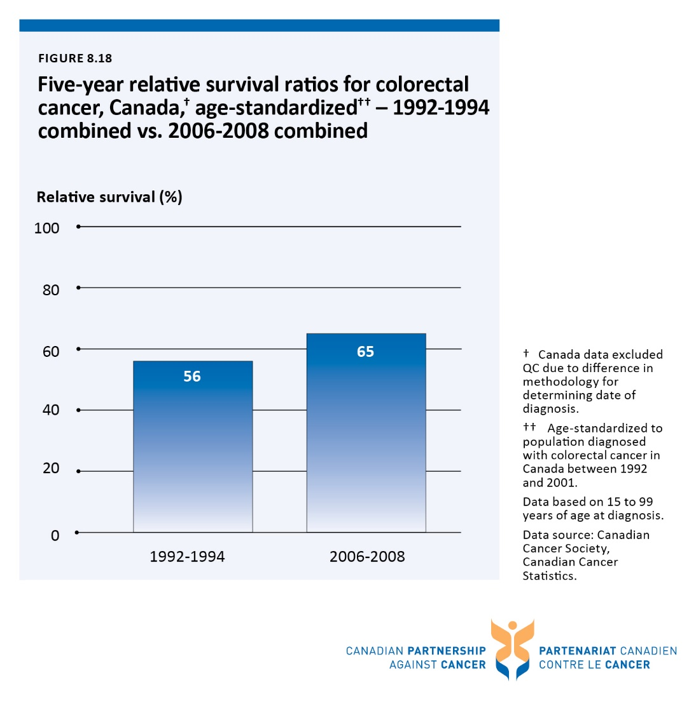

Figure 8.19 Incidence and mortality rates for prostate cancer, Canada, age-standardized to the 2011 population - from 1992 to 2011
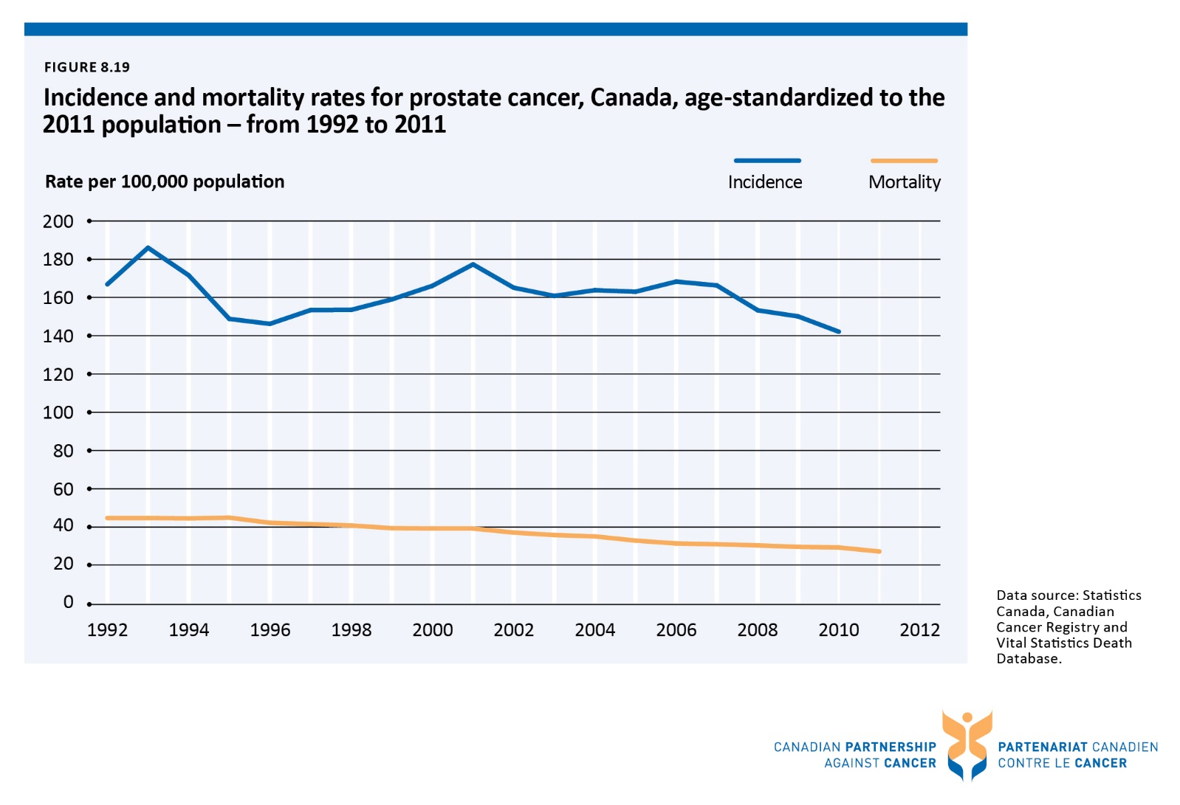

Figure 8.20 Incidence rates for prostate cancer, by province, age-standardized to the 2011 population - 2008-2010 combined
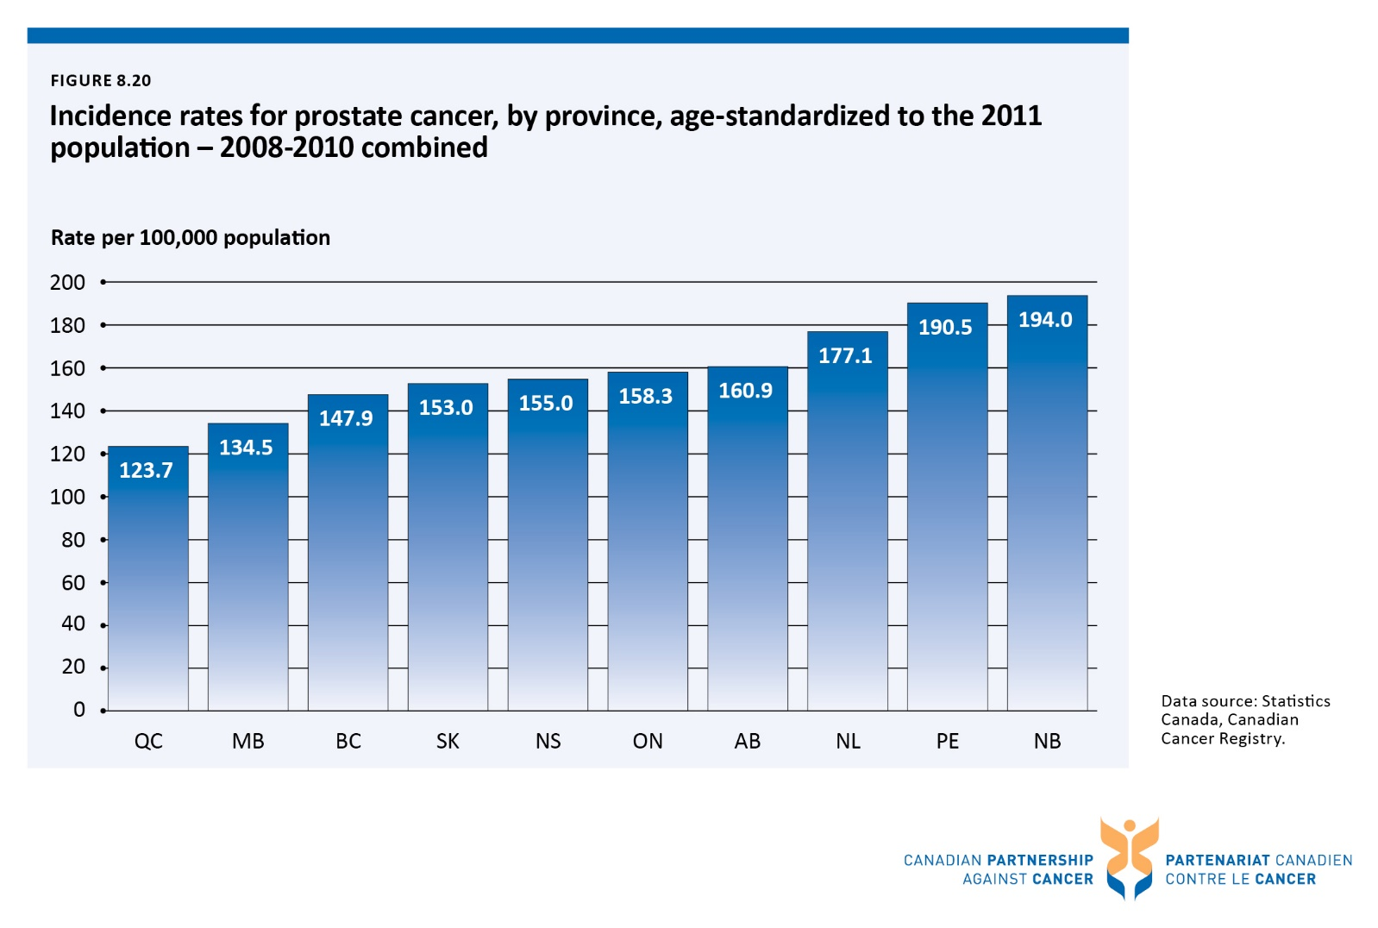

Figure 8.21 Incidence rates for prostate cancer, by stage at diagnosis, by province, age-standardized to the 2011 population - 2010-2012 diagnosis years combined
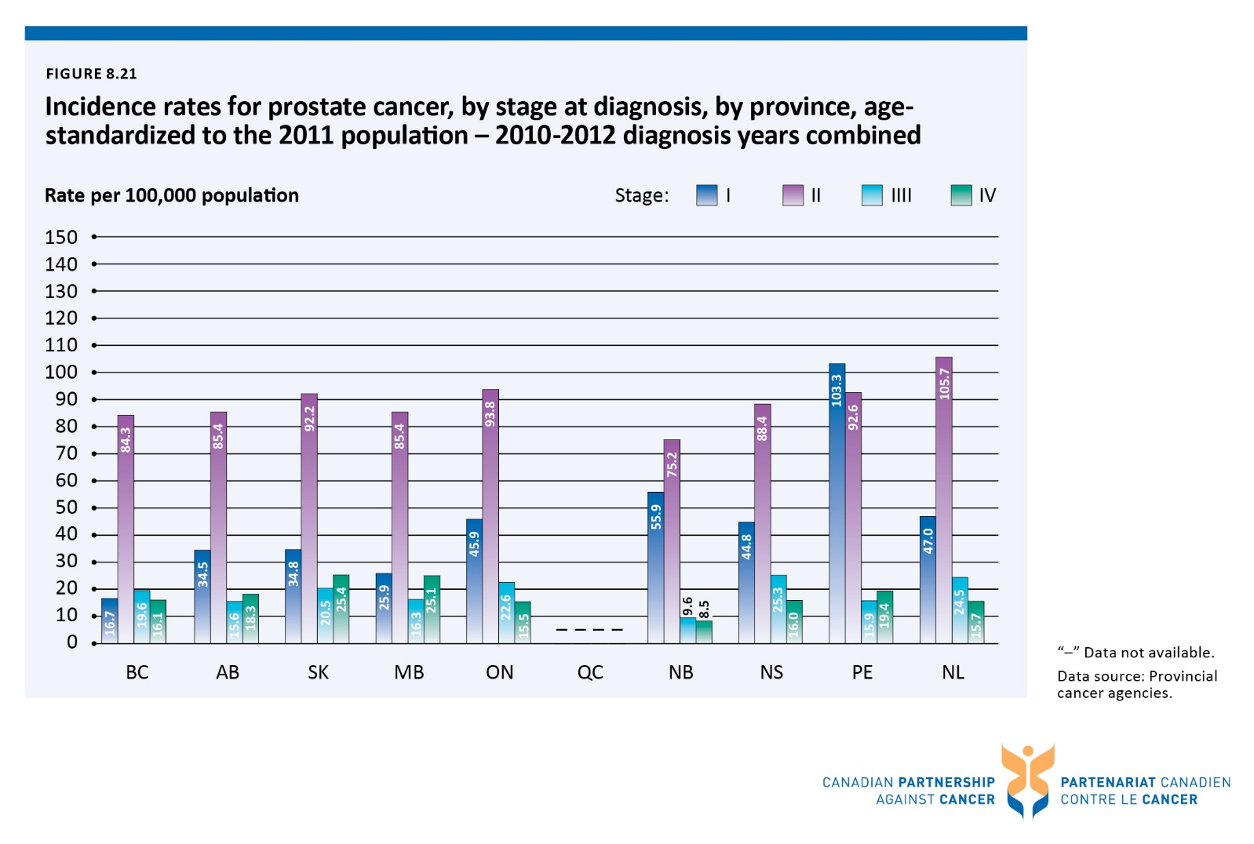

Figure 8.22 Mortality rates for prostate cancer, by province, age-standardized to the 2011 population - 2009-2011 combined
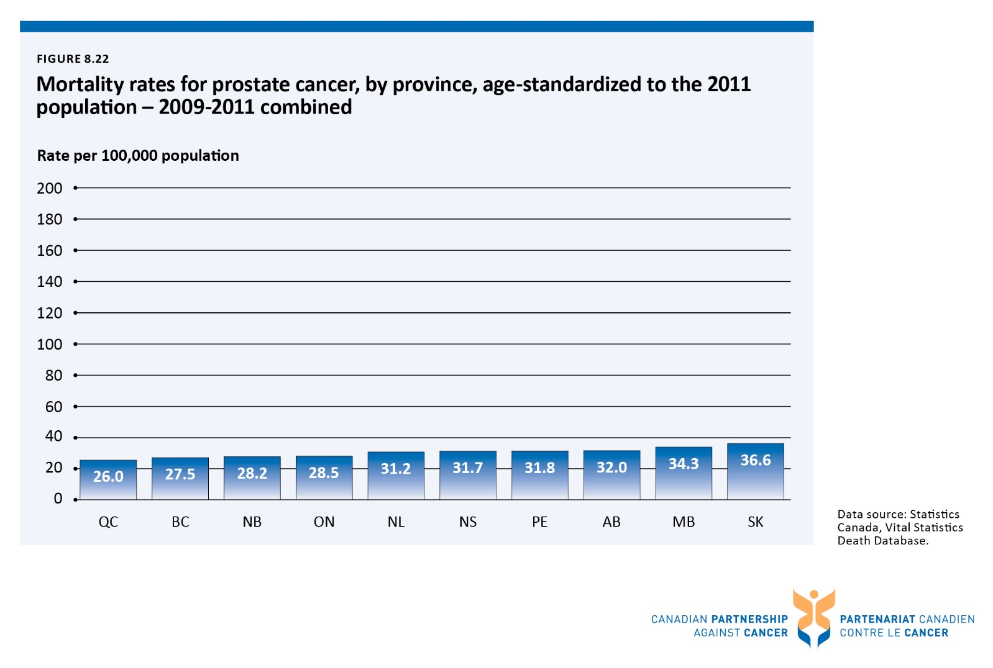

Figure 8.23 Incidence and mortality rates for pancreatic cancer, by sex, Canada, age-standardized to the 2011 population - from 1992 to 2011
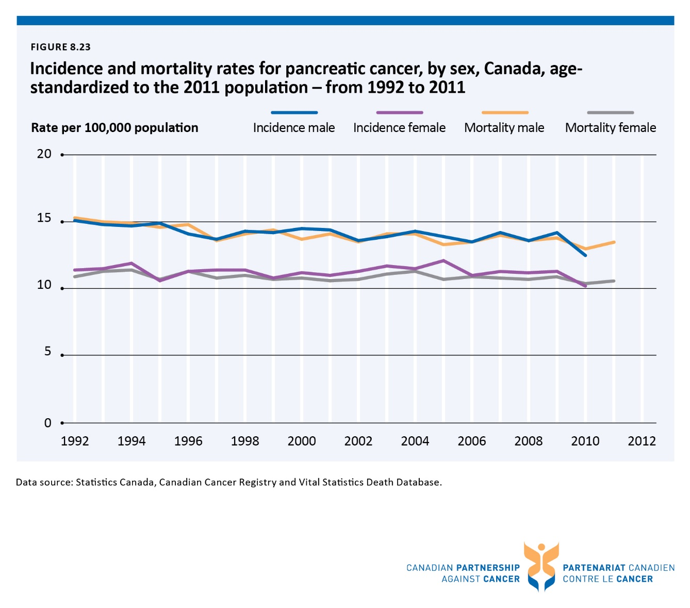

Figure 8.24 Incidence rates for pancreatic cancer, by province, age-standardized to the 2011 population - 2008-2010 combined
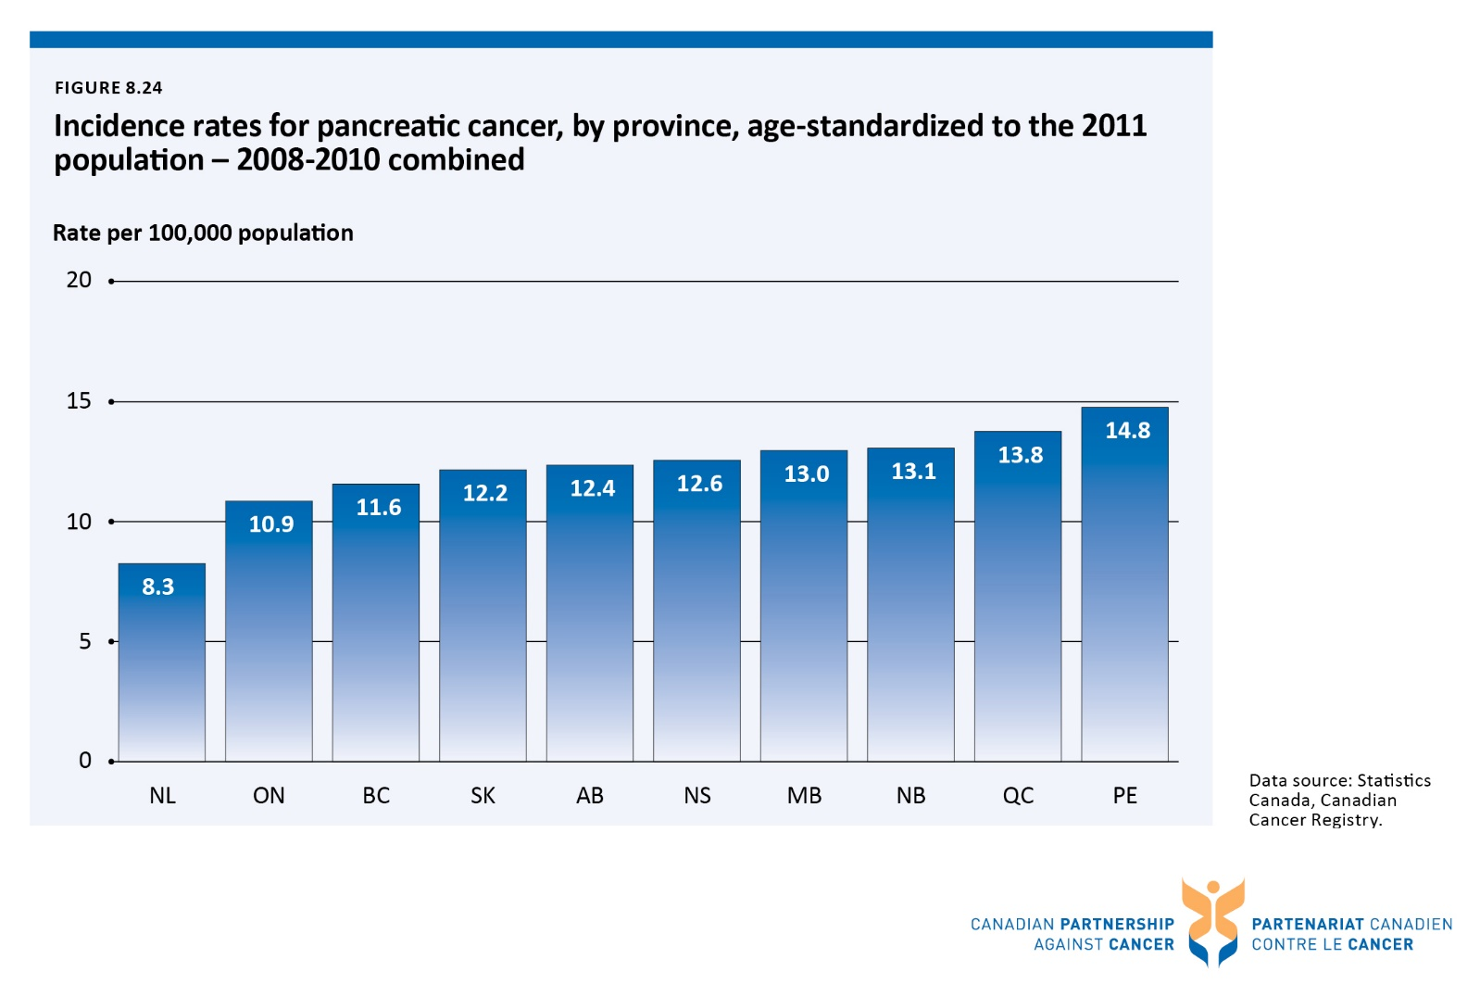

Figure 8.25 Mortality rates for pancreatic cancer, by province, age-standardized to the 2011 population - 2009-2011 combined
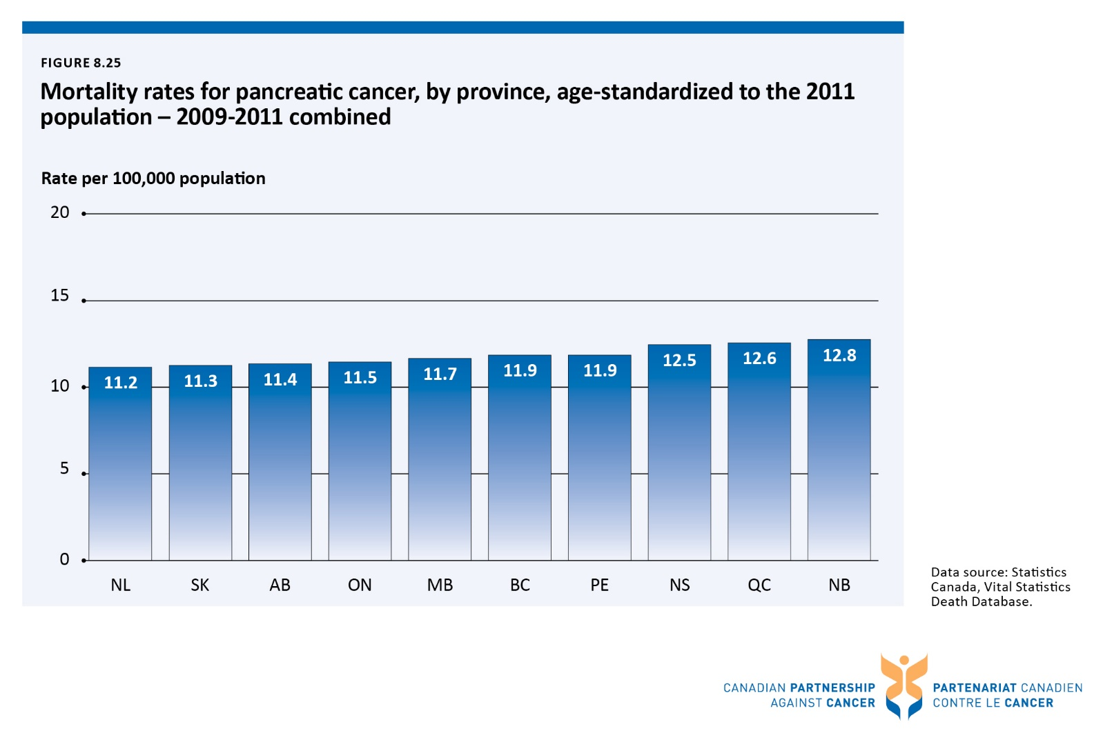

Figure 8.26 Five-year relative survival ratios for pancreatic cancer, by province, age-standardizedᶧ - 2005-2007 combined
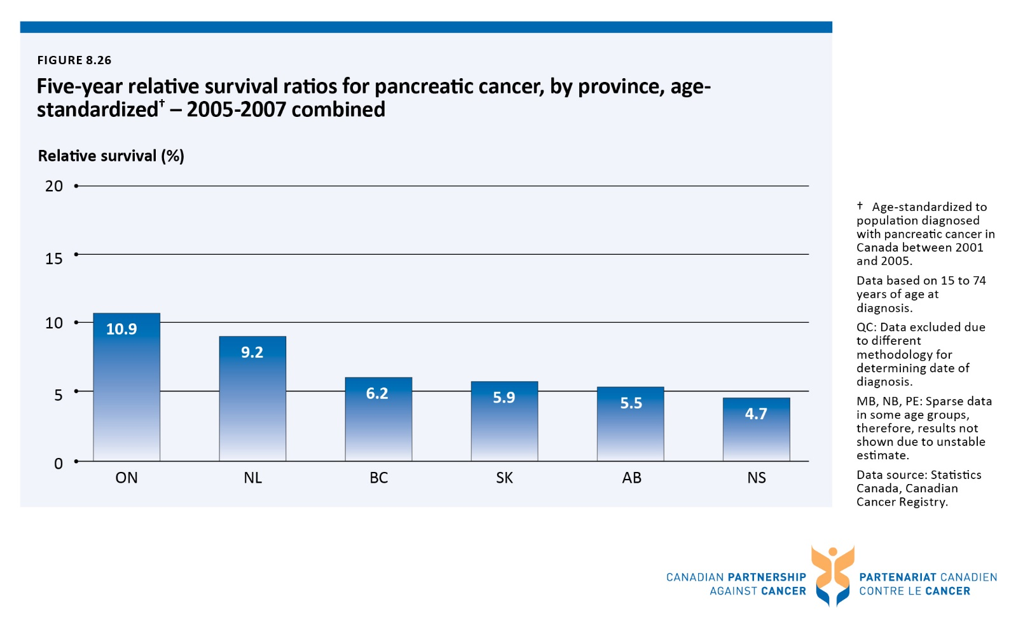

Figure 8.27 Five-year relative survival ratios for pancreatic cancer, Canada,ᶧ age-standardizedᶧᶧ - 1992-1994 combined vs. 2006-2008 combined
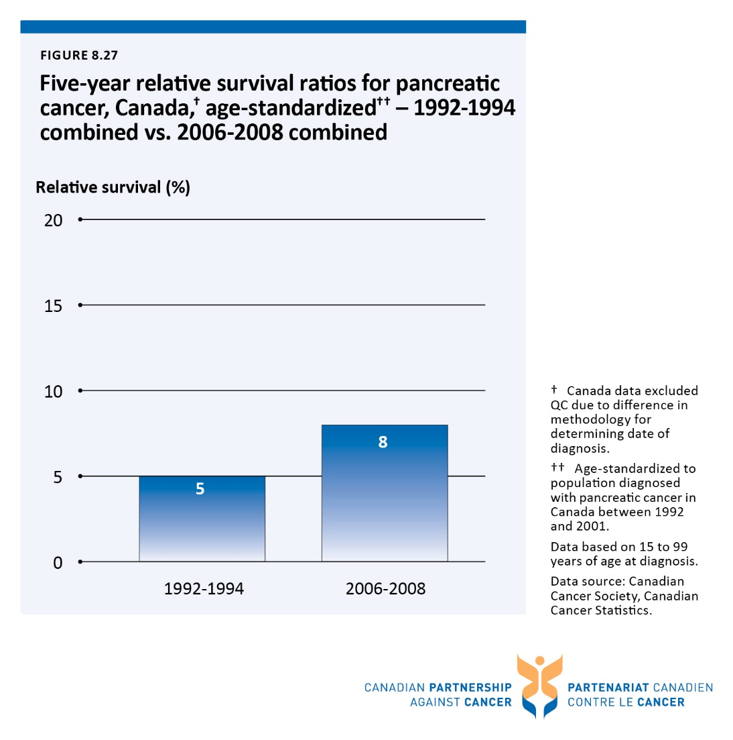

Table 1.1 Implementation and immunization uptake of organized human papillomavirus (HPV) vaccination programs for girls, by province/territory
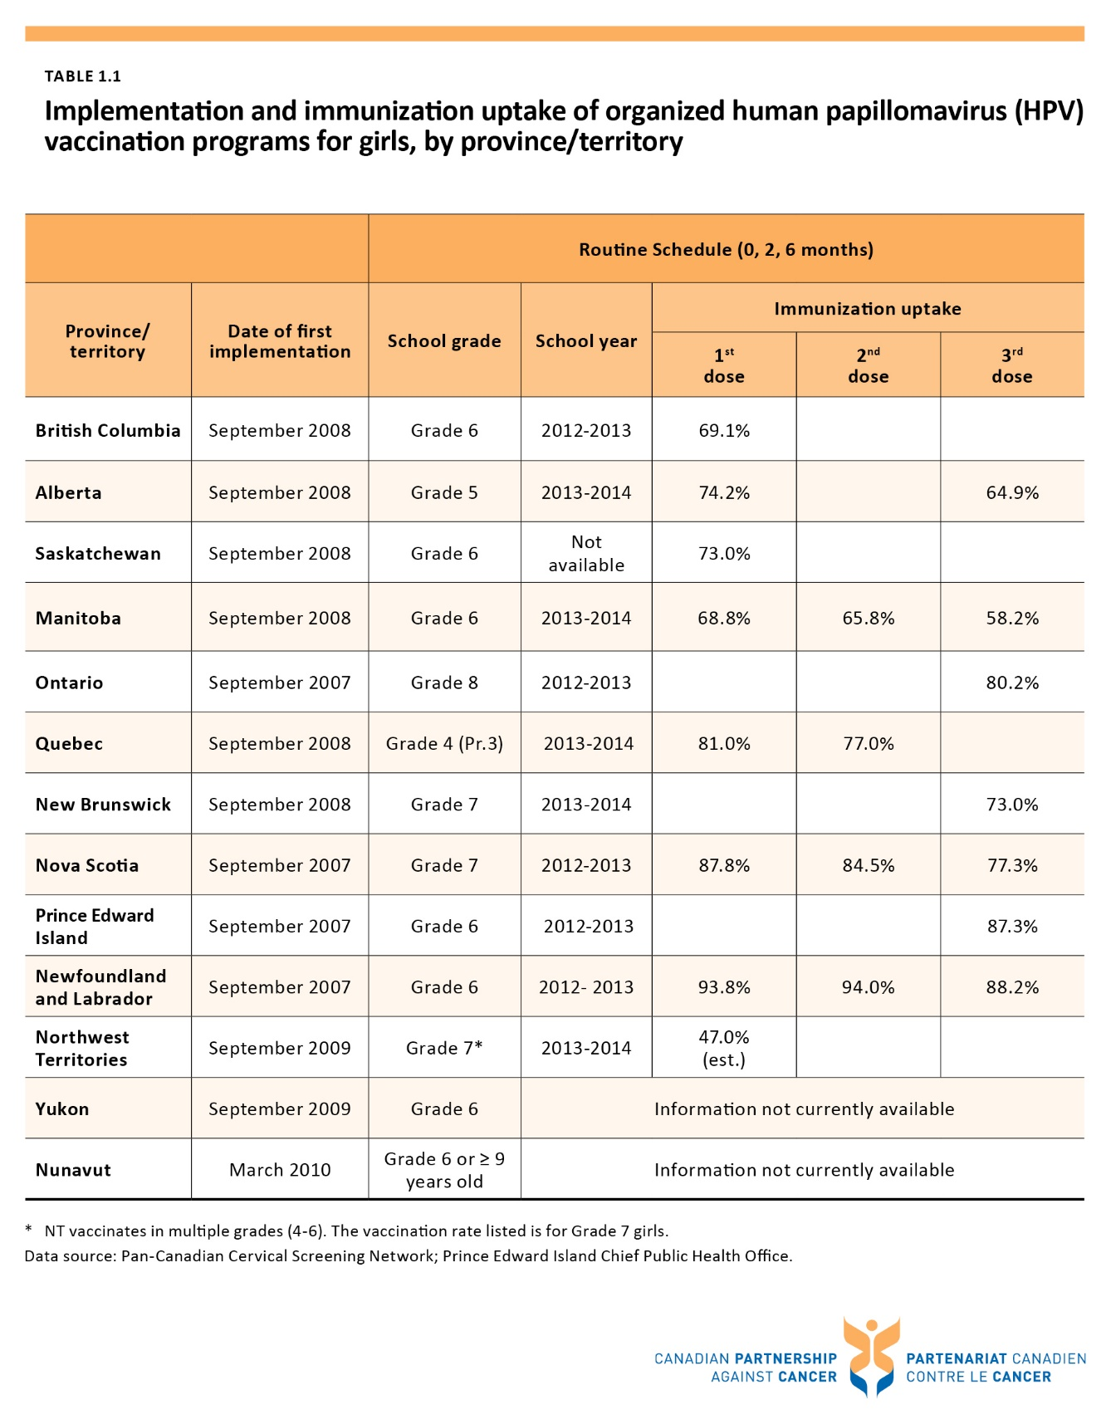

Table 4.1 Percentage of patients treated within the radiation therapy wait time target, four most common cancers and all cancers, by province – 2013 treatment year
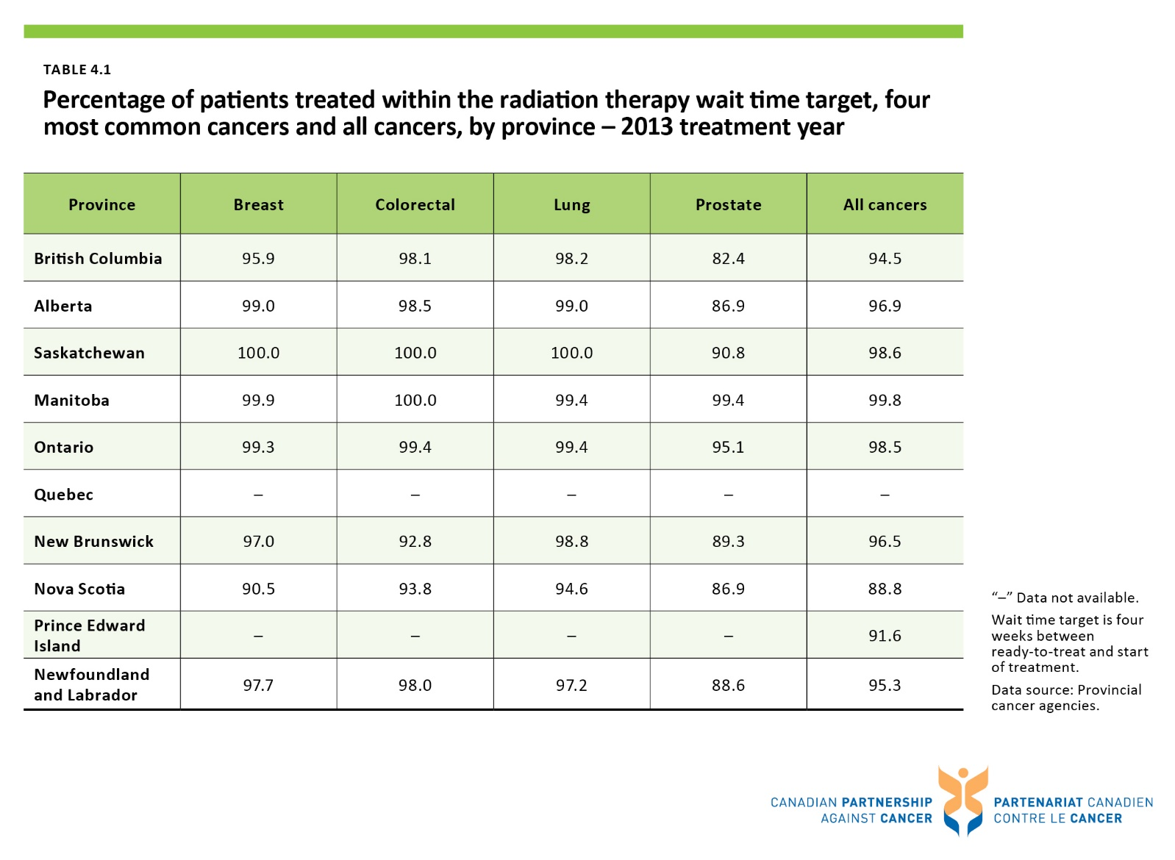

Table 5.1 Extent of usage of standardized screening for distress tools across clinics in provincial cancer agencies and programs – 2014
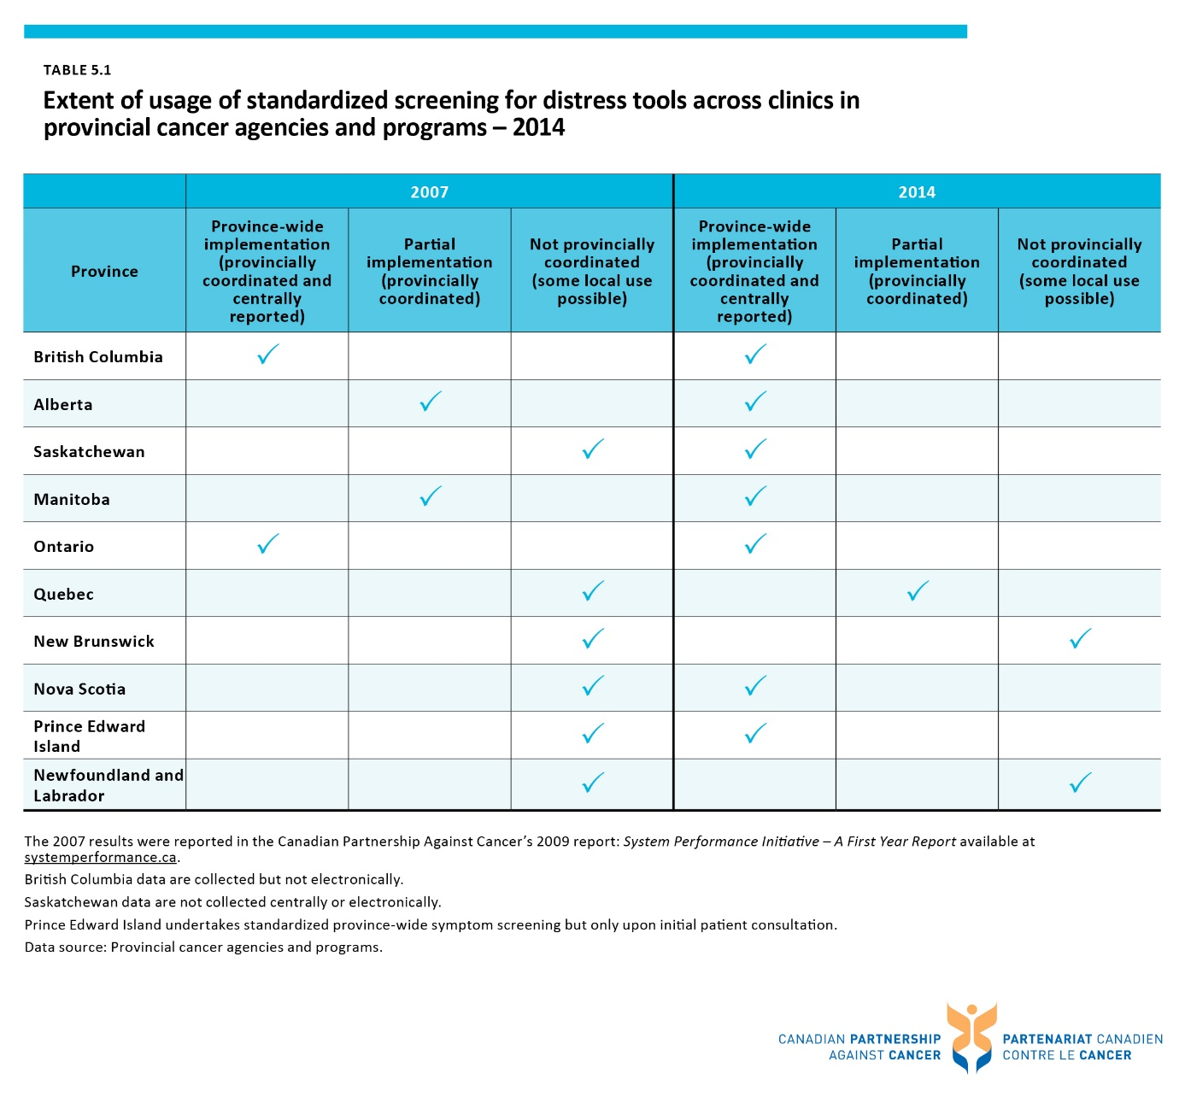

Table 8.1 Percentage of cases for which stage is unknown, by disease site and province - from 2010 to 2012
